Government of Pakistan
National Vocational and Technical Training Commission

Prime Minister’s Youth Skill Development Program (PMYSD)



Course Contents / Lesson Plan
Course Title: Light Transport Vehicle (LTV)
Duration: 3 Months

Table of Contents
1. Introduction 4
2. Purpose of the Qualification: 4
3. Overall objectives of training program 4
4. Entry level of trainees 5
5. Minimum qualification for teachers 5
6. Duration of the course: 5
7. Scheme of Studies 6
8. Details of Modules 7
8.1: Understand Traffic Rules & Regulations of Pakistan and CoDs 7
8.1.1: Basic Introduction of road Transport 7
8.1.2: Learn the process of License to Drive 7
8.1.3: Code of Conduct on the Road Vehicles 7
8.2: Soft Skills, Driver fatigue and workplace health safety 9
8.2.1: Soft Skills 9
8.2.1: Apply general safety practices 9
8.2.2: PPE (Personal Protective Equipment) 9
8.2.3: Health and Safety (First Aids) 9
8.2.4: Apply road safety practices (Safe Driving Techniques) 10
8.2.5: Ensure personal protective equipment (PPE) 10
8.2.6: Maintain First aid Box 10
8.2.7: Maintain Fire Extinguisher 10
8.2.8: Implement safety measures 11
8.2.9: Prepare for emergencies 11
8.2.10: Respond to emergencies 11
8.2.11: Maintain Personal Hygiene 11
8.2.12: Dispose off-waste materials 11
8.3: Light Traffic Vehicle 12
8.3.1: Basics of LTV driving 12
8.3.2: Driving Techniques of LTV 12
8.3.3: Technical information of Vehicle (Parts and Control) 12
8.3.4: Controls of an LTV 13
8.3.5: Driving Abilities 13
8.3.6: Driving Practice of LTV Vehicle 13
8.3.7: Driving and Parking Skills 14
8.3.8: Driving and Parking Skills 14
8.4: GPS Navigation Module for LTV Training Course 15
8.4.1: Benefits of GPS Navigation for LTV Drivers 15
8.4.2: Types of GPS Navigation Systems 15
8.4.3: Operating a GPS Navigation System Safely 15
8.4.4: Important Considerations 16
9. Multi Choice Questions. 16
12: Answer Key 47
13. Basic Language Skills 49
13.1: Basic Language Proficiency (Arabic) 49
13.2: Basic Language Proficiency (English) 66
13.3: Basic Language Proficiency German 81
13.4: Basic Language Proficiency Japanese 91
13.5: Basic Language Proficiency Korean 110

Introduction
The Light Transport Vehicle (LTV) driver course is specialized training programs designed to equip individuals with the necessary skills and knowledge for professional driving in the transportation sector. The LTV driver modules focus on training individuals to operate light transport vehicles, such as cars, vans, and small trucks, emphasizing fundamental driving techniques, traffic laws, safety protocols, vehicle maintenance, and, where applicable, customer service skills. This course is essential for ensuring the safety, efficiency, and reliability of transport services, enhancing the professional capabilities of drivers, and contributing to overall road safety and regulatory adherence in the transportation industry.
Therefore, industry expectations for skilled workforce are also dynamic which can only be managed through setting relevant curriculum in collaboration with the leading industries. Being familiar of this fact, National Vocational & Technical Training Commission (NAVTTC) developed curriculum for LTV driver under National Vocational Qualifications Framework (NVQF). These Modules have been developed by a Qualifications Development Committee (QDC).

Purpose of the Qualification:
The purpose of this qualification is to set high professional standards for LTV drivers. The specific objectives of developing these qualifications are as under:
- Improve the professional competence of the trainees
- Provide opportunities for recognition of skills attained through non-formal or informal pathways
- Improve the quality and effectiveness of training and assessment for LTV drivers
- Enable the existing workforce to capacitate themselves in new technologies and methods

Overall objectives of training program
The LTV qualification consists of 20 % theory and 80 % practical. and having the following Modules
- Understand Traffic Rules & Regulations
- Driver fatigue and workplace health safety
- Light Traffic Vehicle (LTV)
- Basic maintenance skills for LTV

Entry level of trainees
The entry for National Certificate, in LTV Driver is, a person having Matric Certificate.

Minimum qualification for teachers
- BS/BA/ADP in Automobile Technology with 2 years teaching experience having LTV driving experience
- Diploma in Automobile Technology /Senior Technician with 5-year field experience with LTV driving
Medium of instruction
English, Urdu

Duration of the course:
The proposed curriculum is composed of 5 modules that will be covered in 300 Learning hours. Duration of the course is proposed to be 3 months.
The distribution of contact/Learning hours and credit hours are given below:
3 months= 10 Weeks (Technical) + 2 Weeks (Language Skills)
Total Time of Technical Modules = 250 hours
Theory = 50 hours (20 %)
Practical = 200 hours (80 %)

Total Time of Soft Skill = 50 hours
Theory = 10 hours (20 %)
Practice = 40 hours (80 %)

Technical + Soft Skills = 250 + 50 hours
Grand Total = 300 hours. & 30 Credits

Category of NHMP License as per Vehicle
Pictorial Description | Categories of License/Permits | Minimum Maximum Age Required | Required Experience | Category of vehicle as per Weight Limit
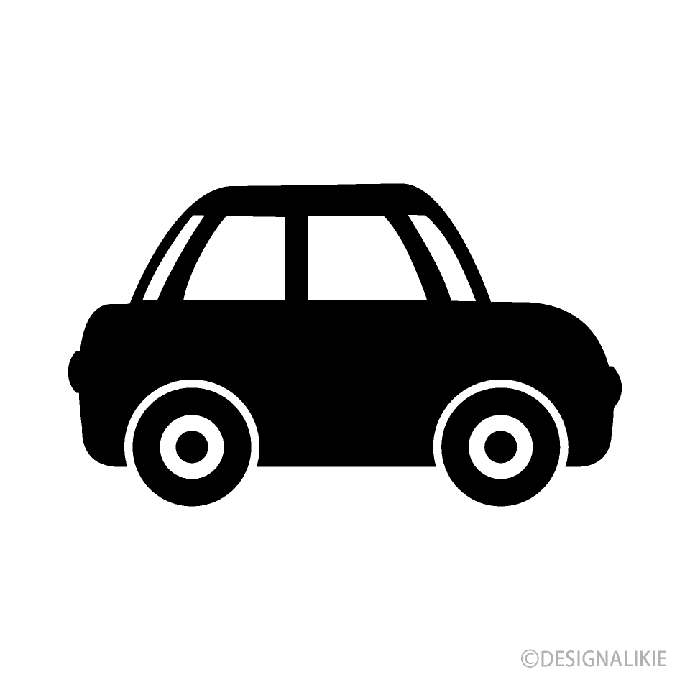 | Motorcycle, Motorcar/Jeep/Car or any other similar category license | 18 Year Minimum | Nil being fresh applicant | Motorcycle/Motorcar: Up to 125 Cc and more than 125 CC  Car/Jeep: Max mass not exceeding 3500 kg
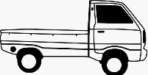 | LTV License  (Commercial Purpose) | (21-60) Years | 03-Year-old Valid car license | Above 3500 Kg
 | LTV/PSV License  (Public Service Vehicle)  Mazda Mini-Bus Rickshaw, Pick up van | (22-60) Years | 01-Year-old NHMP LTV license | Above 3500 kg with seating up to 22
 | HTV-A/ CE license  includes articulated vehicles more than 14 wheelers  (Trailers, lorries etc)  **Only NMHP is authorized licensing Authority in Pakistan | (21-60) Years | 03 years old valid license other than bike or invalid carriage | More than 40,000 kg
 | HTV(Heavy Transport Vehicle) /HTV-B (trucks)  Includes rigid vehicles upto 14 wheelers | (24-60) Years | 03 Years old valid LTV license | Upto 40,000 Kg
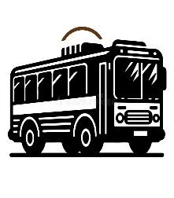 | HTV/PSV license  (Public Service Vehicle)  (Metro Bus, Bus, Daewoo Bus) | (25-60) Years | 01-Year-old valid NHMP HTV license | Seating capacity more than 22

Scheme of Studies
(A). Technical Skills
S. No | Name of Module | Category | Contact Hour |  |  | Credit | Periods per week
S. No | Name of Module | Category | Th | Pr | Total | Credit | Th | Pr | Total
1 | Understand Traffic Rules & Regulations | Core | 6 | 30 | 36 | 3.6 | 0.6 | 3 | 3.6
2 | Driver fatigue and workplace health safety | Functional | 6 | 30 | 36 | 3.6 | 0.6 | 3 | 3.6
3 | Light Traffic Vehicle (LTV) | Core | 22 | 90 | 112 | 11.2 | 2.2 | 9 | 11.2
5 | Basic maintenance skills for LTV | Core | 15 | 51 | 66 | 6.6 | 1.5 | 5.1 | 6.6
Total hours of Technical Modules |  |  | 49 | 201 | 250 | 25 | 4.9 | 20.1 | 25.0

(B). Language/Soft Skills
1 | Language Skills Arabic | Generic | Optional subjects:  Choose any one Language with 10 hours Theory and 40 hours for Practice with a Ratio of 20% theory and 80% Practice.
2 | Language Skills English | Generic
3 | Language Skills German | Generic
4 | Language Skills Japanese | Generic
5 | Language Skills Korean | Generic
Total hours of Soft Skills Modules |  |  | 10 | 40 | 50 | 5 | 5 | 20 | 25.0

Note: - Maximum possible Time of the 3 Months course
1 Period = 1 Hour,
5 Period in a day = 5 hours
5 days in a week = 25 hours
12 Week course. = 300 hours

8. Details of Modules

8.1: Understand Traffic Rules & Regulations of Pakistan and CoDs
Theory: 6 Hours Practical: 30 Hours Total: 36 Hours

8.1.1: Basic Introduction of road Transport
Theory | Practical | Duration
- Introduction and Importance of Road Transport  - Define different regions of world (Asia, Gulf and Europe)  - Knowledge of safety regulations and traffic laws in different regions of Pakistan & Countries of Destinations (CoDs)  - Define Highway codes book.  - Driver Competence & Fitness Test knowledge. | - Audio/Video Presentation  - Group Discussion  - Demos  - Quizzes | Theory: 2hr.  Practical: 12 hrs.  Total: 14 hrs.

8.1.2: Learn the process of License to Drive
Theory | Practical | Duration
- Knowledge about Road Transport Licensing process for different authorities. | - Audio/Video Presentation  - Group Discussion  - Quizzes  - Observations | Theory: 2hr  Practical: 3 hrs.  Total: 5 hrs

8.1.3: Code of Conduct on the Road Vehicles
Theory | Practical | Duration
- Define Use of Seat Belts  - Avoid Distracted Driving knowledge  - Obey Parking Regulations knowledge  - Use of Indicators knowledge  - How to respond to emergencies vehicles knowledge | - Pre departure Inspection of Vehicle.  - Check air pressure.  - Check Oil.  - Check break, indicators and head lights.  - Check water and wipers.  - Check battery.  - Check tires, lights, and fluid levels before any trip.  - To perform forward driving.  - Observer Traffic Singles and Road Sings.  - Follow speed limits.  - Follow Lane Discipline | Theory:2hr  Practical:15 hrs.  Total:17 hrs

Knowledge & Understanding: -
Reference Material (Traffic Rules of Country of Destination): -
Pakistan (NH&MP) (https://dla.nhmp.gov.pk/GUIDE-FOR-PRACTICAL-DRIVING-TEST-P1-PII-Final.pdf)
Saudi Arabia (https://www.rcrc.gov.sa/wp-content/uploads/2019/10/004618.pdf)
Qatar (https://www.scribd.com/document/245603728/Qatar-Traffic-Manual)
UAE (https://licensing.rta.ae/handbook/lmv/lmv_en.pdf)
Bahrain (https://services.bahrain.bh/wps/PA_GDTDhBoardServices/faces/javax.faces.resource/en/GDTLaw.pdf?rel=v1)
Canada (https://www.atstraffic.ca/wp-content/uploads/2016/08/MoST_PM.pdf)
United Kingdom (https://www.gov.uk/government/publications/traffic-signs-manual)
Australia (https://pcc.gov.au/uniform/Australian-Road-Rules-19March2018.pdf)
United States of America (https://2009-2017.state.gov/documents/organization/234570.pdf)
Vienna Convention On Road traffic Rules (1968) (https://treaties.un.org/doc/Publication/MTDSG/Volume%20I/Chapter%20XI/XI-B-19.en.pdf)

8.2: Soft Skills, Driver fatigue and workplace health safety
Theory: 6 Hours Practical: 30 Hours Total: 36 Hours

8.2.1: Soft Skills
Theory | Practical | Duration
Soft Skills Manual developed by NAVTTC, accessed through the following link  (https://navttc.gov.pk/AssetFiles/03Jan24_SoftSkills.pdf) |  | Theory: 10 hr.  Practical: 0hrs.  Total: 10 hrs.

8.2.1: Apply general safety practices
Theory | Practical | Duration
- Stress & Fatigue Management knowledge  - Define Load Management (LTV specific)  - Define PPE (Personal Protective Equipment)  - First Aids knowledge | - Work  - Rest  - Road Clear  - Chain of responsibility  - Work and rest options  - Standard Hours  - Alcohol, drugs and professional drivers | Theory: 0.5hr.  Practical: 2hrs.  Total: 2.5hrs.

8.2.2: PPE (Personal Protective Equipment)
Theory | Practical | Duration
- Define High-visibility clothing  - Define Safety footwear  - Define Eye rinsing liquid  - Define Warning vest  - Define Eye protection (googles) | - Audio/Video Presentation  - Group Discussion  - Quizzes  - Observations | Theory: 0.5hr  Practical:2 hrs  Total: 2.5hr

8.2.3: Health and Safety (First Aids)
Theory | Practical | Duration
- Define ABC (airway, breathing, and circulation) of First aids  - Define Stopped Heart Beats  - Define Bleeding, Chocking, Burns  - Define Unconscientious  - Define Broken Bone/Fracture  - Define health safety measurement. | - Audio/Video Presentation  - Group Discussion  - Quizzes  - Observations  - What to do | Theory: 0.5hr  Practical:3hrs  Total:3.5hrs

8.2.4: Apply road safety practices (Safe Driving Techniques)
Theory | Practical | Duration
- Defensive Driving knowledge  - Speed Management knowledge  - Define Maintaining Vehicle Condition  - Define Avoiding Distractions  - Define Intersection Safety  - Define Proper Lane Usage  - Define Weather Conditions  - Fatigue Management knowledge  - Pedestrian and Cyclist knowledge  - Define Emergency Response Preparedness | - Demonstration  - Audio/Video Presentation  - Group Discussion  - Demos  - Quizzes | Theory: 0.5hr  Practical:3hrs  Total: 3.5hrs

8.2.5: Ensure personal protective equipment (PPE)
Theory | Practical | Duration
- Personal Protective Equipment (PPE) Types and its uses | - Arrange PPEs as per requirement  - Wear proper PPE as per nature of job.  - Store PPE at appropriate place after use | Theory: 0.5 hr.  Practical: 3 hrs.  Total: 3.5hrs.

8.2.6: Maintain First aid Box
Theory | Practical | Duration
- First-Aid-Box and its uses.  - Knowledge of first-aid-box items. | - Ensure availability of first aid box  - Check first aid box for requisite emergency medicines  - Check expiry date of medicines  - Perform first aid treatment against electric shock.  - Perform first aid treatment / bandages against minor injuries | Theory: 0.5hr  Practical:3 hrs  Total: 3.5hrs

8.2.7: Maintain Fire Extinguisher
Theory | Practical | Duration
- Fire Extinguisher its types and uses  - Types of fire extinguishing materials. | - Check expiry of fire extinguisher  - Operate fire extinguisher.  - Replace fire extinguisher | Theory: 0.5hr  Practical:3 hrs  Total: 3.5hrs

8.2.8: Implement safety measures
Theory | Practical | Duration
- Hazard and its Types  - Treatment of various hazards | - Take required health and safety training  - Identify work place hazardous, Reasons and materials | Theory: 0.5hr  Practical:3 hrs  Total: 3.5hrs

8.2.9: Prepare for emergencies
Theory | Practical | Duration
- Know about the techniques for provision of first aid treatment. | - Take emergency response training  - Ensure emergency response exercises.  - Perform mock exercise for first aid of Cardio Respiratory Resuscitation (CPR)  - Perform mock exercise for first aid treatment against electric shock/minor injury | Theory: 0.5 hr  Practical:3 hrs  Total: 3.5 hrs

8.2.10: Respond to emergencies
Theory | Practical | Duration
- Use of emergency equipment  - Know about the emergency plan | - Follow emergency plan  - Communicate instructions  - Assess risk and determine course of action.  - Operate emergency equipment and supplies | Theory: 0.5hr  Practical:1 hrs.  Total: 1.5hrs

8.2.11: Maintain Personal Hygiene
Theory | Practical | Duration
- Hygiene and its Types  - Knowledge of personal hygiene | - Wash hands with soap frequently  - Trim and clean nails  - Maintain good hair hygiene  - Take shower regularly.  - Maintain body odour using deodorants/body spray | Theory: 0.5 hr  Practical:2hrs  Total: 2hrs

8.2.12: Dispose off-waste materials
Theory | Practical | Duration
- Types of waste materials  - Knowledge and understanding of waste material handling. | - Separate waste into recyclable and no recyclable category  - Check local regulations  - Handle hazardous waste carefully  - Adopt responsible waste management habits | Theory: 0.5hr  Practical:2hrs  Total: 2.5hrs

8.3: Light Traffic Vehicle
Theory: 22 Hours Practical: 90 Hours Total: 112 Hours

8.3.1: Basics of LTV driving
Theory | Practical | Duration
- Define LTV Vehicle  - Define Types of LTV Vehicle  - LTV Vehicle (Jeep, Mini bus and Lightweight transport) knowledge  - Basic Requirement of LTV Vehicle License knowledge | - Audio/Video Presentation  - Group Discussion  - Quizzes  - Observations | Theory: 2 hr.  Practical: 6hrs.  Total: 8hrs.

8.3.2: Driving Techniques of LTV
Theory | Practical | Duration
Knowledge about  - Starting and Stopping  - Steering Control  - Accelerating Smoothly  - Braking Technique  - Lane Positioning  - Mirror and Blind Spot Checking  - Turning and Cornering  - Handling Intersections | - To check seat belt and back view mirror.  - Adjust Headrest.  - Switch on & off the vehicle engine.  - To check head lights, breaks lights and indicators.  - To perform check breaks.  - Check turning and cornering the tyres.  - Accelerating smoothly & line positioning. | Theory: 3 hr  Practical:18 hrs.  Total: 21hrs

8.3.3: Technical information of Vehicle (Parts and Control)
Theory | Practical | Duration
- Basic knowledge of  - Engine  - Chassis  - Body  - Suspension System  - Braking System  - Electrical System  - Fuel System  - Cooling System  - Wheels and Tires | To ensure the optimal performance and safety of a vehicle, it is essential to inspect various critical components thoroughly. The Engine, Chassis, Body, Suspension System, Braking System, Electrical System, Fuel System, Cooling System, and Wheels and Tires. | Theory: 3 hr  Practical:9 hrs.  Total: 12 hrs

8.3.4: Controls of an LTV
Theory | Practical | Duration
- Define Dashboard Controls  Define Steering Wheel  - Define Pedals, Gear Selector  - Define Handbrake (Parking Brake)  - Define Turn Signals, Lights | - Perform particle to check the dashboard controls like check chock light, battery light, engine oil light, and any other indication lights.  - Check smoothness of steering wheel.  - Check break, clutch (non-auto vehicle) and accelerator pedal before accelerating the vehicle.  - To check Gear liver (for manual and auto vehicle)  - Check headlights, break lights, and indicators lights | Theory: 2hr  Practical:9hrs.  Total: 11 hrs

8.3.5: Driving Abilities
Theory | Practical | Duration
- Knowledge of Navigation usage  - Basic maintenance knowledge  - Knowledge of safety regulations and traffic laws  - Problem-solving knowledge  - Knowledge of road Concentration | - To understand local map.  - To observe navigation signs.  - To inspect the vehicle part to understand functions.  - To understand and learn traffic rules and laws. | Theory: 3 hr  Practical:12hrs.  Total:15hrs

8.3.6: Driving Practice of LTV Vehicle
Theory | Practical | Duration
Knowledge about forward driving (Narrow Lane, Sandy Patch, Zigzag Road, Causeway, Bridge, Sharp Turnings, Railway Crossing, Speed Breakers). | Practice LTV vehicle for following techniques  - Forward Driving  - Narrow Lane observation.  - Sandy Patch.  - Zigzag Road.  - Causeway.  - Bridge.  - Sharp Turnings.  - Railway Crossing.  - Speed Breakers. | Theory: 3hr  Practical:18 hrs  Total: 21hrs

8.3.7: Driving and Parking Skills
Theory | Practical | Duration
Knowledge about  - I Shape Parking K  - L Shape Parking | To perform parking task  - I Shape Parking  - L Shape Parking | Theory: 3 hr  Practical:9 hrs.  Total: 12hrs

8.3.8: Driving and Parking Skills
Theory | Practical | Duration
Knowledge about  - Reverse Parking  - Parallel Parking  - Garage Parking | To perform parking task  - Reverse Parking  - Parallel Parking  - Garage Parking | Theory: 3hr  Practical:9 hrs.  Total:12hrs

8.4: GPS Navigation Module for LTV Driver Training Course
Theory: 15 Hours Practical: 51 Hours Total: 66 Hours

8.4.1: Benefits of GPS Navigation for LTV Drivers
Theory | Practical | Duration
- Improved route planning and efficiency  - Reduced driver workload and fatigue  - Enhanced situational awareness, especially on unfamiliar routes  - Real-time traffic updates and alternative route suggestions  - Location tracking for fleet management purposes | - Explore stations showcasing live traffic updates, safety alerts, lane guidance for LTV drivers.  - In class demonstration of limited visibility driving vs. GPS guided navigation. | Theory: 3 hr  Practical:12 hrs.  Total: 15hrs

8.4.2: Types of GPS Navigation Systems
Theory | Practical | Duration
- In-dash navigation systems integrated into the vehicle's dashboard  - Portable navigation devices with standalone displays  - Smartphone navigation apps | - In-class demonstration of different GPS navigation systems. | Theory: 3hr  Practical:12hrs.  Total: 15 hrs

8.4.3: Operating a GPS Navigation System Safely
Theory | Practical | Duration
- Pre-trip planning: Entering destination information, checking route details, and identifying potential hazards.  - While driving: Following voice prompts or on-screen instructions cautiously, avoiding distractions, and maintaining focus on the road.  - Limitations awareness: Recognizing that GPS systems can provide inaccurate information or outdated routes. Dependence on GPS should not replace a driver's knowledge of traffic signs, road’ conditions, and safe driving practices. | - Hands-on practice using a simulator or a non-driving environment to plan routes and navigate using a GPS system specific to LTVs.  - Analyse situations where GPS may provide inaccurate information and emphasize the importance of driver judgment. | Theory: 4hr  Practical:15hrs.  Total: 19 hrs

8.4.4: Important Considerations
Theory | Practical | Duration
- Map Updates: Ensure the GPS system has the latest maps to avoid outdated directions.  - Point of Interest (POI) Selection: Choose POIs suitable for large vehicles, considering factors like road width, height restrictions, and parking availability.  - Driver Responsibilities: GPS is a tool, not a substitute for safe driving practices. Always prioritize road signs, traffic regulations, and real-time road conditions over GPS instructions.  - Distraction Prevention: Minimize interaction with the GPS system while driving. Utilize features like voice prompts and pre-programmed destinations. | - Reconstruct a hypothetical LTV accident and discuss safety improvements. | Theory: 5hr  Practical:12 hrs.  Total: 17 hrs

Multi Choice Questions.
Module 1: Understand Traffic Rules & Regulations
- What is the legal age for the drivers to obtain a non-professional driving license in Pakistan?
- 16 years
- 18 years
- 20 years
- 22 years
- Which side of the road should you drive in Pakistan?
- Left side
- Right side
- Center
- Any side
- What does a red traffic light indicate?
- Stop
- Go
- Slow down
- Prepare to go
- What does a flashing yellow light mean?
- Stop
- Go
- Slow down and proceed with caution
- Don’t move
- When approaching a pedestrian crossing ie. Zebra crossing, drivers should:
- Speed up
- Stop if there are pedestrians
- Ignore pedestrians
- Honk to alert pedestrians
- What is the maximum speed limit in urban areas unless otherwise displayed?
- 40 km/h
- 50 km/h
- 80 km/h
- 65 km/h
- Overtaking is prohibited:
- On sharp curves
- At pedestrian crossings
- At intersections
- All of the above
- What does a solid white line on the road to signify?
- You can change lanes
- You cannot change lanes or over take
- Parking is allowed
- It is a pedestrian lane
- In case of an accident, the driver must:
- Drive away quickly
- Stop and provide assistance
- Call the police
- Continue driving if the damage is minor
- What is the penalty for driving without a valid license in Pakistan?
- Fine only
- Imprisonment
- Fine and/or imprisonment
- No penalty
- Using a mobile phone while driving is:
- Permitted
- Permitted with a hands-free device
- Prohibited
- Permitted only for texting
- The use of seat belts is:
- Optional
- Mandatory for the driver only
- Mandatory for both driver and front-seat passenger
- Mandatory for all passengers
- Which document is essential to carry while driving in Pakistan?
- Passport
- Vehicle registration book and Driving License
- Credit card
- Birth certificate
- What is the purpose of a speed bump?
- To increase vehicle speed
- To slow down VEHICLE
- To separate lanes
- To park vehicles
- If a traffic signal is out of order, you should:
- Ignore it and proceed
- Drive as if it is green
- Follow the signals of the traffic warden
- Stop and wait until it is fixed
- A broken white line on the road means:
- No parking
- Passing is allowed if done safely/can overtake
- No passing
- One-way street
- What is the maximum speed limit FOR LTV on motorways in Pakistan?
- 100 km/h
- 110 km/h
- 120 km/h
- 130 km/h
- When should you use your car horn?
- To greet friends
- To alert other drivers of your presence
- To express frustration
- In silent zones
- Why are dippers used?
- For overtaking
- To stop your vehicle
- To show your presence
- none
- When are you allowed to overtake another vehicle on the road?
- On curves
- At intersections
- On a straight road.
- On bridges
- What should a driver do if they miss an exit on the motorway?
- Reverse to the exit
- Make a U-turn
- Continue to the next exit
- Stop and wait for assistance
- What is the purpose of a zebra crossing?
- Parking area
- Pedestrian crossing
- Vehicle stopping area
- Bicycle crossing
- What should a driver do when approaching a roundabout?
- Speed up
- Stop
- Give way to traffic coming from right side
- Enter without checking
- Issuance of driving license system is followed by:
- Ordinance 1965
- Ordinance 1966
- Ordinance 1968
- Ordinance 1970

Module 2: Apply General & Road Safety
- What is the primary purpose of road warning signs?
A) To inform drivers of nearby restaurants
B) To guide drivers to the nearest gas station
C) To warn drivers of potential hazards ahead
D) To provide advertisements
- What does triangular sign indicate?
A) Prohibited actions
B) Mandatory actions
C) Warning of potential hazards
D) Information
- Which color is commonly used for warning signs on the road?
A) Blue
B) Green
C) Yellow
D) Red
- What does a yellow diamond-shaped sign with a black exclamation mark indicate?
A) No parking
B) Yield
C) General caution
D) Pedestrian crossing
- What does this sign mean?

A) U-turn ahead
B) Go straight or Left
C) Truck stop ahead
D) Road narrows ahead
- What does this sign mean?

A) U-turn ahead
B) Give Way
C) Roundabout
D) Honk continuously
- What does a flashing red traffic light signify?
A) Slow down
B) Stop, then proceed when safe
C) Caution, proceed with care
D) Pedestrian crossing
- What should a driver do when they see a sign indicating "Slippery When Wet"?
A) Speed up to avoid skidding
B) Maintain a constant speed
C) Reduce speed and drive with caution
D) Stop immediately
- Which sign indicates a school zone?
A) A triangular sign with children crossing
B) A diamond sign with a pedestrian symbol
C) A circular sign with a bicycle symbol
D) A square sign with a bus symbol
- What is the purpose of a speed limit sign?
A) To inform drivers of the maximum safe speed for the specific area
B) To suggest a speed to drive at
C) To indicate a minimum speed requirement
D) To warn of upcoming speed traps
- What does this sign mean?
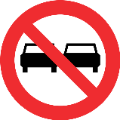
A) No entry
B) Overtaking in not allowed
C) Left turn permitted
D) Left lane ends
- Which safety feature is most effective in preventing fatalities in vehicle collisions?
A) Head rest
B) Seat belts
C) Anti-lock braking system (ABS)
D) Traction control
- How many types of traffic sign boards are?
A) 2
B) 5
C) 3
D) 4
- How often should heavy vehicle drivers conduct a pre-trip inspection?
A) Once a week
B) Every trip
C) Once a month
D) Before heading out on route.
- Traffic signs in blue, green or black color indicate?
A) Mandatory
B) Information
C) Warning
D) Prohibited
- Which sign indicates danger ahead?
A | B | C | D
 |  |  | 
- What should you do if you see a sign warning of animals crossing the road?
A) Speed up to pass the area quickly
B) Drive with caution and be prepared to stop
C) Ignore the sign
D) Sound your horn continuously
- Which sign indicates ROAD NARROWS ON RIGHT?
A | B | C | D
 |  |  | 
- Which document is essential for legally driving a heavy vehicle?
A) Personal ID card
B) Vehicle registration
C) Heavy Vehicle License (LTV license)
D) Vehicle insurance policy
- What does a double solid yellow line on the road signify?
A) Passing is allowed in both directions
B) No passing in either direction
C) Passing allowed on the left only
D) Passing allowed on the right only
- How should you after witnessing a sign indicating a narrow bridge ahead?
A) Speed up to cross quickly
B) Slow down and be prepared to stop if necessary
C) Drive in the middle of the bridge
D) Change lanes immediately
- Is the extreme left lane used only for overtaking?
A) Wrong
B) Right
C) No idea
D) None
- Which type of road sign is usually triangular in shape?
A) Regulatory signs
B) Warning signs
C) Informational signs
D) Directional signs
- What should a driver do if they encounter a flashing yellow traffic light?
A) Stop completely
B) Proceed with caution
C) Speed up
D) Ignore the light
- What is the purpose of reflective tape on heavy vehicles?
A) To enhance visibility during the day
B) To reduce fuel consumption
C) To improve nighttime visibility
D) To indicate vehicle weight
- What is the safest way to approach a sharp curve?
- Accelerate into the curve
- Brake hard in the middle of the curve
- Slow down before entering the curve
- Maintain the same speed throughout

Module 3: Light Traffic Vehicle
- Which LTV type typically has a rear cargo area that is separate from the passenger area?
A) Coupe
B) Sedan
C) SUV
D) Pickup truck
- What is the correct hand position on the steering wheel for optimal control?
A) 12 o'clock
B) 10 and 2 o'clock
C) 9 and 3 o'clock
D) 8 and 4 o'clock
- When parallel parking, what is the first step?
A) Turn the steering wheel towards the curb
B) Align your car parallel to the car in front of the space
C) Accelerate into the space
D) Turn on your hazard lights
- What is the recommended following distance under normal driving conditions?
A) 1 second
B) 5 seconds
C) 2 seconds
D) 4 seconds
- Which of the following vehicles is considered a Light Traffic Vehicle (LTV)?
A) Semi-truck
B) SUV
C) Dump truck
D) Bulldozer
- What is the purpose of the blind spot check?
A) To check tire pressure
B) To see vehicles in your side mirrors
C) To view areas not visible in mirrors
D) To check fuel levels
- When should you use your vehicle's horn?
A) To greet other drivers
B) To alert others of your presence in an emergency
C) To express frustration
D) To make pedestrians move faster
- Which type of LTV is designed for both city and light off-road use?
A) Sedan
B) Coupe
C) Crossover
D) Convertible
- Which type of LTV is commonly used for transporting goods?
A) Sedan
B) Hatchback
C) Pickup truck
D) Coupe
- When driving in foggy conditions, which lights should you use?
A) High beam headlights
B) Low beam headlights or fog lights
C) Parking lights
D) Hazard lights
- Which type of transmission is known for providing better fuel efficiency?
A) Manual transmission
B) Automatic transmission
C) Continuously Variable Transmission (CVT)
D) Dual-clutch transmission
- What should you do if your tire blows out while driving?
A) Brake immediately
B) Accelerate to regain control
C) Grip the steering wheel firmly and slow down gradually
D) Turn on your hazard lights and stop abruptly
- Which technique helps in reducing fuel consumption?
A) Rapid acceleration
B) Maintaining a steady speed
C) Frequently changing lanes
D) Keeping windows open at high speeds
- What is the purpose of the "two-second rule" in LTV driving?
A) To maintain a safe following distance
B) To measure stopping distance
C) To determine reaction time
D) To check blind spots
- What is the main advantage of all-wheel drive (AWD) vehicles?
A) Improved fuel economy
B) Better handling and traction in various road conditions
C) Higher top speed
D) Lower maintenance costs
- Which driving practice is most effective in preventing accidents?
A) Tailgating
B) Defensive driving
C) Distracted driving
D) Speeding
- What is the best practice for using mirrors while driving an LTV?
A) Adjust only the side mirrors
B) Adjust mirrors after starting the vehicle
C) Adjust all mirrors before starting to drive
D) Use mirrors only when parking
- What is the primary use of a sedan vehicle?
A) Transporting heavy goods
B) Family transportation and daily commuting
C) Off-road driving
D) Racing
- What is the benefit of maintaining correct tire pressure?
A) Improved fuel efficiency
B) Increased vehicle weight
C) Reduced vehicle height
D) Enhanced acceleration
- What is the best way to improve visibility during heavy rain?
A) Use high beam headlights
B) Use low beam headlights and windshield wipers
C) Turn off headlights
D) Speed up to clear the area quickly
- What is the purpose of the Vehicle Stability Control (VSC) system?
A) To enhance acceleration
B) To maintain traction and prevent skidding
C) To improve fuel efficiency
D) To reduce vehicle noise
- What should you do when you see a pedestrian at a crosswalk?
A) Speed up to pass before they cross
B) Stop and yield the right of way
C) Honk to alert them to move quickly
D) Continue driving if there is no traffic light
- What is the primary function of a vehicle's transmission system?
A) To generate electrical power
B) To control the speed and torque of the vehicle
C) To inflate the tires
D) To filter the engine oil
- Which technique is used to ensure safe lane changes?
A) Signal, check mirrors, and blind spots, then change lanes
B) Change lanes quickly without signaling
C) Only check mirrors before changing lanes
D) Signal and change lanes immediately

Module 5: Practice LTV basic maintenance skills
- What is the primary purpose of regular vehicle maintenance?
A) To increase vehicle speed
B) To ensure safety and reliability
C) To improve vehicle aesthetics
D) To reduce insurance costs
- How often should engine oil be checked in LTVs?
A) Once a year
B) Every 5,000 miles
C) Weekly
D) Monthly
- Which fluid is essential for the proper functioning of an LTV's braking system?
A) Engine oil
B) Brake fluid
C) Transmission fluid
D) Power steering fluid
- What is the first step in performing a pre-trip inspection?
A) Checking tire pressure
B) Starting the engine
C) Inspecting lights and signals
D) Checking the fuel level
- What should you check regarding the lights on both LTVs?
A) Brightness and alignment
B) Color and style
C) Size and shape
D) Manufacturer
- What tool is commonly used to check tire pressure?
A) Torque wrench
B) Tire gauge
C) Pressure washer
D) Thermometer
- Which document should always be kept up-to-date for vehicle maintenance?
A) Driver's license
B) Vehicle registration
C) Maintenance logbook
D) Insurance policy
- What should be done if the check engine light comes on?
A) Ignore it and continue driving
B) Check for any obvious issues and consult a mechanic
C) Disconnect the battery
D) Turn off all electronic devices
- How often should the coolant level be checked in an LTV?
A) Every day
B) Weekly
C) Monthly
D) Only during scheduled maintenance
- Which component is crucial for starting the vehicle?
A) Alternator
B) Battery
C) Radiator
D) Catalytic converter
- What is the purpose of the serpentine belt in a vehicle?
A) To enhance acceleration
B) To drive multiple peripheral devices in the engine
C) To reduce engine noise
D) To filter the engine oil
- When should the transmission fluid be checked?
A) Every 1,000 miles
B) During each oil change
C) When the vehicle is new
D) Only when there is a problem
- What is the main sign of worn brake pads?
A) High-pitched squealing noise
B) Smooth braking
C) Increased fuel consumption
D) Improved acceleration
- Why is it important to maintain proper alignment in LTVs?
A) To increase vehicle speed
B) To ensure even tire wear and proper handling
C) To reduce vehicle weight
D) To enhance visibility
- How often should windshield wipers be replaced?
A) Every month
B) Every 6 to 12 months
C) Every 2 years
D) Only when they are broken
- What is the function of the alternator in a vehicle?
A) To start the engine
B) To charge the battery and power the electrical system
C) To cool the engine
D) To filter the fuel
- How can you check for a potential coolant leak?
A) Look for wet spots under the vehicle
B) Check tire pressure
C) Listen for unusual engine noises
D) Check fuel level
- What is the purpose of a vehicle's suspension system?
A) To increase speed
B) To absorb and dampen shocks for a smoother ride
C) To reduce fuel consumption
D) To enhance engine performance
- Which fluid should be checked to ensure smooth steering operation?
A) Brake fluid
B) Engine oil
C) Transmission fluid
D) Power steering fluid
- How often should the spark plugs be replaced in an LTV?
A) Every 3,000 miles
B) Every 12,000 miles
C) Every 30,000 to 50,000 miles
D) Every 100,000 miles
- What is a common sign of a failing alternator?
A) Engine overheating
B) Dimming headlights
C) High-pitched squealing noise
D) Smooth braking
- Why is it important to regularly change the engine oil and oil filter?
A) To increase speed
B) To ensure engine lubrication and long life
C) To enhance vehicle aesthetics
D) To reduce vehicle weight
- What is the function of the fuel filter in a vehicle?
A) To increase fuel efficiency
B) To remove impurities from the fuel before it reaches the engine
C) To cool the fuel
D) To increase vehicle speed
- What should you do if you notice unusual vibrations while driving?
A) Ignore them
B) Check for proper tire balance and alignment
C) Increase speed
D) Turn off the engine
- Why is it important to maintain the correct coolant level?
A) To increase speed
B) To prevent engine overheating
C) To reduce fuel consumption
D) To enhance visibility

12: Answer Key

Module 1
B | A | A | C | B | D | D | B | B | A
C | C | B | B | C | B | C | B | A | C
C | B | C | D | A

Module 2
C | C | C | C | B | B | B | C | A | A
B | B | C | B | B | A | B | A | C | B
B | A | B | B | C | C

Module 3
D | C | B | C | B | C | B | C | C | B
A | C | B | A | B | B | C | B | A | B
B | B | B | A

Module 4
C | C | C | B | B | B | B | B | B | D
B | B | B | B | C | C | C | A | B | B
 |  |  |  |  | 26. | 27. | 28.
B | B | C | D | B | C | B | C

Module 5
B | C | B | C | A | B | C | B | B | B
B | B | A | B | B | B | A | B | D | C
B | B | B | B | B

- Basic Language Skills

13.1: Basic Language Proficiency (Arabic)
Theory: 10 Hours Practical: 40 Hours Total: 50 Hours
التحية والتعارف (Introduction & Greetings)
Theory | Practical | Duration
- شرح الكلمات الجديدة بالأردية  - تدريب الحوار بين الطالبين  - تدريب الطلاب على استخدام الكلمات  - تدريب على الاستماع  - مشاهدة فيديو للحوار | التعارف بين الشخصين  قاسِمٌ: السلامُ عليْكم!  عَلِيٌّ: وَعَلَيْكُمُ السَّلامُ ورَحْمَةُ اللهِ وبَرَكَاتُهُ!.  قاسِمٌ: كَيْفَ حَالُكَ؟  عَلِيٌّ: بِخَيْرٍ وَالْحَمْدُ لِلهِ.  قاسِمٌ: أَنَا اِسْمِيْ قَاسِمٌ، وَأَنْتَ مَا اسْمُكَ؟  عَلِيٌّ: اسْمِيْ عَلِيٌ. مِنْ أَيْنَ أَنْتَ يَا قَاسِمُ؟.  قاسِمٌ: أَنَا مِنْ تُرْكِيَا، وَأَنْتَ مَا جِنْسِيَّتُكَ؟  عَلِيٌّ: أَنَا سُعُوْدِيٌ.  قاسِمٌ: تَشَرَّفْنَا.  عَلِيٌّ: تَشَرَّفْنَا بِكَ.  قاسِمٌ: إِلَى الِّلقَاء.  عَلِيٌّ: مَعَ السَّلَامَةِ.  - أَجِبْ لِمَا يَأْتِيْ:  1. السَّلَامُ عليكُمْ ..................  2. مَااسْمُكَ؟ ..................  3. كَيْفَ حَالُكَ؟ ..................  4. مِنْ أَيْنَ أَنْتَ؟ ..................  5.مَا جِنْسِيَّتُكَ؟ ..................  6. هَلْ أَنْتَ بَاكسْتانِيٌّ؟ ..................  7. هَلْ هُوَ مِنْ سُورِيَّا؟ ..................  8. مَعَ السَّلاَمَة ..................  - تَبَادَلِ السُّؤَالَ والجَوَابَ مَعْ زَمِيْلِك، كَمَا فِي الْمِثَالِ:  المثال, مِنْ أَيْنَ أَنْتَ؟ , أَنْتَ – بَاكِسْتَان, أَنَا مِنْ بَاكِسْتَان  1, ________ , أَنْتِ - العرَاق________,  2, ________, هُوَ - سُوْرِيَا_________,  3, ________ , هِيَ - مِصْر________,  4, ________ , أَنْتِ - باكِسْتَان______,  - املإِ الفَرَاغَ في الجُمَل الآتِيَةِ مِمَّا يَاْتِيْ:  سُودَانيَّة، كَيْفَ، مِنْ، أَيْنَ، لِــ، مُدَرِّسٌ، سَهْلًا، إلى، خَيْر، سعيدة.  1. أَهْلًا وَ .........  2. الحَمْدُ ....... اللهِ.  3. سمِيْر........  4. فُرْصَةٌ...........  5. فاطمة...............  6. أنَا ....... مِصْر.  7. بــــــــــ ..........  8. ...... حالُكَ؟  9. مِنْ ....... أَيْنَ أَنْتِ؟  10. ...... اللِّقاء | Theory:90 min  Practical:270min.  Total: 6hr.
السفر (Travelling)
Theory | Practical | Duration
- شرح الكلمات الجديدة بالأردية  - تدريب الحوار بين الطالبين  - تدريب الطلاب على استخدام الكلمات  - تدريب على الاستماع  - مشاهدة فيديو للحوار | الحوار في المطار عند المغادرة  حَمَد: السَّلَامُ عَلَيْكُمْ!  الْمَوَظَّفُ: وَعَلَيْكُمُ السَّلَامُ وَرَحْمَةُ اللهِ وبَرَكِاتُهُ!  الْمَوَظَّفُ: تَذْكِرَةَ الطَّائِرَةِ وَجَوَازَ السَّفَرِ مِنْ فَضْلِكَ.  حَمَد: تَفَضَّلْ.  الْمَوَظَّفُ: كَمْ حَقِيْبَةً مَعَكَ ؟  حَمَد: مَعِيْ حَقِيْبَةٌ وَاحِدَةٌ.  الْمَوَظَّفُ: أَعْطِنِيْ جوَازَ السَّفَرِ، لَوْ سَمَحْتَ.  حَمَد: بِكُلِّ سُرُوْرٍ، تَفَضَّلْ.  الْمَوَظَّفُ: حَسَنٌ. رِحْلَةٌ سَعِيْدَةٌ.  حَمَد: شُكْرًا.  اقْرَأِ الْجَمَلَ الْآتِيَةَ، ولَاحِظْ مَا تَحْتَهُ خَطٌّ:  1. لَوْ سَمَحْتَ، أَعْطِنِيْ الْقَلَمَ. تَفَضَّلْ.  2. مِنْ فَضْلِكَ، أُرِيْدُ فِنْجَانَ قَهْوَةٍ.  3. أَعْطِنِيْ جَوَازَ السَّفَرِ، لَوْ سَمَحْتَ. بِكُلِّ سُرُوْرٍ.  4. شُكْرًا عَلَى الْمُسَاعَدَةِ.  5. عَفْوًا، أَيْنَ الْمَطَارُ؟  6. أَرَاكَ غَدًا، إِنْ شَاءَ اللهُ.  7. إِلَى اللِّقَاءِ.  8. مَعَ السَّلَامَةِ.  اكتُبِ التَّعْبِيْرَ الْمُنَاسِبَ فِي الفَرَاغ:  لَوْ سَمَحْتَ، إِلَى اللِّقَاء، مَعَ السَّلَامَةِ، تَفَضَّلْ، عَفْوًا.  1. ................... ، أُرِيْدُ بَعْضَ السُّكَّرِ  2. أَعْطِنِيْ الْقَلَمَ مِنْ فَضْلِكَ. ....................  3. أَنَا مُسَافِرٌ. .....................  4. ................ ، هَلْ أَسْتَطِيْعُ أَنْ أَجْلِسَ هُنَا، نَعَمْ تَفَضَّلْ.  5. .................. ، أَرَاكَ الْأُسْبُوعَ الْقَادِمَ  - الحوار في المطار عند الوصول  هَذَا هُوَ مَطَارُ الخُرْطُوْمِ، هَذِهِ هِيَ طِائِرَةُ الْكُوِيْتِ، يُوْسُفُ يَدْخُلُ صَالَةَ الْوُصُوْلِ، يُوْسُفُ الْآنَ أَمَامَ مَكْتَبِ الْجَوَازَات.  يُوْسَفُ: السَّلَامُ عَلَيْكُمْ!  مُوَظَّفُ الْجَوَازَاتِ: وَعَلَيْكُمُ السَّلَامُ وَرَحْمَةُ اللهِ وبَرَكِاتُهُ!  مُوَظَّفُ الْجَوَازَاتِ: بِطَاقَةَ الْوُصُوْلِ مِنْ فَضْلِك!  يُوْسَفُ: هَذِهِ هِيَ.  مُوَظَّفُ الْجَوَازَاتِ: جَوَازُ السَّفَرِ مِنْ فَضْلِكَ!  يُوْسَفُ: هَذَا هُوَ.  .مُوَظَّفُ الْجَوَازَاتِ: مَا سَبَبُ الزِّيَارَةِ ؟ .  يُوْسَفُ: العمل في الشركة أنا سائقٌ.  مُوَظَّفُ الْجَوَازَاتِ: مَا العُنْوَانُ فٍي الْخُرْطُوْمِ ؟  يُوْسَفُ: مَعْهَدُ اللُّغَةِ الْعَرَبِيَّةِ.  مُوَظَّفُ الْجَوَازَاتِ: هَذَا هُوَ الْجَوَازُ.  يُوْسَفُ: شُكْرًا.  مُوَظَّفُ الْجَوَازَاتِ: مَعَ السَّلَامَةِ.  الحوار في المطار عندما فقد المسافر حقيبته  المشافر: معذرة، رحلتي وصلت من باكستان، أبحث عن حقيبتي. لم أجد على الحزام الناقل هل يمكنك مساعدتي؟  وكيل الأمتعة: اسمح لي أن أتحقق من الحالة نيابةً عنك. يرجى وصف الأمتعة الخاصة بك؟  المشافر: إنها حقيبة سوداء.  وكيل الأمتعة: هل يمكنني الحصول على رقم بطاقة الأمتعة الخاصة بك؟ / دعني أبحث عن تفاصيل رحلتك. يبدو أن حقيبتك لا تزال في مرحلة النقل ويجب أن تصل في الرحلة التالية.  المسافر (بعد أن وجد الحقيبة): " ها هي! شكرًا لك على مساعدتك.  وكيل الأمتعة: مرحبًا بك. طاب يومك! | Theory:90 min  Practical:270min.  Total: 6hr.
السكن (Residence)
Theory | Practical | Duration
- شرح الكلمات الجديدة بالأردية  - تدريب الحوار بين الطالبين  - تدريب الطلاب على استخدام الكلمات  - حفظ الأرقام (1- 100)  - تدريب على الاستماع  - مشاهدة فيديو للحوار | الحوار عن عنوان البيت  أَحْمَدُ: السَّلَامُ عَلَيْكُمْ!  حَسَّانُ: وَعَلَيْكُمُ السَّلَامُ وَرَحْمَةُ اللهِ وَبَرَكَاتُهُ!  أَحْمَدُ: أَيْنَ تَسْكُنُ ؟  حَسَّانُ: أَسْكُنُ فِيْ حَيِّ الْمَطَارِ. وَأَيْنَ تَسْكُنُ أَنْتَ ؟  أَحْمَدُ: أَسْكُنُ فِيْ حَيِّ الْجَامِعَةِ.  حَسَّانُ: هَلْ تَسْكُنُ فِيْ بَيْتٍ ؟  أَحْمَدُ: نَعَمْ أَسْكُنُ فِيْ بَيْتٍ.  أَحْمَدُ: هَلْ تَسْكُنُ فِيْ بَيْتٍ ؟  حَسَّانُ: لَا، أَسْكُنُ فِيْ شَقَّةٍ.  أَحْمَدُ: مَا رَقْمُ شَقَّتِكَ ؟  حَسَّانُ: 5. مَا رَقْمُ بَيْتِكَ ؟  أَحْمَدُ: 9.  أَيَّامَ الْأُسْبُوْعِ:  الْأَحَدُ – الْإِثْنَيْن – الثُّلَاثَاء – الأَرْبِعَاءُ - الْخَمِيْسُ – الْجُمُعَةُ - السَّبْتُ  الحوار عند اِسْتِئْجَارٌ الشقة  المُسْتَأْجِرُ: السَّلَامُ عَلَيْكُمْ!  الْمُؤَجِّرُ: وَعَلَيْكُمُ السَّلَامُ وَرَحْمَةُ اللهِ وَبَرَكَاتُهُ!  المُسْتَأْجِرُ: أُرِيْدُ شَقَّةً، مِنْ فَضْلِكَ.  الْمُؤَجِّرُ: لَدَيْنَا شَقَّةٌ جَمِيْلَةٌ.  المُسْتَأْجِرُ: كَمْ غُرْفَةً فِي الشَّقَّةِ؟  الْمُؤَجِّرُ: فِي الشَقَّةِ خَمْسُ غُرَفٍ.  المُسْتَأْجِرُ: فِيْ أَيِّ دَوْرٍ الشَّقَّةُ ؟  الْمُؤَجِّرُ: الشَّقَّةُ فِي الدَّوْرِ الْخَامِسِ ؟  المُسْتَأْجِرُ: أُرِيْدُ مُشَاهَدَةَ الشَّقَّةِ.  الْمُؤَجِّرُ: تَفَضَّلْ.  الْمُؤَجِّرُ: هَذِهِ هِيَ الشَّقَّةُ.  المُسْتَأْجِرُ: هَذِهِ شَقَّةٌ جَمِيْلَةٌ.  الحوار في غرفة الاستقبال لحجز الغرفة  عمر: وعليكم السلام ورحمة الله وبركاته  موظف الاستقبال: السلام عليكم ورحمة الله وبركاته  الشخص: أريد سكنا من فضلك أخبرني عن الخدمات المرافقة به  موظف الاستقبال: لدينا قاعة طعام وغرفة مشتركة مع التلفزيون والحمام وخدمة الواي فائي المجانية في جميع أنحاء المنزل.  الشخص: تبدو جيدة! أريد أن أعرف عن غرفة النوم ؟  موظف الاستقبال: لدينا غرف نوم مريحة، وحمامات مشتركة في كل طابق، ومطبخ حيث يمكن للمرء طبخ الطعام.  الشخص: هل هناك أي قواعد محددة يجب أن أعرفها؟  موظف الاستقبال: نعم، يجب على الضيوف العودة بحلول الساعة 11 مساءً لأسباب أمنية. إذا كنت تريد الوصول خارج هذه الساعات، فما عليك سوى إخبارنا بذلك مسبقًا.  الشخص: حسنًا، من الجيد أن نعرف ذلك. أريد الآن حجز غرفة.  موظف الاستقبال: مرحباً بك! إذا كان هناك أي شيء آخر تحتاجه، فلا تتردد في السؤال.  الشخص: شكرا مرة أخرى، أتمنى لك يوما سعيدا!  موظف الاستقبال: وأنت أيضاً! | Theory:60 min  Practical:270min.  Total: 5.5hr.
التسوق (Shopping)
Theory | Practical | Duration
- شرح الكلمات الجديدة بالأردية  - تدريب الحوار بين الطالبين  - تدريب الطلاب على استخدام الكلمات  - تدريب على الاستماع  - مشاهدة فيديو للحوار | الحوار في دكان الملابس  البائعُ: مَرْحَبًا، أَيُّ خِدْمَةٍ؟  المُشْتَرِي: أُرِيْدُ قَمِيْصًا/سروال/ الأحذية، لَوْ سَمَحْتَ.  البائعُ: تَفَضَّلْ هُنَا، هَذَا قِسْمُ الْقَمْصَانِ/سراويل/ أحذية. هَذَا قَمِيْصٌ/سروال أَبْيَضُ، وَهَذَا أَصْفَرُ، وَهَذَا أَزْرَقُ، وهَذَا أَحْمَرُ، وهَذَا أَسْوَدُ.  المُشْتَرِي: بِكَمْ الْقَمِيْصُ/السروال؟ .  البائعُ: القَمِيْصُ/ السروال بِعِشْرِيْنَ/ بثلاثين دِيْنَارًا.  البائِعُ: أَيُّ قَمِيْصٍ/سروال تُرِيْدُ؟.  المُشْتَرِي: أُرِيْدُ القَمِيْصَ/ الْأَزْرَقَ.  البائعُ: هَذَا هُوَ القَمِيْص/ السروال الأَزْرَقَ.  البائعُ: لَدَيْنَا أَثْوَابٌ جَمِيْلَةٌ.  المُشْتَرِي: بِكَمْ الثَّوْبَ؟  البائعُ: الثَّوْبُ بِثَلَاثِيْنَ دِيْنَارًا.  المُشْتَرِي: أُرِيْدُ الثَّوْبَ الْأَبْيَضَ. وهل تقدمون خصما على هذه الأثواب ؟  البائعُ: نعم، لدينا خصم %30 (ثلاثين بالمئة)  المُشْتَرِي: حسنا ! من فضلك أخبرني المبلغ المطلوب  البائعُ: الْمَطْلُوبُ خَمْسُونَ دِيْنَارًا.  المُشْتَرِي: تَفَضَّل، هَذِهِ خَمْسُونَ دِيْنَارًا.  تعبيرات التسوق  تِجَارةٌ إلَكْتِرُوْنِيَّة (الیکٹرانک ٹریڈ)، بيع وشراء عَبْرَ الْإِنْتَر نَتْ + الشبكة، أو الشَّبْكَة الْعَنْكَبُوْتِيَّة، تخْفِيْضَات الْمَوْسِم أو تَخْفِيْضَات مَوْسِميَة (في نهاية الشِّتَاء، وفي نهاية الصيف)، التسوُّق عَبْرَ الْإِنْتَرْنَتْ أو عَبْرَ الشَّابِكَة (آن لائن شاپنگ)، الشَّخْصُ الَّذِيْ يُحِبُّ التَّسَوُّقَ كَثِيْرًا = تقول لهُ: هُوَ يَعْشَقُ التَّسَوُّقَ.  التسوق مع الأسرة  أحمد: السلامُ عليْكم يَا أُمِّيْ! إلَى أَيْنَ أَنْتِ ذَاهِبةٌ؟  الأُمُّ: وَعَلَيْكُمُ السَّلامُ ورَحْمَةُ اللهِ وبَرَكَاتُهُ، أَنَا ذَاهِبَةٌ إِلى السُّوقِ يَا وَلَدِيْ.  فاطمة: هَلْ يُمْكِنُ لِيْ أَنْ أَتَسَوَّقَ مَعَكِ يَا أُمِّيْ؟  الأُمُّ: عَلَى الرَّحْبِ والسَّعَةِ، تَفَضَّلِيْ.  الأمُّ وابنَتُهَا تَصِلَانِ إلى السُّوقِ  البَائِعُ: أَيُّ خِدْمَةٍ؟، كَيْفَ يُمْكِنُنِيْ أَنْ أُسَاعِدَكِ سَيِّدَتِيْ؟  الأُمُّ: لَوْ سَمَحْتَ! هَلْ يُوجَدُ لَدَيْكُمْ تَخْفِيْضَاتٌ؟  البائِعُ: نَعَمْ سَيِّدَتِيْ، لَدَيْنَا تَخْفِيْضَاتٌ تَصِلُ إلى ثلاثين في المِئَةِ (30 %).  الأمُّ: لَوْ سَمَحْتَ! أُرِيْدُ حِذّاءً لِبِنْتِيْ.  البائِعُ: كَمْ مَقَاسُ رِجْلِ ابْنَتِكِ سَيِّدَتِيْ؟  الأمُّ: ثلاثٌ وثلاثونَ (33).  يأتِيْ البائِعُ بالحِذاء الأسْوَدِ.  فاطمة: لا أُرِيْدُ هذا الحِذَاءَ، أُرِيْدُ حذاءً بُنِّيًّا .  الأمُّ: لَوْ سَمَحْتَ! هَلْ لَدَيْكَ حِذَاءٌ بُنِيٌّ؟  البائِعُ: سَأَنْظُرُ في المَخْزَنِ.  بَعْدَ دقَائِق.  البائعُ: هذا آخِرُ حذَاءٍ، وهو على مَقَاسِ رِجْلِ ابْنَتِكِ؟  البائِعُ: تفضَّلِيْ يا ابنتي! قَيْسِيْ الحِذَاءَ.  فاطمة: نَعَمْ، الحِذّاء جَيِّدٌ.  الأُمُّ: لَوْ سَمَحْتَ! كَمْ سِعْرُ الْحِذَاء؟  البائِعُ: قبل التَّخْفِيضِ: سِعْرُهُ مِئَةُ لَيْرَةً (100).  بَعْدَ التَّخْفِيْضِ: سِعْرُهُ سَبْعُوْنَ لَيْرَةً (70) فقط.  الأمُّ: تَفَضَّلْ يَا أَخِيْ! هذه سَبْعُونَ لَيْرَةً.  البائِعُ: مُبَارَك يَا ابْنَتِيْ  فاطمة: شُكْرًا لَكَ يَا عَمٌّ  أسئِلَة عامَّة حَوْلَ التَّسَوُّقِ:  1. هل تُحِبُّوْنَ التَّسَوُّقَ؟  2. أيَّ شيْئٍ في التَّسَوُّق تُحِبُّونَه كثيرًا؟  3. كَمْ مَرَّةً تَتَسَوَّقُ فِي الشَّهْر ؟  4. أَيْنَ تُحِبُّ التَّسَوُّقَ ؟  5. كَمْ مَسَافَةً لِلسُّوقِ الْمَرْكَزِيْ مِن بَيْتِكُمْ؟  6. هلْ هُناكَ تَخْفِيْضَاتٌ مَوْسَمِيَّةٌ في السُّوقِ الْمَرْكَزِيْ؟  بيع لوازم البيت  البائعُ: تَفَضَّلْ، أَيُّ خِدْمَةٍ؟  المَرْأَةُ: أُرِيْدُ سَمَكًا، وَلَحْمًا، ودَجَاجًا.  البائعُ: تَفَضَّلِيْ السَّمَكَ، والَّلحْمَ، والدَّجَاجَ. وَمَاذَا تُرِيْدِيْنَ أَيْضًا؟  المَرْأَةُ: أُرِيْدُ خِيَارًا، وبَصَلًا، وطَمَاطِمَ.  البائعُ: تَفَضَّلِيْ الخِيَارَ، والبَصَلَ، والطَّمَاطِمَ. وَمَاذَا تُرِيْدِيْنَ أَيْضًا؟  المَرْأَةُ: أُرِيْدُ سُكَّرًا، وَشَايًا، وَ بُنًّا.  البائعُ: تَفَضَّلِيْ السُكَّرَ، وَالشَّايَ، والْبُنَّ. وَمَاذَا تُرِيْدِيْنَ أَيْضًا؟  المَرْأَةُ: نَعَمْ، طَبَقُ بَيْضٍ، وَعُلْبَةُ مِلْحٍ.  البائعُ: هّذَا طَبَقُ البَيْضٍ، وَهَذِهِ عُلْبَةُ الْمِلْحِ.  البائعُ: المَطْلُوبُ ثَمَانُوْنَ دِيْنَارًا.  المَرْأَةُ: تَفَضَّلْ، هَذِهِ ثَمَانُوْنَ دِيْنَارًا. | Theory:60 min  Practical:270min.  Total: 5.5hr.
عند الطبيب (To the Doctor)
Theory | Practical | Duration
- شرح الكلمات الجديدة بالأردية  - تدريب الحوار بين الطالبين  - تدريب الطلاب على استخدام الكلمات  - تدريب على الاستماع  - مشاهدة فيديو للحوار | الحوار عن الإجازة بسبب المرض  الْمُديرُ: السلام عليكم ورحمة الله وبركاته  العَامِلُ: وعليكم السلام ورحمة الله وبركاته  الْمُديرُ: لماذا تَغيَّبْتَ عَن الدِّرَاسةِ.  العَامِلُ: أُصِبْتُ بزكامٍ شديدٍ.  الْمُديرُ: بِم شعرتَ؟  العَامِلُ: شعرتُ بصداعٍ شديدٍ في البارحةِ، وارتفعتْ درجة حرَارِتي.  الْمُديرُ: هَل قَابلتَ الطبيبَ؟  العَامِلُ: نعم، ذهبتُ إلى المستَشْفَى بالإسعافِ وقابلتُ الطبيبَ.  الْمُديرُ: هَل فَحَصَك الطبيبُ؟ وماذا قال لكَ؟  العَامِلُ: نعم، فحصَنِي الطبيبُ، وفحص صدري وقلبي ووضع مقياس الحرارة في فمي، وقاس درجة الحرارة وضغط الدَّمِ، وكتَبَ الطبيبُ وصفَةَ العلاجِ ونصحني بتناولِ الدَّواء والحِمْيَةِ.  الْمُديرُ: أين التقرير الطِّبيُّ؟  العَامِلُ : هذا هو التقرير الطبي.  الْمُديرُ: بم تشعر الآن؟  العَامِلُ: الحمد لله، أشعر بالراحة الآن وتحسَّنَتْ حالتي.  الْمُديرُ: قواك الله  العَامِلُ: شكراً لكم.  الحوار مع الطبيب في العيادة أو المستشفى  الطبيب: بم تشعر الآن؟  محمد: عندي ألم شديد في بطني.  الطبيب: هل عندك صُداع.  محمد: لا  الطبيب: هل لديك قيء؟  محمد: لا.  الطبيب: هل عندك إسْهَالٌ؟  محمد: نَعَم، قليل  الطبيب: أرجو أن تضع مقياس الحرارة في فمِكَ.  محمد: يضعه في فمه.  الطبيب: اكشف صدرك من فضلك؟ (يشكف صدره)  محمد: شكرًا ، يفحص الطبيبُ الصدر والظهر بالسماعة.  الطبيب: صدرك سليم - الحمد لله.  محمد: ماذا عندي؟  الطبيب: عندك حُمى خفيفة، وصفة العلاج: أقراص، شراب، وحقن.  محمد: كم يوما أتناول الدواء ؟  الطبيب: على الأقل ثلاثة أيام  محمد: إن شاء الله- سأزوركم بعد ثلاثة أيام  الطبيب: شفاك الله  الآلام يشعر بها المريض في أعضا الجسد المختلفة  أكمل كما في النموذج  (رأسي) عندي ألم شديد في رأسي. أشعر بألم شيديد في رأسي وأنا مصاب بألم شديد في رأسي  - ظهري .................................  - سِنِّي .................................  - كتفي اليمنى .................................  - كتفي اليسرى ................................  - رجلي اليمنى .................................  - ضرسي .................................  - بطني .................................  - عيني اليمنى ................................  - عيني اليسرى ...............................  - رقبتي ...............................  - يدي ...............................  - ركبتي ...............................  - ساقي ................................  الحوار الثاني مع الطبيب  الطبيب: بماذا تشعر؟  المريض: أشعر بألم شديد في رقبتي وظهري  الطبيب: متى بدأ الألم.  مريض: منذ أسبوع  الطبيب: متى شعرتَ بالألم الشديد؟  مريض: اليوم في الصباح  الطبيب: هل تناولت الدواء؟  المريض: نعم، تناولتُ قرصًا ليخفف الألم فقط.  الطبيب: حسنًا، تفضل، ارقد على السرير. اكشف صدرك وظهرك.  المريض: هل عرفتَ السبب؟  الطبيب: لا سأعرف بعد أن أفحص جسمك من فضلك.  المريض: الألم هنا يادكتور  الطبيب: تنفس بعمقٍ  المريض: وأحسُّ هنا أيضًا  الطبيب: اطمئن: ظهرك سليم، بعض الآلام في رقبتك.  المريض: هل الحرارة مرتفعة يا دكتور.  الطبيب: نعم، هناك ارتفاع قليل في الحرارة، ولكن لا بأس، اطمئن.  المريض: شكرًا  الطبيب: تناول هذا الدواء بانتظام. تناول قرصًا ثلاث مرات قبل الطعام، وخذحقنة كل مساء. وتناول ملعقة صغيرة من هذا الشراب بعد أكل الطعام.  المريض: هل أتناول كل ألوان الطعام. ماذا أتبع من الحِمْيَةِ؟  الطبيب: أطعمة خفيفة وفواكه ومشروبات، وحليباً دافئًا وامتنع عن اللحوم والأملاح.  المريض: كم يومًا يستمر العلاج؟  الطبيب: أربعة أيام، زُرني بعد ذلك.  المريض: إن شاء الله.  الطبيب: مع السلامة. أتمنى لك الشفاء العاجل.  المريض: شكرًا يادكتور. | Theory:60 min  Practical:270min.  Total: 5.5hr.
الجوُّ (The Weather)
Theory | Practical | Duration
- شرح الكلمات الجديدة بالأردية  - تدريب الحوار بين الطالبين  - تدريب الطلاب على استخدام الكلمات  - تدريب على الاستماع  مشاهدة فيديو للحوار | الحوار عن الفصول الأربعة  أحمد: السَّلام عليكم ورحمة الله وبركاته.  حسن: وعَليكم السلام ورحمة الله وبركاته.  أحمد: كيف الجو في الخارجِ؟  حسن: الجو حارٌ في الخارجِ، هذا فصلُ الصيفِ.  أحمد: كم كان الحر شديدًا في هذه السنة؟  حسن: لقد بلغَتْ درجةُ الحرارةِ فوقَ خمسين درجةً أوأكثر من ذلك.  أحمد: ليتَ الصيفَ ينتهى بسرعةٍ.  حسن: ولكن الحرارة مفيدةٌ للزَّرعِ والثِّمارِ والفَواكِه.  أحمد: هذا صحيحٌ، ففي الصيفِ تنْضج الثّمارُ ويَكْثرُ الزرعُ.  حسن: لو لا الصيفُ لما وجدْنا الطعامَ.  أحمد: لاشكَّ فِي ذلك، إن في اختلافِ الفصُولِ رحمةٌ.  حسن: طبعًا، ففي فصْل الشتاءِ بردٌ وفي الخريفِ مَطَرٌ، وفي الصيف حرٌ وفي الربيعِ معتدلٌ. وفي كل فصلٍ فاكهةٌ لذيذةٌ.  أحمد: حقَّاً، مَا أجْمَلَ هذه الفصُولَ!  حسن: مَا أروع حِكَم اللهِ فيها!  الحوار عن فصل الربيع وجماله  عصام: ما أجمل الطقس هذه الأيام؟  ياسر: هذا فصلُ الربيعِ يا صديقي. الجو معتدل هذه الأيام، ليس حارًا ولا باردًا.  عصام: الجو لطيف، والزهور متفتحة في كل مكان، وكل شيء أخضر حولنا.  ياسر: مَا أجمل ألوان هذه الزهور، وما أطيب رائحتها؟  عصام: طبعًا، فصل الربيع فصلُ الجمالِ والخُضرَةِ.  ياسر: فصل الربيع الفصل الذي يحبُّه الجميع.  عصام: لماذا تفضل هذا الفصل؟  ياسر: لأن فيه جو لطيف، وطقس رائعٌ. وفيه تهبط الطيور على أغصان الأشجار. وتغرد أحْلَى الألحان. تزهر الأشجار وتورق، وتلتبسُ الأرض لباساً أخضر.  عصام: تخضب الأرض وتخضر الحدائق.  ياسر: سبحان الذي صنع كل هذا الجمالِ.  عصام: هيا يا صديقي، نستمتع بجمال هذا الجو الرائع، والمناظر السحرية.  الحوار عن فصل الخريف والأمطار  سالم: مَا أكثر الأمطار هذه السنة؟  غانم: هذا فصلُ الخريفِ، تَسقُطُ فيه أمطارٌ غَزيْرَةٌ ويَعْقُبها حَبسٌ شديدٌ.  سالم: الجو حارٌ جدًا، ودرجةُ الرطوبةِ عاليةٌ.  غانم: ارتَفعتْ الحدَّةُ واشتدَّتْ درجةُ الحرارةِ.  سالم: ما اشتدَّ الحرُّ في هذا الفصلِ.  غانم: تسقُطُ أوراقُ الأشجارِ وتذْبُلُ.  سالم: ماذا تَلبَسُ في هذه الأيام؟  غانم: أَلْبسُ الملابس الخَفِيْفَةَ وهي مصْنُوعَةُ من القُطْنِ.  سالم: ماذا تُفَضِّل من المشرُوبَاتِ؟  غانم: أُفضُّل المشروباتِ الباردةَ مثل عَصْيرَ اللَّيْمُونِ والأناناس والرُّمان والخُوْخِ.  سالم: ماذا تَستَخْدمُ عند نزولِ المطرِ؟  غانم: أَسْتَخدِمُ المظَّلةَ عند نزولِ المطرِ.  سالم: هل تُحبُّ هذا الفَصْلَ؟  غانم: لَا، أُحبُّ هذا الفصْلَ لأَّن فيه حَبْسٌ شديدٌ، والجوُّ مرطوبٌ فيه كذَلك.  سالم: لكنَّنِي أُفضِّلُ هذا الفَصْلَ لأَّن الأمطار تجعل السماءَ صافيةً.  غانم: حقًّا، ما أجمل هذا الفصل! | Theory:60 min  Practical:270min.  Total: 5.5hr.
العمل (The Work/Job)
Theory | Practical | Duration
شرح الكلمات الجديدة بالأردية  تدريب الحوار بين الطالبين  تدريب الطلاب على استخدام الكلمات  تدريب على الاستماع  مشاهدة فيديو للحوار | الحوار عن المهن المختلفة  خالد: السَّلامُ عليكُم ورحمَة اللهِ وبَرَكاتُه أيُّها الزُّمَلاء الكِرام  الجميع: وَعليكُم السَّلامُ ورحمَة اللهِ وبَركاتُهُ الأَخ الكريم  خالد: اسمِي خَالدٌ أَنَا مُهندِسٌ في الشَّركة الحُكُومِية.  عمر: اسمِي عُمَر وأَنَا طَبيبٌ في المستشفَى الكَبير.  بدر: اسمِي بَدر أَنَا مُدَرِّسٌ في المدرسَةِ الحُكُومِية.  قاسم: اسمِي قَاسمٌ وأَنا طَيّارٌ في شركة الطَّيران.  فهد: وأنَا فَهدٌ أَعملُ في المكتبِ الحُكُومي كمؤظفٍ.  خالد: أهلًا وسهلًا، كمْ ساعةً تَعملُ أنتَ يا عُمر؟  عمر: أَنا أعملُ في المستشفى ثمانٍ سَاعاتٍ تقريبًا  خالد: يا بدر مَاذا تُدَرِّسُ في المدرسةِ الحُكومية؟  بدر: أنَا أُدَرِّسُ مَادةَ العُلُومِ.  خالد: يَا قَاسم في أيِّ شَركةٍ تَعملُ؟  قاسم: أَنَا أَعملُ في شَركة الخُطوطِ الجَوِّيةِ السُّعودِية.  خالد: يا فهدٌ مَتى تَذهَبُ إلى مَكتَبِكَ صَباحًا ؟  فهد: أَنَا أَخْرُجُ مِن السَّاعة السَّابِعة والنِّصفِ  خالد: شُكرًا أيُّها الزُّملاء. مع السَّلامةِ  أكمل الجملة بالكلمة المناسبة:  الشَخصُ الذِي يَبنِي المَباني فَهُوَ .............  الشَّخص الذِي يَصنَعُ الأشياء مِن الحَدِيدِ فهو .........  الشَّخص الذِي يَصنَعُ الأشياء مِن الخَشَبِ فهو .......  الشَّخص الذي يُصلِحُ الأنابيب فهو .............  الشخص الذي يَقُصُّ شَعْرَ الإنسانِ فَهُو ............  الشَّخص الذِي يَبيعُ لَحمَ الحَيواناتِ فَهُو ............  الشَّخص الذي يُصلِحُ الأشياء الكَهْرُبائِية فَهُو .....  الشَّخص الذِي يَقُودُ السَّيارةَ أو الحَافِلةَ فَهُو .........  الشخص الذي يطبخ الطعام فَهُو ...............  الشخص الذي يعمل في المزرعة فَهُو ............  حوار بين المشرف والعامل حول الراتب  العامل: صباح الخير، أستاذ خالد.  المشرف خالد: صباح النور، حسن. كيف حالك اليوم؟  العامل حسن: بخير، شكراً. أردت التحدث معك بشأن راتبي، إذا كان لديك بعض الوقت.  المشرف: بالطبع، تفضل بالجلوس. ما الأمر؟  العامل: لقد لاحظت أن راتبي لم يتغير منذ فترة طويلة، وأشعر بأنني أعمل بجد وأقدم أفضل ما لدي. هل هناك إمكانية لزيادة الراتب أو تقديم مكافآت؟  المشرف: أفهم شعورك يا حسن. دعني أشرح لك الأمر. نحن في الوقت الحالي نواجه بعض التحديات المالية في المصنع، ولكن دعني أرى ماذا يمكننا أن نفعل. هل لديك أمثلة على ما قدمته من إنجازات أو تحسينات في عملك؟  العامل: نعم، لقد قمت بتحسين كفاءة الإنتاج في خط التجميع بنسبة 20% من خلال اقتراح بعض التعديلات. كما أنني ساعدت في تدريب العمال الجدد وأشرفت على تنفيذ بعض الإجراءات الجديدة التي قللت من نسبة الأخطاء.  المشرف: هذا رائع يا حسن. بالتأكيد، هذه إنجازات تستحق التقدير. هل أرسلت هذه الإنجازات إلى قسم الموارد البشرية؟  العامل: نعم، قمت بإرسال تقرير مفصل عن هذه الإنجازات الشهر الماضي.  المشرف: جيد. سأتابع مع قسم الموارد البشرية بشأن تقريرك وسأناقش إمكانية زيادة راتبك بناءً على مساهماتك. أيضًا، هل هناك أي تفاصيل أخرى تود مناقشتها؟  العامل: نعم، كنت أتساءل إذا كان هناك نظام مكافآت للموظفين الذين يحققون أداءً متميزًا؟  المشرف: في الواقع، نحن نفكر في وضع نظام مكافآت جديد لتحفيز الموظفين على الأداء المتميز. سأتأكد من أن مساهماتك وطلباتك تؤخذ بعين الاعتبار عند وضع هذا النظام.  العامل: شكراً لك، أستاذ خالد. هذا يعني لي الكثير. هل هناك أي إجراءات إضافية يجب علي اتباعها؟  المشرف: في الوقت الحالي، تابع عملك الجيد وكن صبوراً. سأقوم بتحديثك بأي تطورات. وإذا كانت هناك أي معلومات جديدة من قسم الموارد البشرية، سأخبرك فوراً.  العامل: شكراً جزيلاً لك على تفهمك ودعمك. أتطلع إلى سماع الأخبار الجيدة قريباً.  المشرف: لا شكر على واجب، حسن. نحن نقدّر جهودك ونسعى دائماً لدعم موظفينا. أتمنى لك يوماً موفقاً في العمل.  العامل: شكراً لك، أستاذ خالد. يومك سعيد. | Theory:60 min  Practical:260min.  Total: 5.33hr
ورشة السيارات/ الحادث على الشارع (Car Workshop/ Car Accident on the Road)
Theory | Practical | Duration
- شرح الكلمات الجديدة بالأردية  - تدريب الحوار بين الطالبين  - تدريب الطلاب على استخدام الكلمات  - تدريب على الاستماع  - مشاهدة فيديو للحوار | الحوار في ورشة السيارات  العميل: مرحباً، صباح الخير.  الفني: صباح الخير، أهلاً وسهلاً. كيف يمكنني مساعدتك اليوم؟  العميل: لدي مشكلة في سيارتي. بدأت تصدر صوتاً غريباً عند التشغيل وأشعر بأنها لا تعمل بشكل جيد.  الفني: أفهم. هل يمكنك توضيح نوع الصوت ومتى يحدث بالضبط؟  العميل: نعم، الصوت يشبه الصرير، ويظهر عند بدء التشغيل، وأحياناً أثناء القيادة.  الفني: حسناً، هل لاحظت أي مشاكل أخرى مثل اهتزازات أو نقص في الأداء؟  العميل: نعم، هناك اهتزازات خفيفة عندما أقوم بالتسارع.  الفني: شكراً على التوضيح. سأقوم بفحص السيارة الآن. يرجى الانتظار لبضع دقائق.  (بعد فترة من الفحص)  الفني: يبدو أن المشكلة تتعلق بحزام المحرك. إنه مهترئ ويحتاج إلى استبدال. بالإضافة إلى ذلك، هناك بعض الأجزاء في نظام الإشعال تحتاج إلى فحص شامل.  العميل: كم سيستغرق إصلاح هذه المشكلة؟  الفني: استبدال الحزام لن يستغرق وقتاً طويلاً، حوالي ساعة. ولكن الفحص الشامل لنظام الإشعال قد يستغرق بضع ساعات إضافية للتأكد من عدم وجود مشاكل أخرى.  العميل: حسناً، وما التكلفة المتوقعة لهذه الإصلاحات؟  الفني: تكلفة استبدال الحزام ستكون حوالي 100 دولار، والفحص الشامل لنظام الإشعال قد يكلف حوالي 150 دولاراً إضافية، بناءً على النتائج والإصلاحات المطلوبة.  العميل: يبدو معقولاً. من فضلك، قم بالإصلاحات اللازمة.  الفني: بالطبع، سنبدأ العمل على الفور. يمكنك الانتظار في غرفة الانتظار أو ترك السيارة والعودة لاحقاً.  العميل: سأنتظر هنا، شكراً لك.  الفني: لا شكر على واجب. سنخبرك عندما تكون السيارة جاهزة. | Theory:60 min  Practical:260min.  Total: 5.33hr
الطعام والشراب (Food & Drinks)
Theory | Practical | Duration
- شرح الكلمات الجديدة بالأردية  - تدريب الحوار بين الطالبين  - تدريب الطلاب على استخدام الكلمات  - تدريب على الاستماع  - مشاهدة فيديو للحوار | الحوار في المطعم  عمر: السَّلامُ عَليكُمْ وَرَحْمَةُ اللهِ وبَرَكَاتُه  فهد: وَعَليكُم السَّلام وَرَحمةُ اللهِ وبرَكَاتُه  عمر: أَشْعُرُ بِالجُوعِ هَيَّا نَذهَبْ إلى الَمطْعَمِ  فهد: أَنَا كَذَلِكَ أَشْعُرُ بِالجُوعِ.  عمر: إلى أيِّ مَطْعَمٍ نَأكُلُ الطَّعَامَ؟  فهد: المَطْعَمُ عَلى شَارعِ القُدّسِ جَيِّدٌ  عمر: حَسَنًا، هَيَّا نَذْهَبْ إليه.  (في المعطم)  نَادِلُ الَمطْعَمِ: أَهْلًا وَسَهلًا – أَيّ خِدمةٍ ؟  عمر: هَاتِ قَائِمةَ الطَّعامِ  نادلُ المَطْعَمِ: تَفَضَّلْ ، هَذِهَ قَائِمَةُ الطَّعَامِ  عمر: يَا فَهدُ مَاذا تُفَضِّلُ مِنَ الطَّعَامِ؟  فهد: أُفَضِّلُ السَّمَكَ وَبَعضُ الأَرزِ  عمر: وَأنَا أُفَضِّلُ الدَّجَّاجَ المَشْوِي  عمر: وَمَاذَا تُفَضِّلُ مِنَ الشَّرابِ  فهد: أُفَضِّلُ المَاءَ فَقَطْ  عمر: أَحْضِرْ الدَّجَاجَ المَشْوِي والسَّمَكَ وَبَعضَ الأَرُزَ.  نادِلُ المَطْعَمِ: حَاضِرٌ  (عمر وفهد يأكلان الطعام)  عمر: هَاتِ فَأْتُورةَ الطَّعَامِ  نادلُ المَطْعَمِ: هَذِهِ هِيَ فَأتُورَةُ الطَّعَامِ  عمر: المَطْلُوبُ خَمْسِينَ رِيالًا، تَفَضَّلْ.  نادلُ المَطْعَمِ: شُكْرًا.  الحوار عن الوجبات اليومية  زَينب: السَّلامُ عَليكُم وَرَحمَة اللهِ وبَركَاتُهُ  مَريَم: وَعليكُمُ السَّلام وَرحْمَةُ اللهِ وَبَركَاتُهُ  زينب: كَيفَ حَالُكِ يَا زينبُ؟ أَرَاكِ نَحِيفَةً فِي هَذِهِ الأيام  مَريم: الْحَمدُ لِلهِ أَنَا بِخَيرٍ وَلَستُ مَريضةً بِلْ أُريد أَن أَنقُصَ وَزنِي.  زينب: وَماذا تَفْعَلِينَ لِأجلِ ذَلكَ؟  مريم: آكلُ طَعامًا قَليلًا  زينب: كَمْ وَجَبَةً تَأكُلِينَ في اليوم؟  مَريم: آكلُ وَجَبَتَينِ: الفَطُورُ وَالعَشاء  زينب: وَمَاذا تَأكُلِينَ في الفُطُور؟  مريم: آكُلُ السَّلَطَةَ وَالفَاكِهةَ وَأَشْرَبُ العَصِيرَ.  زينب: وَماذَا تَأكلينَ في العَشاء؟  مريم: آكُلُ الخَضْرَوَاتِ والأَرزَ وَأَشْرَبُ الَماءَ  زينب: وَلِكِنْ آكُلُ ثَلاثَ وَجَبَاتٍ فِي اليَومِ وَأُحِبُّ الطعامَ الكَثيرَ  مريم: ومَاذا تَأكُلِينَ في الفَطُورِ؟  زينب: آكُلُ الخُبزَ والبَيضَ والزُبدةَ وآكلُ في الغَدَاء: اللَّحمَ والدَّجَاجَ والخُبزَ وآكُلُ في العَشاء: السَّمكَ والأَرزَ والفَاكِهةَ وأَشْرَبُ المَاءِ  مريم: هَذا كَثيرٌ جِدًا يا زينب أَصْبَحْتِ سَمِينةٌ جِدًا.  زينب: وأنتِ تأكلينَ قَليلًا جِدًا وأَصْبَحتِ نَحِيفةً جِدًا.  مريم: مَع السَّلامةِ  زينب: مَعَ السَّلامَةِ | Theory:60 min  Practical:260min.  Total: 5.33hr

13.2: Basic Language Proficiency (English)
Theory: 10 hours Practical: 40 hours Total: 50 hours
Basic Introduction & Greetings
Theory | Practical | Duration
Listening and speaking  - Demo by teacher/ pair of students-  - Video presentation to connect with actual scenario  - Role play {Pair/ group activity) | Kamal: Assalam-o-Alaikum!  Samir: Waalaikum Assalam!  Kamal: How are you?  Samir: I’m good Alhamdulillah and what about you?  Kamal: I’m fine too!  Kamal: I am Kamal Ibrahim and what’s your name?  Samir: I am Samir Muhammad/ My name is Samir Muhammad.  Kamal: Who is she?  Samir: She is Laila Ahmed.  Kamal: Welcome, how are you, Laila?  Laila: Fine, Alhamdulillah, and how are you?  Kamal: Fine, Alhamdulillah. What is your nationality, Laila?  Laila: I am Lebanese/ I am from Lebanon.  Samir: I am from Egypt, Laila is from Lebanon, and where are you from, Kamal?  Kamal: I am Sudanese/ I am from Sudan.  Samir: I am an engineer, Laila is a teacher, and you, Kamal, what do you do?  Kamal: I am a doctor at the university.  Samir: What do you like to do in your spare time? / What are your interests? / What is your hobby?  Kamal: I love gardening and enjoy morning walk. / I love reading books and watching movies. / I socialize/ hangout with my friends/ family / I love cooking/ baking/ dress designing  Samir: Good to meet you. / Nice meeting you  Kamal: Same here. See you again.  Samir: Yes sure! / Why not! Have a good day.  Kamal: Good day to you too. Bye! | Theory:40min  Practical:200mi  Total:4hrs
Conversation about weather- Hot and humid
Theory | Practical | Duration
Listening and speaking  - Demo by teacher/ pair of students-  - Video presentation to connect with actual scenario  - Role play {Pair/ group activity) | Salem: It is very hot and humidity.  Ghanem: Yes, it is. The intensity will increase with rise in temperature.  Salem: The heat is unbearable.  Salem: What do you wear these days?  Ghanem: I wear light cotton clothes.  Salem: What do you prefer to drink?  Ghanem: I prefer cold drinks such as lemonade, pineapple, pomegranate and peach juice.  Salem: Do you have an umbrella/ rain coat?  Ghanem: Yes, I have it. / Take it  Salem: Do you like rainy weather?  Ghanem: No, I don’t like it because it causes humidity.  Salem: But I like it because rain brings fresh air.  Ghanem: Indeed! | Theory: 20min  Practical:100min  Total:2hr
Conversation about weather-Spring season
Theory | Practical | Duration
Listening and speaking  - Demo by teacher/ pair of students-  - Video presentation to connect with actual scenario  - Role play {Pair/ group activity) | Issam: These days, the weather is awesome.  Yasser: This is spring, my friend. The weather is mild these days, neither hot nor cold.  Issam: Subhan Allah! I can see the beautiful flowers surrounded by greenery everywhere/ Of course, spring is the season of beauty and greenery.  Yasser: Spring is the season that everyone loves.  Issam: Why do you like to do these days?  Yasser: I prefer hanging out with friends/ family/ enjoy the beautiful weather/ natural beauty.  Issam: Come on, my friend, let us enjoy the beauty of this wonderful atmosphere and the magical scenery | Theory: 20min  Practical:100min  Total:2hr
Conversation about weather-Summer season
Theory | Practical | Duration
Listening and speaking  - Demo by teacher/ pair of students-  - Video presentation to connect with actual scenario  - Role play {Pair/ group activity) | Ahmed: Assalam-o-Alaikum  Hassan: Waalaikum Assalam!  Ahmed: How is the weather outside?  Hassan: It's hot outside, it's summer.  Ahmed: How intense was the heat this year?  Hassan: The temperature has reached above fifty degrees or more.  Ahmed: I wish summer would end quickly.  Hassan: But heat is beneficial for crops, fruits, and fruits.  Ahmed: This is true. In the summer, the fruits ripen and the planting increases.  Hassan: If it were not for summer, we would not have food.  Ahmed: There is no doubt about that. There is a mercy in the difference in seasons.  Ahmed: True. | Theory: 20min  Practical:100min  Total:2hr
Dialogues of a person at airport while check-in / check-out
Theory | Practical | Duration
Listening and speaking  - Demo by teacher/ pair of students-  - Video presentation to connect with actual scenario  - Role play {Pair/ group activity) | Check-In  Hamad: Assalam-o-Alaikum!  Employee: Waalaikum Assalam! Plane ticket and passport, please.  Hamad: take this.  Employee: How many bags do you have?  Hamad: I have one bag.  Employee: Give me the passport, please.  Hamad: Have a look.  The employee: Hassan. Happy trip.  Hamad: Thank you.  Check-out.  Youssef: Good morning!  Passport Officer: Good morning!  Passport Officer: Arrival card, please!  Youssef: Here it is.  Passport Officer: Passport, please!  Youssef: Take this.  Passport Officer: What is the reason for the visit?  Youssef: Studying/ visiting/ for job/ on business trip.  Passport Officer: What is the address in _______________?  Youssef: Arabic Language Institute/ place name  Passport employee: This is the passport.  Youssef: Thank you. | Theory: 20min  Practical:100min  Total:2hr
Dialogues of a person at airport at boarding gate and onboard
Theory | Practical | Duration
Listening and speaking  - Demo by teacher/ pair of students-  - Video presentation to connect with actual scenario  - Role play {Pair/ group activity) | Checking In- Boarding Gate  Passenger: Excuse me, is this the gate for flight AA123 to Chicago?  Attendant: Yes, it is. Boarding will start in about 15 minutes.  Onboard a Plane  Flight Attendant: Welcome aboard. May I see your boarding pass?  Passenger: Here you go. Where can I store my bag? Please guide me to find my seat!  Flight Attendant: Of course. Your seat is in row 12, aisle on your right."  Arrival at Destination:  Passenger (to Customs Officer): Good afternoon. I'm here for a short visit.  Officer: Welcome. How long will you be staying?  Passenger: Just a week. Here's my passport. | Theory: 20min  Practical:100min  Total:2hr
Dialogues to use while looking for the luggage at the airport
Theory | Practical | Duration
Listening and speaking  - Demo by teacher/ pair of students-  - Video presentation to connect with actual scenario  - Role play {Pair/ group activity) | At Baggage Claim  Passenger: Excuse me, my flight just arrived from Pakistan, I'm looking for my bag. It hasn't come out on the carousel (conveyer belt)? / I'm having trouble finding my bag. Can you help me track it down?  Baggage Agent: Let me check the status for you. Please describe your luggage?  Passenger: It's a black suitcase with a red ribbon tied around the handle.  Airport Staff: Can I have your baggage tag number? / Let me look up your flight details. It seems your bag is still in transit and should arrive on the next flight.  Receiving Baggage  Passenger (after locating bag): Great, there it is! Thank you for your help. Baggage Handler: You're welcome. Have a nice day! Baggage Handler: You're welcome. Have a nice day! | Theory:30min  Practical:90min  Total: 2hr
Residence- Dialogues with hostel owner for booking a room.
Theory | Practical | Duration
Listening and speaking  - Demo by teacher/ pair of students-  - Video presentation to connect with actual scenario  - Role play {Pair/ group activity) | At the reception  Hostel Owner: Good evening! How can I help you?  Person: I'm interested in staying at your hostel. Please tell me about the facilities you offer?  Hostel Owner: We have a dining hall that serves meals, a common room with TV, a laundry room available for use and free Wi-Fi throughout the hostel.  Person: Looks good! May I know about the rest area?  Hostel Owner: We have comfortable bedrooms with bunk beds, shared bathrooms on each floor, and a kitchen where one can cook meal.  Person: Are there any specific rules I should know about?  Hostel Owner: Yes, guests need to be back by 11 PM for security reasons. If you need to arrive outside these hours, just let us know in advance.  Person: Alright, that's good to know. I'll now want to book a room. Kindly share the monthly rent.  Hostel Owner: You're welcome! It is only_____ Dirham/Riyale.  Person: Thanks again, have a good day!  Receptionist: You too! | Theory: 20min  Practical:100min  Total:2hr
Dialogue with a person while hiring a residence
Theory | Practical | Duration
Listening and speaking  - Demo by teacher/ pair of students-  - Video presentation to connect with actual scenario  - Role play {Pair/ group activity) | Renter: Assalam-o-Alaikum!  Owner: Waalaikum Assalam!  Renter: I want an apartment, please.  Owner: We have a beautiful apartment.  Renter: How many rooms are in the apartment?  Owner: The apartment has five rooms.  Renter: What floor is the apartment on?  Owner: The apartment is on the fifth floor?  Renter: I want to view the apartment.  Owner: This is the apartment.  Renter: This is a beautiful apartment. What is the monthly rent?  Owner: It is only_____ Dirham/Riyale. | Theory: 20min  Practical:100min  Total:2hr
Dialogue with a person asking him about his residence
Theory | Practical | Duration
Listening and speaking  - Demo by teacher/ pair of students  - Video presentation to connect with actual scenario  - Role play {Pair/ group activity) | Ahmed: Assalam-o-Alaikum!  Hassan: Waalaikum Assalam!  Ahmed: Where do you live?  Hassan: I live in the airport neighborhood. Where do you live?  Ahmed: I live in the University neighborhood.  Hassan: Do you live in a house?  Ahmed: Yes, I live in a house.  Ahmed: Do you live in a house?  Hassan: No, I live in an apartment.  Ahmed: What is your apartment number?  Hassan: 5. What is your house number?  Ahmed: 9. | Theory: 20min  Practical:100min  Total:2hr
Shopping- Buying things for residence
Theory | Practical | Duration
Listening and speaking  - Demo by teacher/ pair of students-  - Video presentation to connect with actual scenario  - Role play {Pair/ group activity) | Buyer: Assalam-o-Alaikum!  Seller: Waalaikum Assalam!  Seller: What do you want to buy?  Buyer: I want some furniture for the bedroom?  Seller: We have a good collection. You can select that suits you. What do you want for the living room?  Buyer: I want a sofa and a rug.  Seller: What do you want for the kitchen?  Buyer: I want an oven and a refrigerator.  Seller: What do you want for the bathroom?  Buyer: I want a heater and a mirror.  Buyer: I want to see the furniture.  Seller: Please. | Theory: 20min  Practical:100min  Total:2hr
Shopping- Buying dresses
Theory | Practical | Duration
Listening and speaking  - Demo by teacher/ pair of students  - Video presentation to connect with actual scenario  - Role play {Pair/ group activity) | Seller: What do you want to buy sir?  Buyer: I would like a shirt/ pair of trousers/ shoes please.  Seller: Come here, this is the T-shirts/ trousers/ shoes section. This is white shirt/ trousers, this is yellow, this is blue, this is red, and this is black/ these are different styles and colour of shoes  Buyer: How much is this shirt/ pair of trousers/ shoes?  Seller: The shirt/ pair of trousers/ shoes costs twenty dinars.  Seller: Which shirt/ pair of trousers/ shoes do you want?  Buyer: I want the blue shirt / pair of trousers/ shoes.  Seller: This is the blue shirt / pair of trousers/ shoes.  Seller: We have beautiful dresses/ shirt / pair of trousers/ shoes.  Buyer: How much is this dress/ shirt / pair of trousers/ shoes.?  Seller: The dress is worth thirty dinars.  Buyer: I want the white dress. Do you offer any discounts?  Seller: Yes, ma’am, we offer discounts of up to thirty percent (30%). Please share the final bill.  Buyer: Fifty dinars. | Theory: 30min  Practical:90min  Total:2hr
Shopping- Buying grocery
Theory | Practical | Duration
Listening and speaking  - Demo by teacher/ pair of students  - Video presentation to connect with actual scenario  - Role play {Pair/ group activity) | Seller: How may I help you sir?  Buyer: I want fish, meat, and chicken.  Seller: Enjoy the fish, meat, and chicken. What else do you want?  Buyer: I want cucumbers, onions, and tomatoes/ potatoes/ ginger/ garlic/ green chilies.  Seller: Here are the things. What else do you want?  Buyer: I want sugar, tea, and coffee.  Seller: Bring sugar, tea, and coffee. What else do you want?  Buyer: A tray of eggs, and a box of salt, pack of milk/bottle of milk  Seller: Here is the dozen of eggs/ tray of eggs, and this is the box of salt.  Buyer: What is the total cost?  Seller: It is eighty dinars. | Theory: 30min  Practical:90min  Total:2hr
Conversation between manager and the employee about being absent due to illness
Theory | Practical | Duration
Listening and speaking  - Demo by teacher/ pair of students  - Video presentation to connect with actual scenario  - Role play {Pair/ group activity) | Manager: Assalam-o-Alaikum  Employee: Waalaikum Assalam  Manager: Why were you absent yesterday?  Employee: I had a severe cold and cough/ high fever/ headache/ stomach ache/ stomach upset /dizziness.  Manager: Have you seen the doctor?  Employee: Yes, I did.  Manager: What did he tell you?  Employee: He told me that I’ll be fine soon and he wrote a prescription for the treatment and advised me to take medicine and to eat healthy diet.  Manager: Have you brought the medical report?  Employee: Here it is.  Manager: You can apply for medical leave. | Theory: 30min  Practical:90min  Total:2hr
Conversation between the Doctor and the patient about illness
Theory | Practical | Duration
Listening and speaking  - Demo by teacher/ pair of students  - Video presentation to connect with actual scenario  - Role play {Pair/ group activity) | Doctor: What do you feel/ What is the problem?  Muhammad: I have severe pain in my stomach.  Doctor: Do you have a headache?  Muhammad: No/ yes  Doctor: Do you feel nausea/ vomiting?  Muhammad: No/ yes.  Doctor: Do you have diarrhea?  Muhammad: Yes, a little  Doctor: Please put the thermometer in your mouth.  Muhammad: What is the illness?  Doctor: You have a mild fever.  Muhammad: For how many days do I have to take the medicine?  Doctor: At least three days  Muhammad: I will visit you in three days  Doctor: May God heal you | Theory: 30min  Practical:90min  Total:2hr
Conversation between the Doctor and the patient about illness
Theory | Practical | Duration
Listening and speaking  - Demo by teacher/ pair of students  - Video presentation to connect with actual scenario  - Role play {Pair/ group activity) | Doctor: How do you feel?  Patient: I feel severe pain in my neck and back.  Doctor: When did the pain start?  Patient: Since last week/ yesterday/ today/ in the morning/ last night  Doctor: Have you taken the medicine?  Patient: Yes, I took a pill just to relieve the pain. Do you know the reason?  Doctor: No, I will know after I examination.  Patient: I feel pain here.  Doctor: Breathe deeply  Patient: And I feel it here too. Doctor, is the temperature high?  Doctor: Yes, there is slight increase in temperature, but that's okay, rest assured.  Patient: Thank you  Doctor: Take this medicine regularly. Take one tablet three times before food, and take an injection every evening. Drink a teaspoon of this drink after eating food.  Patient: What diet should I follow?  Doctor: Light foods, fruits, drinks, warm milk, and abstain from meat and salt.  Patient: How many days does the treatment last?  Doctor: Four days, visit me after that.  Patient: God willing.  Doctor: Goodbye. Get well soon.  Patient: Thank you, Doctor. | Theory:40min  Practical:200min  Total:4hrs
Conversation in a Car Workshop
Theory | Practical | Duration
Listening and speaking  - Demo by teacher/ pair of students  - Video presentation to connect with actual scenario  - Role play {Pair/ group activity) | Customer: Good morning.  Mechanic: Good morning! How can I help you?  Customer: I’ve been having some trouble with my car/ It's making a strange noise when I start it/ It doesn’t seem to be running smoothly.  Mechanic: Can you describe the noise? / When does it happen?  Customer: It is a strange sound/ It happens when I start the car/ while I’m driving.  Mechanic: Have you noticed any other issues, like vibrations or a loss of power?  Customer: It is slight vibrations when I accelerate.  Mechanic: Thanks for the details. I'll take a look at your car now. Please have a seat in waiting area.  Customer: How long will the repairs take?  Mechanic: This might take a couple of hours/ sometime/ It depends on what we find.  Customer: What are your service charges?  Mechanic: It will cost ______ Riyale  Customer: Please inform when it is done.  Mechanic: Sure! We’ll let you know. | Theory: 30min  Practical:90min  Total:2hr
Dialogue between Supervisor and Worker in a Factory about specific issues
Theory | Practical | Duration
Listening and speaking  - Demo by teacher/ pair of students  - Video presentation to connect with actual scenario  - Role play {Pair/ group activity) | Worker: Good morning, supervisor. I'd like to discuss a few important matters with you today.  Supervisor: Good morning! Sure, what's on your mind?  Worker: I have revied our workplace policies, but I have a few questions to understand them. Kindly explain some points?  Supervisor: Let's go through them together. Which policies specifically are you unsure about?  Worker: Another issue I've been experiencing language barriers with some team members. It's causing delays in our projects. Do you have any suggestions on how we can improve communication/ my performance skills?  Supervisor: Thanks for sharing this issue. We will work out to explore solutions, such as language training or assigning a translator.  Worker: I noticed a deduction in my salary this month, and I don’t know the reason. Could you help me understand the reasons behind it?  Supervisor: Let me check that for you. It is likely related to our performance standards. I'll review them and provide you with a clear explanation.  Worker: I was expecting my probation period to conclude soon, but I've been informed about a possible extension. Could you explain what factors contributed to this decision?  Supervisor: Certainly. Let's sit down and discuss your performance during this period and any areas where improvement is needed. This will help us understand the cause of this extension.  Worker: Thank you for addressing the concerns, supervisor. I appreciate your guidance in resolving these issues.  Supervisor: You're welcome. It's important to keep communication open and find solutions together. Let's ensure we address these matters effectively for a better work environment | Theory:40min  Practical:80min  Total:2hrs
Dialogue between Supervisor and Worker in a Factory about routine performance
Theory | Practical | Duration
Listening and speaking  - Demo by teacher/ pair of students  - Video presentation to connect with actual scenario  - Role play {Pair/ group activity) | Worker: Good morning.  Supervisor: Good morning. How can I help you today?  Worker: I wanted to discuss something about my job. Do you have a few minutes?  Supervisor: Of course. Have a seat. What’s on your mind?  Worker: Well, I've been feeling a bit odd with my current workload/ It seems like I've been assigned more tasks recently/ I'm finding it hard to keep up.  Supervisor: I understand. We have been experiencing an increase in orders, and that's put a lot of pressure on everyone/ Can you specify the tasks that are causing you the difficulty?  Worker: Sure. The main issue is the additional quality checks that were added to my responsibilities. It’s taking a lot of time, and I’m struggling to finish my regular tasks on time.  Supervisor: I see. Quality checks are important, but we don’t want them to interfere with your primary duties. Let me see if we can reassign some of these tasks or provide additional help.  Worker: That would be great. Also, I was wondering if there’s any chance of getting some training on the new machinery. I feel that I’m not fully confident in using it efficiently.  Supervisor: Absolutely. Training is crucial for both safety and efficiency. I’ll arrange a training session for you and any other workers who might need it. Is there anything else you’d like to discuss?  Worker: Actually, yes. I’ve been with the company for over three years now, and I haven’t had a review or a raise. I wanted to know if we could discuss that as well.  Supervisor: I appreciate your dedication and hard work, John. Let’s schedule a performance review for next week. We can discuss your progress, set goals, and talk about potential raises at that time.  Worker: Thank you. I really appreciate it.  Supervisor: No problem. We value your contributions to the team, and we want to ensure you have the support you need. Anything else?  Worker: That’s all for now. Thanks for listening and for your support.  Supervisor: My pleasure. Have a great day, and keep up the good work.  Worker: Thanks. You too. | Theory:40min  Practical:80min  Total:2hrs
Conversation of a driver making an emergency call after an accident
Theory | Practical | Duration
Listening and speaking  - Demo by teacher/ pair of students  - Video presentation to connect with actual scenario  - Role play {Pair/ group activity) | Driver: I need emergency services, there's been an accident at [location].  Emergency helper: Stay calm, sir/ma'am. / What's the nature of the accident? Are there injuries?  Driver: Yes, it's bad. My car is wrecked, and there's another vehicle involved. I think someone might be hurt.  Emergency helper: Alright, help is on the way. / Can you confirm if everyone is conscious? / Are you injured?  Driver: I'm okay, just shaken. The other driver seems to be unconscious. We need an ambulance quickly!  Emergency helper: Understood. Police and paramedics are enroute. / Please try to keep yourself and others safe until they arrive. / Can you tell me if there's any leaking fuel or hazards?  Driver: I'll check... No, I don't see anything leaking. / But the road is blocked, and it's dark here.  Emergency helper: Thank you for checking. Officers will be there shortly to assist with traffic control. / Stay with me on the line until help arrives. You're doing great.  Driver: Okay, thank you. I'll stay here.  Emergency helper: Help is almost there. Keep your hazard lights on and try to remain calm.  Driver: I will. Hurry, please.  Emergency helper: "They're almost there. Thank you for your patience. Help will be with you very soon. | Theory:40min  Practical:200min  Total:4hrs
Conversation about eating
Theory | Practical | Duration
Listening and speaking  - Demo by teacher/ pair of students  - Video presentation to connect with actual scenario  - Role play {Pair/ group activity) | At a restaurant  Omar: Assalam-o-Alaikum  Fahd: Waalaikum Assalam  Omar: I feel hungry. Let’s go to the restaurant.  Fahd: I feel hungry too.  Omar: Where do we eat?  Fahd: The restaurant on Al-Quds Street is good  Omar: Okay, let's go to it.  (in restaurant)  Restaurant waiter: Welcome sir  Omar: Bring me the menu  Restaurant waiter: Here is the menu.  Omar: Fahd, what do you want to eat?  Fahd: I prefer fish and some rice  Omar: I prefer grilled chicken  Omar: would you like cold drink or water?  Fahd: Just water please.  Omar: (Giving order) Bring the grilled chicken, fish, and some rice.  Restaurant waiter: present  (Omar and Fahd eat food)  Omar: Bring me the food bill  Restaurant waiter: This is the food bill.  Omar: Keep the change please.  Restaurant waiter: Thank you.  At home  Khaled: May God’s peace, mercy, and blessings be upon you.  Omar: May God’s peace, mercy, and blessings be upon you.  Khaled: I am very hungry  Omar: The food is ready on the table  Khaled: What is this? Fish, meat, chicken, rice, salad, fruit, that's too much.  Omar: Don't eat - Don't eat - Wait.  Khaled: Why? I am hungry  Omar: We eat with the guests  Khaled: The guests? who?  Omar: Some of my family members  Khaled: Where are the guests?  Omar: In the living room  Khaled: Really | Theory:40min  Practical:200min  Total:4hrs

13.3: Basic Language Proficiency German
MODULES
Scheduled Weeks | Module Title | Days | Hours | Learning Units | Home Assignment
Week 1 | Introduction to German Basics | Day 1 | Hour 1 | Course Introduction | - Task 1
Week 1 | Introduction to German Basics | Day 1 | Hour 2 | Intro to Alphabet | - Task 1
Week 1 | Introduction to German Basics | Day 1 | Hour 3 | Alphabet Practice | - Task 1
Week 1 | Introduction to German Basics | Day 1 | Hour 4 | Alphabet practice | - Task 1
Week 1 | Introduction to German Basics | Day 2 | Hour 1 | Learning of key sounds | - Task 1
Week 1 | Introduction to German Basics | Day 2 | Hour 2 | Learning of key sounds | - Task 1
Week 1 | Introduction to German Basics | Day 2 | Hour 3 | Practice of key sounds | - Task 1
Week 1 | Introduction to German Basics | Day 2 | Hour 4 | Practice of key sounds | - Task 1
Week 1 | Introduction to German Basics | Day 3 | Hour 1 | Learning of Vocabulary (Daily life) | - Task 1
Week 1 | Introduction to German Basics | Day 3 | Hour 2 | Practice of Vocabulary | - Task 1
Week 1 | Introduction to German Basics | Day 3 | Hour 3 | Practice of key sounds | - Task 1
Week 1 | Introduction to German Basics | Day 3 | Hour 4 | Practice of key sounds | - Task 1
Week 1 | Introduction to German Basics | Day 4 | Hour 1 | Learning of Subject pronouns | - Task 1
Week 1 | Introduction to German Basics | Day 4 | Hour 2 | Practice of Subject Pronouns | - Task 1
Week 1 | Introduction to German Basics | Day 4 | Hour 3 | Learning of vocabulary (Emotions and Expressions) | - Task 1
Week 1 | Introduction to German Basics | Day 4 | Hour 4 | Practice of Vocabulary | - Task 1
Week 1 | Introduction to German Basics | Day 5 | Hour 1 | Learning of Counting (1-12) | - Task 1
Week 1 | Introduction to German Basics | Day 5 | Hour 2 | Practice of counting | - Task 1
Week 1 | Introduction to German Basics | Day 5 | Hour 3 | Learning of vocabulary (fruit, vegetables, colors) | - Task 1
Week 1 | Introduction to German Basics | Day 5 | Hour 4 | practice of Vocabulary | - Task 1
Week 2 | Learning Fundamentals of German | Day 1 | Hour 1 | Learning of counting (13-100) | - Task 2  Details may be seen at Annexure-I
Week 2 | Learning Fundamentals of German | Day 1 | Hour 2 | Practice of counting | - Task 2  Details may be seen at Annexure-I
Week 2 | Learning Fundamentals of German | Day 1 | Hour 3 | Learning of vocabulary (professions ,weather condition) | - Task 2  Details may be seen at Annexure-I
Week 2 | Learning Fundamentals of German | Day 1 | Hour 4 | Practice of Vocabulary | - Task 2  Details may be seen at Annexure-I
Week 2 | Learning Fundamentals of German | Day 2 | Hour 1 | Learning of counting (100-1000) | - Task 2  Details may be seen at Annexure-I
Week 2 | Learning Fundamentals of German | Day 2 | Hour 2 | Practice Of counting | - Task 2  Details may be seen at Annexure-I
Week 2 | Learning Fundamentals of German | Day 2 | Hour 3 | Learning of week days | - Task 2  Details may be seen at Annexure-I
Week 2 | Learning Fundamentals of German | Day 2 | Hour 4 | Practice of week days | - Task 2  Details may be seen at Annexure-I
Week 2 | Learning Fundamentals of German | Day 3 | Hour 1 | Revision of counting | - Task 2  Details may be seen at Annexure-I
Week 2 | Learning Fundamentals of German | Day 3 | Hour 2 | Revision of counting | - Task 2  Details may be seen at Annexure-I
Week 2 | Learning Fundamentals of German | Day 3 | Hour 3 | Learning of vocabulary (Food ,Restaurant , Hotel ) | - Task 2  Details may be seen at Annexure-I
Week 2 | Learning Fundamentals of German | Day 3 | Hour 4 | Practice of vocabulary | - Task 2  Details may be seen at Annexure-I
Week 2 | Learning Fundamentals of German | Day 4 | Hour 1 | Learning of month names | - Task 2  Details may be seen at Annexure-I
Week 2 | Learning Fundamentals of German | Day 4 | Hour 2 | Practice of month names | - Task 2  Details may be seen at Annexure-I
Week 2 | Learning Fundamentals of German | Day 4 | Hour 3 | Self-introduction | - Task 2  Details may be seen at Annexure-I
Week 2 | Learning Fundamentals of German | Day 4 | Hour 4 | Self-introduction | - Task 2  Details may be seen at Annexure-I
Week 2 | Learning Fundamentals of German | Day 5 | Hour 1 | Greetings | - Task 2  Details may be seen at Annexure-I
Week 2 | Learning Fundamentals of German | Day 5 | Hour 2 | Greetings | - Task 2  Details may be seen at Annexure-I
Week 2 | Learning Fundamentals of German | Day 5 | Hour 3 | Revision of counting and weekdays | - Task 2  Details may be seen at Annexure-I
Week 2 | Learning Fundamentals of German | Day 5 | Hour 4 | Revision of month names | - Task 2  Details may be seen at Annexure-I
Week 3 | Sentence making with helping verbs | Day 1 | Hour 1 | Learning of helping verbs (is, am ,are) | - Task 3  Details may be seen at Annexure-I
Week 3 | Sentence making with helping verbs | Day 1 | Hour 2 | Practice by sentence making | - Task 3  Details may be seen at Annexure-I
Week 3 | Sentence making with helping verbs | Day 1 | Hour 3 | Practice by sentence making | - Task 3  Details may be seen at Annexure-I
Week 3 | Sentence making with helping verbs | Day 1 | Hour 4 | Learning and practice of vocabulary (Transport, Accommodation, Animals) | - Task 3  Details may be seen at Annexure-I
Week 3 | Sentence making with helping verbs | Day 2 | Hour 1 | Learning of helping verbs(was, were) | - Task 3  Details may be seen at Annexure-I
Week 3 | Sentence making with helping verbs | Day 2 | Hour 2 | Practice by Sentence making | - Task 3  Details may be seen at Annexure-I
Week 3 | Sentence making with helping verbs | Day 2 | Hour 3 | Practice by sentence making | - Task 3  Details may be seen at Annexure-I
Week 3 | Sentence making with helping verbs | Day 2 | Hour 4 | Learning and practice of vocabulary( Flowers, Music, grocery ) | - Task 3  Details may be seen at Annexure-I
Week 3 | Sentence making with helping verbs | Day 3 | Hour 1 | Learning of helping verbs (has, have ) | - Task 3  Details may be seen at Annexure-I
Week 3 | Sentence making with helping verbs | Day 3 | Hour 2 | Sentence making practice | - Task 3  Details may be seen at Annexure-I
Week 3 | Sentence making with helping verbs | Day 3 | Hour 3 | Sentence making practice | - Task 3  Details may be seen at Annexure-I
Week 3 | Sentence making with helping verbs | Day 3 | Hour 4 | Learning and practice of vocabulary (Sports, Gender Articles) | - Task 3  Details may be seen at Annexure-I
Week 3 | Sentence making with helping verbs | Day 4 | Hour 1 | Learning of helping verbs(had) | - Task 3  Details may be seen at Annexure-I
Week 3 | Sentence making with helping verbs | Day 4 | Hour 2 | Sentence making practice | - Task 3  Details may be seen at Annexure-I
Week 3 | Sentence making with helping verbs | Day 4 | Hour 3 | Sentence making practice | - Task 3  Details may be seen at Annexure-I
Week 3 | Sentence making with helping verbs | Day 4 | Hour 4 | Learning and practice of vocabulary (action verbs, Travelling) | - Task 3  Details may be seen at Annexure-I
Week 3 | Sentence making with helping verbs | Day 5 | Hour 1 | Revision of helping verbs | - Task 3  Details may be seen at Annexure-I
Week 3 | Sentence making with helping verbs | Day 5 | Hour 2 | Revision of helping verbs | - Task 3  Details may be seen at Annexure-I
Week 3 | Sentence making with helping verbs | Day 5 | Hour 3 | Revision of helping verbs | - Task 3  Details may be seen at Annexure-I
Week 3 | Sentence making with helping verbs | Day 5 | Hour 4 | Learning and practice of vocabulary (Day time , Technology) | - Task 3  Details may be seen at Annexure-I
Week 4 | Tenses Learning /verb conjugations | Day 1 | Hour 1 | Learning of present Tense | - Task 4  Details may be seen at Annexure-I
Week 4 | Tenses Learning /verb conjugations | Day 1 | Hour 2 | Sentence making practice | - Task 4  Details may be seen at Annexure-I
Week 4 | Tenses Learning /verb conjugations | Day 1 | Hour 3 | Learning and practice of verbs | - Task 4  Details may be seen at Annexure-I
Week 4 | Tenses Learning /verb conjugations | Day 1 | Hour 4 | Learning and practice of vocabulary (Events, places, Countries ) | - Task 4  Details may be seen at Annexure-I
Week 4 | Tenses Learning /verb conjugations | Day 2 | Hour 1 | Learning of present tense | - Task 4  Details may be seen at Annexure-I
Week 4 | Tenses Learning /verb conjugations | Day 2 | Hour 2 | Practice by Sentence making | - Task 4  Details may be seen at Annexure-I
Week 4 | Tenses Learning /verb conjugations | Day 2 | Hour 3 | Learning and practice of verbs | - Task 4  Details may be seen at Annexure-I
Week 4 | Tenses Learning /verb conjugations | Day 2 | Hour 4 | Revision of vocabulary | - Task 4  Details may be seen at Annexure-I
Week 4 | Tenses Learning /verb conjugations | Day 3 | Hour 1 | Learning of present tense | - Task 4  Details may be seen at Annexure-I
Week 4 | Tenses Learning /verb conjugations | Day 3 | Hour 2 | Practice of present tense | - Task 4  Details may be seen at Annexure-I
Week 4 | Tenses Learning /verb conjugations | Day 3 | Hour 3 | Learning and practice of verbs | - Task 4  Details may be seen at Annexure-I
Week 4 | Tenses Learning /verb conjugations | Day 3 | Hour 4 | Learning and practice of vocabulary (Directions, Education ) | - Task 4  Details may be seen at Annexure-I
Week 4 | Tenses Learning /verb conjugations | Day 4 | Hour 1 | Learning of Present Tense | - Task 4  Details may be seen at Annexure-I
Week 4 | Tenses Learning /verb conjugations | Day 4 | Hour 2 | Sentence making practice | - Task 4  Details may be seen at Annexure-I
Week 4 | Tenses Learning /verb conjugations | Day 4 | Hour 3 | Learning and practice of verbs | - Task 4  Details may be seen at Annexure-I
Week 4 | Tenses Learning /verb conjugations | Day 4 | Hour 4 | Learning and practice of vocabulary (kitchen, drinks) | - Task 4  Details may be seen at Annexure-I
Week 4 | Tenses Learning /verb conjugations | Day 5 | Hour 1 | Revision of present tense | - Task 4  Details may be seen at Annexure-I
Week 4 | Tenses Learning /verb conjugations | Day 5 | Hour 2 | Revision of present Tense | - Task 4  Details may be seen at Annexure-I
Week 4 | Tenses Learning /verb conjugations | Day 5 | Hour 3 | Reading practice | - Task 4  Details may be seen at Annexure-I
Week 4 | Tenses Learning /verb conjugations | Day 5 | Hour 4 | Speaking practice (W Family Questions ) | - Task 4  Details may be seen at Annexure-I
Week 5 | Grammar Learning and other module practice | Day 1 | Hour 1 | Basic preposition learning | - Task 5  Details may be seen at Annexure-I
Week 5 | Grammar Learning and other module practice | Day 1 | Hour 2 | Practice of preposition | - Task 5  Details may be seen at Annexure-I
Week 5 | Grammar Learning and other module practice | Day 1 | Hour 3 | Speaking practice (W Family Question) | - Task 5  Details may be seen at Annexure-I
Week 5 | Grammar Learning and other module practice | Day 1 | Hour 4 | Reading practice | - Task 5  Details may be seen at Annexure-I
Week 5 | Grammar Learning and other module practice | Day 2 | Hour 1 | Learning of vocabulary (Relatives, Spices) | - Task 5  Details may be seen at Annexure-I
Week 5 | Grammar Learning and other module practice | Day 2 | Hour 2 | Practice of vocabulary | - Task 5  Details may be seen at Annexure-I
Week 5 | Grammar Learning and other module practice | Day 2 | Hour 3 | Listening practice (Conversation in Hotel) | - Task 5  Details may be seen at Annexure-I
Week 5 | Grammar Learning and other module practice | Day 2 | Hour 4 | Speaking practice (Question , Answer) | - Task 5  Details may be seen at Annexure-I
Week 5 | Grammar Learning and other module practice | Day 3 | Hour 1 | Learning of clock time | - Task 5  Details may be seen at Annexure-I
Week 5 | Grammar Learning and other module practice | Day 3 | Hour 2 | Practice of clock time | - Task 5  Details may be seen at Annexure-I
Week 5 | Grammar Learning and other module practice | Day 3 | Hour 3 | Speaking practice (Dialogue Discussion) | - Task 5  Details may be seen at Annexure-I
Week 5 | Grammar Learning and other module practice | Day 3 | Hour 4 | Listening practice (Conversation in Bank) | - Task 5  Details may be seen at Annexure-I
Week 5 | Grammar Learning and other module practice | Day 4 | Hour 1 | Learning of plural form | - Task 5  Details may be seen at Annexure-I
Week 5 | Grammar Learning and other module practice | Day 4 | Hour 2 | Practice of pluralform | - Task 5  Details may be seen at Annexure-I
Week 5 | Grammar Learning and other module practice | Day 4 | Hour 3 | Liening practice (Conversation with Friends) | - Task 5  Details may be seen at Annexure-I
Week 5 | Grammar Learning and other module practice | Day 4 | Hour 4 | Revision of vocabulary | - Task 5  Details may be seen at Annexure-I
Week 5 | Grammar Learning and other module practice | Day 5 | Hour 1 | Learning of Bills and currency | - Task 5  Details may be seen at Annexure-I
Week 5 | Grammar Learning and other module practice | Day 5 | Hour 2 | Revision of prepositions | - Task 5  Details may be seen at Annexure-I
Week 5 | Grammar Learning and other module practice | Day 5 | Hour 3 | Speaking practice (W Family Questions) | - Task 5  Details may be seen at Annexure-I
Week 5 | Grammar Learning and other module practice | Day 5 | Hour 4 | Listening practice (Conversation in Hospital) | - Task 5  Details may be seen at Annexure-I
Week 6 | Basic Grammar Learning and other module practice | Day 1 | Hour 1 | Learning of vocabulary (hobby, furniture ) | - Task 6  Details may be seen at Annexure-I
Week 6 | Basic Grammar Learning and other module practice | Day 1 | Hour 2 | Practice of vocabulary | - Task 6  Details may be seen at Annexure-I
Week 6 | Basic Grammar Learning and other module practice | Day 1 | Hour 3 | Reading practice | - Task 6  Details may be seen at Annexure-I
Week 6 | Basic Grammar Learning and other module practice | Day 1 | Hour 4 | Listening practice (Conversation with Friends) | - Task 6  Details may be seen at Annexure-I
Week 6 | Basic Grammar Learning and other module practice | Day 2 | Hour 1 | Revision of Vocabulary | - Task 6  Details may be seen at Annexure-I
Week 6 | Basic Grammar Learning and other module practice | Day 2 | Hour 2 | Revision of Vocabulary | - Task 6  Details may be seen at Annexure-I
Week 6 | Basic Grammar Learning and other module practice | Day 2 | Hour 3 | Revision of Vocabulary | - Task 6  Details may be seen at Annexure-I
Week 6 | Basic Grammar Learning and other module practice | Day 2 | Hour 4 | Revision of Vocabulary | - Task 6  Details may be seen at Annexure-I
Week 6 | Basic Grammar Learning and other module practice | Day 3 | Hour 1 | Revision of helping verbs | - Task 6  Details may be seen at Annexure-I
Week 6 | Basic Grammar Learning and other module practice | Day 3 | Hour 2 | Revision of helping verbs | - Task 6  Details may be seen at Annexure-I
Week 6 | Basic Grammar Learning and other module practice | Day 3 | Hour 3 | Revision of helping verbs | - Task 6  Details may be seen at Annexure-I
Week 6 | Basic Grammar Learning and other module practice | Day 3 | Hour 4 | Revision of helping verbs | - Task 6  Details may be seen at Annexure-I
Week 6 | Basic Grammar Learning and other module practice | Day 4 | Hour 1 | Learning of gender articles | - Task 6  Details may be seen at Annexure-I
Week 6 | Basic Grammar Learning and other module practice | Day 4 | Hour 2 | Practice of gender articles | - Task 6  Details may be seen at Annexure-I
Week 6 | Basic Grammar Learning and other module practice | Day 4 | Hour 3 | Learning of vocabulary (adjectives) | - Task 6  Details may be seen at Annexure-I
Week 6 | Basic Grammar Learning and other module practice | Day 4 | Hour 4 | Practice vocabulary | - Task 6  Details may be seen at Annexure-I
Week 6 | Basic Grammar Learning and other module practice | Day 5 | Hour 1 | Learning of opposite words | - Task 6  Details may be seen at Annexure-I
Week 6 | Basic Grammar Learning and other module practice | Day 5 | Hour 2 | Practice of opposite words | - Task 6  Details may be seen at Annexure-I
Week 6 | Basic Grammar Learning and other module practice | Day 5 | Hour 3 | Reading practice | - Task 6  Details may be seen at Annexure-I
Week 6 | Basic Grammar Learning and other module practice | Day 5 | Hour 4 | Listening practice (conversation about shopping) | - Task 6  Details may be seen at Annexure-I
Week 7 | Season Learning and Grammar (Model Verbs) | Day 1 | Hour 1 | Learning of Season | - Task 7  Details may be seen at Annexure-I
Week 7 | Season Learning and Grammar (Model Verbs) | Day 1 | Hour 2 | Practice of Season | - Task 7  Details may be seen at Annexure-I
Week 7 | Season Learning and Grammar (Model Verbs) | Day 1 | Hour 3 | Speaking Practice (Question, Answer) | - Task 7  Details may be seen at Annexure-I
Week 7 | Season Learning and Grammar (Model Verbs) | Day 1 | Hour 4 | Reading Practice | - Task 7  Details may be seen at Annexure-I
Week 7 | Season Learning and Grammar (Model Verbs) | Day 2 | Hour 1 | Learning of model verb (want) | - Task 7  Details may be seen at Annexure-I
Week 7 | Season Learning and Grammar (Model Verbs) | Day 2 | Hour 2 | Practice by sentence making | - Task 7  Details may be seen at Annexure-I
Week 7 | Season Learning and Grammar (Model Verbs) | Day 2 | Hour 3 | Listening Practice (conversation about Birthday party) | - Task 7  Details may be seen at Annexure-I
Week 7 | Season Learning and Grammar (Model Verbs) | Day 2 | Hour 4 | Speaking Practice(dialogue about shopping) | - Task 7  Details may be seen at Annexure-I
Week 7 | Season Learning and Grammar (Model Verbs) | Day 3 | Hour 1 | Revision of model verb | - Task 7  Details may be seen at Annexure-I
Week 7 | Season Learning and Grammar (Model Verbs) | Day 3 | Hour 2 | Vocabulary Practice (weather) | - Task 7  Details may be seen at Annexure-I
Week 7 | Season Learning and Grammar (Model Verbs) | Day 3 | Hour 3 | Reading Practice | - Task 7  Details may be seen at Annexure-I
Week 7 | Season Learning and Grammar (Model Verbs) | Day 3 | Hour 4 | Listening Practice (conversation in school) | - Task 7  Details may be seen at Annexure-I
Week 7 | Season Learning and Grammar (Model Verbs) | Day 4 | Hour 1 | Learning of model verb (Should) | - Task 7  Details may be seen at Annexure-I
Week 7 | Season Learning and Grammar (Model Verbs) | Day 4 | Hour 2 | Sentence making practice with model verb | - Task 7  Details may be seen at Annexure-I
Week 7 | Season Learning and Grammar (Model Verbs) | Day 4 | Hour 3 | Reading practice | - Task 7  Details may be seen at Annexure-I
Week 7 | Season Learning and Grammar (Model Verbs) | Day 4 | Hour 4 | Speaking practice (Question, Answer) | - Task 7  Details may be seen at Annexure-I
Week 7 | Season Learning and Grammar (Model Verbs) | Day 5 | Hour 1 | Practice of model verb (should ) | - Task 7  Details may be seen at Annexure-I
Week 7 | Season Learning and Grammar (Model Verbs) | Day 5 | Hour 2 | Reading practice | - Task 7  Details may be seen at Annexure-I
Week 7 | Season Learning and Grammar (Model Verbs) | Day 5 | Hour 3 | Speaking Practice (Discussion about party) | - Task 7  Details may be seen at Annexure-I
Week 7 | Season Learning and Grammar (Model Verbs) | Day 5 | Hour 4 | Vocabulary Revision | - Task 7  Details may be seen at Annexure-I
Week 8 | Grammar (Model Verbs) and other Modules practice | Day 1 | Hour 1 | Learning of model verb (must) | - Task 8  Details may be seen at Annexure-I
Week 8 | Grammar (Model Verbs) and other Modules practice | Day 1 | Hour 2 | Sentence making practice with model verb | - Task 8  Details may be seen at Annexure-I
Week 8 | Grammar (Model Verbs) and other Modules practice | Day 1 | Hour 3 | Reading Practice | - Task 8  Details may be seen at Annexure-I
Week 8 | Grammar (Model Verbs) and other Modules practice | Day 1 | Hour 4 | Speaking Practice (Question, Answer) | - Task 8  Details may be seen at Annexure-I
Week 8 | Grammar (Model Verbs) and other Modules practice | Day 2 | Hour 1 | Diseases | - Task 8  Details may be seen at Annexure-I
Week 8 | Grammar (Model Verbs) and other Modules practice | Day 2 | Hour 2 | Learning of model verb (Can) | - Task 8  Details may be seen at Annexure-I
Week 8 | Grammar (Model Verbs) and other Modules practice | Day 2 | Hour 3 | Sentence making practice with model verb | - Task 8  Details may be seen at Annexure-I
Week 8 | Grammar (Model Verbs) and other Modules practice | Day 2 | Hour 4 | Listening Practice (conversation about language class) | - Task 8  Details may be seen at Annexure-I
Week 8 | Grammar (Model Verbs) and other Modules practice | Day 3 | Hour 1 | Learning of model verb (would) | - Task 8  Details may be seen at Annexure-I
Week 8 | Grammar (Model Verbs) and other Modules practice | Day 3 | Hour 2 | Sentence making practice of model verb | - Task 8  Details may be seen at Annexure-I
Week 8 | Grammar (Model Verbs) and other Modules practice | Day 3 | Hour 3 | Speaking practice (dialogue discussion) | - Task 8  Details may be seen at Annexure-I
Week 8 | Grammar (Model Verbs) and other Modules practice | Day 3 | Hour 4 | Body parts Learning | - Task 8  Details may be seen at Annexure-I
Week 8 | Grammar (Model Verbs) and other Modules practice | Day 4 | Hour 1 | Learning of model verb (may) | - Task 8  Details may be seen at Annexure-I
Week 8 | Grammar (Model Verbs) and other Modules practice | Day 4 | Hour 2 | Sentence making practice of model verb | - Task 8  Details may be seen at Annexure-I
Week 8 | Grammar (Model Verbs) and other Modules practice | Day 4 | Hour 3 | Speaking practice (Question , Answer) | - Task 8  Details may be seen at Annexure-I
Week 8 | Grammar (Model Verbs) and other Modules practice | Day 4 | Hour 4 | Clothes | - Task 8  Details may be seen at Annexure-I
Week 8 | Grammar (Model Verbs) and other Modules practice | Day 5 | Hour 1 | Revision of Model Verbs | - Task 8  Details may be seen at Annexure-I
Week 8 | Grammar (Model Verbs) and other Modules practice | Day 5 | Hour 2 | Revision of Model Verbs | - Task 8  Details may be seen at Annexure-I
Week 8 | Grammar (Model Verbs) and other Modules practice | Day 5 | Hour 3 | Revision of Model Verbs | - Task 8  Details may be seen at Annexure-I
Week 8 | Grammar (Model Verbs) and other Modules practice | Day 5 | Hour 4 | Revision of Model Verbs | - Task 8  Details may be seen at Annexure-I
Week 9 | Letter/E-Mail/SMS writing and other modules practice | Day 1 | Hour 1 | Formal letter writing | - Task 9  Details may be seen at Annexure-I
Week 9 | Letter/E-Mail/SMS writing and other modules practice | Day 1 | Hour 2 | Formal letter writing | - Task 9  Details may be seen at Annexure-I
Week 9 | Letter/E-Mail/SMS writing and other modules practice | Day 1 | Hour 3 | Vocabulary practice | - Task 9  Details may be seen at Annexure-I
Week 9 | Letter/E-Mail/SMS writing and other modules practice | Day 1 | Hour 4 | Speaking practice | - Task 9  Details may be seen at Annexure-I
Week 9 | Letter/E-Mail/SMS writing and other modules practice | Day 2 | Hour 1 | Practice letter writing | - Task 9  Details may be seen at Annexure-I
Week 9 | Letter/E-Mail/SMS writing and other modules practice | Day 2 | Hour 2 | Practice letter writing | - Task 9  Details may be seen at Annexure-I
Week 9 | Letter/E-Mail/SMS writing and other modules practice | Day 2 | Hour 3 | Vocabulary practice | - Task 9  Details may be seen at Annexure-I
Week 9 | Letter/E-Mail/SMS writing and other modules practice | Day 2 | Hour 4 | Speaking practice | - Task 9  Details may be seen at Annexure-I
Week 9 | Letter/E-Mail/SMS writing and other modules practice | Day 3 | Hour 1 | Formal E mail writing learning | - Task 9  Details may be seen at Annexure-I
Week 9 | Letter/E-Mail/SMS writing and other modules practice | Day 3 | Hour 2 | Formal E mail writing practice | - Task 9  Details may be seen at Annexure-I
Week 9 | Letter/E-Mail/SMS writing and other modules practice | Day 3 | Hour 3 | Reading practice | - Task 9  Details may be seen at Annexure-I
Week 9 | Letter/E-Mail/SMS writing and other modules practice | Day 3 | Hour 4 | Listening practice | - Task 9  Details may be seen at Annexure-I
Week 9 | Letter/E-Mail/SMS writing and other modules practice | Day 4 | Hour 1 | Formal letter writing practice | - Task 9  Details may be seen at Annexure-I
Week 9 | Letter/E-Mail/SMS writing and other modules practice | Day 4 | Hour 2 | Formal E mail writing practice | - Task 9  Details may be seen at Annexure-I
Week 9 | Letter/E-Mail/SMS writing and other modules practice | Day 4 | Hour 3 | Vocabulary practice | - Task 9  Details may be seen at Annexure-I
Week 9 | Letter/E-Mail/SMS writing and other modules practice | Day 4 | Hour 4 | Listening practice | - Task 9  Details may be seen at Annexure-I
Week 9 | Letter/E-Mail/SMS writing and other modules practice | Day 5 | Hour 1 | Latter Practice  Email Practice | - Task 9  Details may be seen at Annexure-I
Week 9 | Letter/E-Mail/SMS writing and other modules practice | Day 5 | Hour 2 | Reading practice | - Task 9  Details may be seen at Annexure-I
Week 9 | Letter/E-Mail/SMS writing and other modules practice | Day 5 | Hour 3 | Vocabulary practice | - Task 9  Details may be seen at Annexure-I
Week 9 | Letter/E-Mail/SMS writing and other modules practice | Day 5 | Hour 4 | Speaking practice | - Task 9  Details may be seen at Annexure-I
Week 10 | Letter/E-Mail/SMS writing and other modules practice | Day 1 | Hour 1 | In Formal letter writing | - Task 10  Details may be seen at Annexure-I
Week 10 | Letter/E-Mail/SMS writing and other modules practice | Day 1 | Hour 2 | In Formal letter writing | - Task 10  Details may be seen at Annexure-I
Week 10 | Letter/E-Mail/SMS writing and other modules practice | Day 1 | Hour 3 | Vocabulary Practice | - Task 10  Details may be seen at Annexure-I
Week 10 | Letter/E-Mail/SMS writing and other modules practice | Day 1 | Hour 4 | Speaking Practice | - Task 10  Details may be seen at Annexure-I
Week 10 | Letter/E-Mail/SMS writing and other modules practice | Day 2 | Hour 1 | In Formal letter Practice | - Task 10  Details may be seen at Annexure-I
Week 10 | Letter/E-Mail/SMS writing and other modules practice | Day 2 | Hour 2 | In Formal letter Practice | - Task 10  Details may be seen at Annexure-I
Week 10 | Letter/E-Mail/SMS writing and other modules practice | Day 2 | Hour 3 | Speaking Practice | - Task 10  Details may be seen at Annexure-I
Week 10 | Letter/E-Mail/SMS writing and other modules practice | Day 2 | Hour 4 | Listening Practice | - Task 10  Details may be seen at Annexure-I
Week 10 | Letter/E-Mail/SMS writing and other modules practice | Day 3 | Hour 1 | Formal E mail writing learning | - Task 10  Details may be seen at Annexure-I
Week 10 | Letter/E-Mail/SMS writing and other modules practice | Day 3 | Hour 2 | Formal E mail writing learning | - Task 10  Details may be seen at Annexure-I
Week 10 | Letter/E-Mail/SMS writing and other modules practice | Day 3 | Hour 3 | Country Names | - Task 10  Details may be seen at Annexure-I
Week 10 | Letter/E-Mail/SMS writing and other modules practice | Day 3 | Hour 4 | Speaking Practice | - Task 10  Details may be seen at Annexure-I
Week 10 | Letter/E-Mail/SMS writing and other modules practice | Day 4 | Hour 1 | In Formal SMS l writing learning | - Task 10  Details may be seen at Annexure-I
Week 10 | Letter/E-Mail/SMS writing and other modules practice | Day 4 | Hour 2 | In Formal SMS l writing Practice | - Task 10  Details may be seen at Annexure-I
Week 10 | Letter/E-Mail/SMS writing and other modules practice | Day 4 | Hour 3 | Reading Practice | - Task 10  Details may be seen at Annexure-I
Week 10 | Letter/E-Mail/SMS writing and other modules practice | Day 4 | Hour 4 | Speaking Practice | - Task 10  Details may be seen at Annexure-I
Week 10 | Letter/E-Mail/SMS writing and other modules practice | Day 5 | Hour 1 | Revision of all Formal In Formal Latters, E-Mail and SMS | - Task 10  Details may be seen at Annexure-I
Week 10 | Letter/E-Mail/SMS writing and other modules practice | Day 5 | Hour 2 | Revision of all Formal In Formal Latters, E-Mail and SMS | - Task 10  Details may be seen at Annexure-I
Week 10 | Letter/E-Mail/SMS writing and other modules practice | Day 5 | Hour 3 | Revision of all Formal In Formal Latters, E-Mail and SMS | - Task 10  Details may be seen at Annexure-I
Week 10 | Letter/E-Mail/SMS writing and other modules practice | Day 5 | Hour 4 | Revision of all Formal In Formal Latters, E-Mail and SMS | - Task 10  Details may be seen at Annexure-I
Week 11 | Letters / E-Mails /SMS , other modules practice | Day 1 | Hour 1 | Formal Letter and Emails Practice | - Task 11  Details may be seen at Annexure-I
Week 11 | Letters / E-Mails /SMS , other modules practice | Day 1 | Hour 2 | Formal Letter and Emails Practice | - Task 11  Details may be seen at Annexure-I
Week 11 | Letters / E-Mails /SMS , other modules practice | Day 1 | Hour 3 | Formal Letter and Emails Practice | - Task 11  Details may be seen at Annexure-I
Week 11 | Letters / E-Mails /SMS , other modules practice | Day 1 | Hour 4 | Formal Letter and Emails Practice | - Task 11  Details may be seen at Annexure-I
Week 11 | Letters / E-Mails /SMS , other modules practice | Day 2 | Hour 1 | Informal Letters, E-Mails and SMS Practice | - Task 11  Details may be seen at Annexure-I
Week 11 | Letters / E-Mails /SMS , other modules practice | Day 2 | Hour 2 | Informal Letters, E-Mails and SMS Practice | - Task 11  Details may be seen at Annexure-I
Week 11 | Letters / E-Mails /SMS , other modules practice | Day 2 | Hour 3 | Informal Letters, E-Mails and SMS Practice | - Task 11  Details may be seen at Annexure-I
Week 11 | Letters / E-Mails /SMS , other modules practice | Day 2 | Hour 4 | Informal Letters, E-Mails and SMS Practice | - Task 11  Details may be seen at Annexure-I
Week 11 | Letters / E-Mails /SMS , other modules practice | Day 3 | Hour 1 | Listening Practice | - Task 11  Details may be seen at Annexure-I
Week 11 | Letters / E-Mails /SMS , other modules practice | Day 3 | Hour 2 | Reading practice | - Task 11  Details may be seen at Annexure-I
Week 11 | Letters / E-Mails /SMS , other modules practice | Day 3 | Hour 3 | Speaking practice | - Task 11  Details may be seen at Annexure-I
Week 11 | Letters / E-Mails /SMS , other modules practice | Day 3 | Hour 4 | Writing practice | - Task 11  Details may be seen at Annexure-I
Week 11 | Letters / E-Mails /SMS , other modules practice | Day 4 | Hour 1 | Revision of model verbs | - Task 11  Details may be seen at Annexure-I
Week 11 | Letters / E-Mails /SMS , other modules practice | Day 4 | Hour 2 | Revision of model verbs | - Task 11  Details may be seen at Annexure-I
Week 11 | Letters / E-Mails /SMS , other modules practice | Day 4 | Hour 3 | Revision of model verbs | - Task 11  Details may be seen at Annexure-I
Week 11 | Letters / E-Mails /SMS , other modules practice | Day 4 | Hour 4 | Revision of model verbs | - Task 11  Details may be seen at Annexure-I
Week 11 | Letters / E-Mails /SMS , other modules practice | Day 5 | Hour 1 | Revision of present Tense | - Task 11  Details may be seen at Annexure-I
Week 11 | Letters / E-Mails /SMS , other modules practice | Day 5 | Hour 2 | Revision of present Tense | - Task 11  Details may be seen at Annexure-I
Week 11 | Letters / E-Mails /SMS , other modules practice | Day 5 | Hour 3 | Revision of present Tense | - Task 11  Details may be seen at Annexure-I
Week 11 | Letters / E-Mails /SMS , other modules practice | Day 5 | Hour 4 | Revision of present Tense | - Task 11  Details may be seen at Annexure-I
Week 12 | Test Activity | Day 1 | Hour 1 | Listening Test | - Task 12  Details may be seen at Annexure-I  Final Project
Week 12 | Test Activity | Day 1 | Hour 2 | Reading Test | - Task 12  Details may be seen at Annexure-I  Final Project
Week 12 | Test Activity | Day 1 | Hour 3 | Vocabulary Test | - Task 12  Details may be seen at Annexure-I  Final Project
Week 12 | Test Activity | Day 1 | Hour 4 | Alphabet Test | - Task 12  Details may be seen at Annexure-I  Final Project
Week 12 | Test Activity | Day 2 | Hour 1 | Preposition, clock time Test | - Task 12  Details may be seen at Annexure-I  Final Project
Week 12 | Test Activity | Day 2 | Hour 2 | Model verb Test | - Task 12  Details may be seen at Annexure-I  Final Project
Week 12 | Test Activity | Day 2 | Hour 3 | Season, months, weekdays Test | - Task 12  Details may be seen at Annexure-I  Final Project
Week 12 | Test Activity | Day 2 | Hour 4 | Speaking Test | - Task 12  Details may be seen at Annexure-I  Final Project
Week 12 | Test Activity | Day 3 | Hour 1 | Possessive Article, counting Test | - Task 12  Details may be seen at Annexure-I  Final Project
Week 12 | Test Activity | Day 3 | Hour 2 | Present Tense Test | - Task 12  Details may be seen at Annexure-I  Final Project
Week 12 | Test Activity | Day 3 | Hour 3 | Vocabulary Test | - Task 12  Details may be seen at Annexure-I  Final Project
Week 12 | Test Activity | Day 3 | Hour 4 | Letter writing Test | - Task 12  Details may be seen at Annexure-I  Final Project
Week 12 | Test Activity | Day 4 | Hour 1 | Helping Verb Test | - Task 12  Details may be seen at Annexure-I  Final Project
Week 12 | Test Activity | Day 4 | Hour 2 | Listening Test | - Task 12  Details may be seen at Annexure-I  Final Project
Week 12 | Test Activity | Day 4 | Hour 3 | Letter writing Test | - Task 12  Details may be seen at Annexure-I  Final Project
Week 12 | Test Activity | Day 4 | Hour 4 | Speaking Test | - Task 12  Details may be seen at Annexure-I  Final Project
Week 12 | Test Activity | Day 5 | Hour 1 | Gender Article Test | - Task 12  Details may be seen at Annexure-I  Final Project
Week 12 | Test Activity | Day 5 | Hour 2 | Self -introduction Test | - Task 12  Details may be seen at Annexure-I  Final Project
Week 12 | Test Activity | Day 5 | Hour 3 | Reading Test | - Task 12  Details may be seen at Annexure-I  Final Project
Week 12 | Test Activity | Day 5 | Hour 4 | Vocabulary Test | - Task 12  Details may be seen at Annexure-I  Final Project

Tasks for Certificate in German Language A1
Task No. | Task | Description | Week
 | Intro to German | Write Alphabet with sounds and speak, write key sounds and pronounce words, write pronouns subject | Week 1
 | Fundamentals of German | Write and prepare month names, counting from 1 to 1000, weekdays, vocabulary, greetings | Week 2
 | Helping Verbs | Write sentences (positive, negative, interrogative ) using all helping verbs | Week 3
 | Present Tense | Write sentences (positive, negative, interrogative ) of present tense | Week 4
 | Clock Time, vocabulary and Question making | Write clock time and vocabulary. write w family questions | Week 5
 | Basic Grammar Learning task | Write and prepare vocabulary words and Gender articles .write Questions , Answers | Week 6
 | Season and Grammar (Model verb) | Write and prepare seasons and make sentences (positive, negative and interrogative) using Model verb | Week 7
 | Grammar (Model verb) | Make sentences (positive, negative and interrogative) using Model verb. Write a dialogue on shopping | Week 8
 | Letter writing | Write an informal letter and an E-Mail | Week 9
 | Letter writing | Write an Informal letter and E-Mail | Week10
 | SMS writing | Write an Informal SMS | Week11
 | Test Activity | Prepare Tests according to schedule | Week12

13.4: Basic Language Proficiency Japanese

MODULES
Schedu led  Weeks | Module Title | Days | Hours | Learning Units | Home Assignment
Week 1 | Introduction to Japanese Language | Day 1 | Hour 1 | Basic Introduction of Japanese Language | - Task 1  Details may be seen at Annexure-I
Week 1 | Introduction to Japanese Language | Day 1 | Hour 2 | Hiragana Sounds’ Introduction | - Task 1  Details may be seen at Annexure-I
Week 1 | Introduction to Japanese Language | Day 1 | Hour 3 | Hiragana Writing  (Goju On 1-5 Rows) | - Task 1  Details may be seen at Annexure-I
Week 1 | Introduction to Japanese Language | Day 1 | Hour 4 | Hiragana Writing  (Goju On 6-10 Rows) | - Task 1  Details may be seen at Annexure-I
Week 1 | Introduction to Japanese Language | Day 2 | Hour 1 | Hiragana Writing  (Daku On/ Han Daku On) | - Task 1  Details may be seen at Annexure-I
Week 1 | Introduction to Japanese Language | Day 2 | Hour 2 | Hiragana Writing You On/  (Daku On/ Han Daku On)  Soku On | - Task 1  Details may be seen at Annexure-I
Week 1 | Introduction to Japanese Language | Day 2 | Hour 3 | Numbers  (1-100) | - Task 1  Details may be seen at Annexure-I
Week 1 | Introduction to Japanese Language | Day 2 | Hour 4 | Numbers  (101-10000) | - Task 1  Details may be seen at Annexure-I
Week 1 | Introduction to Japanese Language | Day 3 | Hour 1 | Time  Days of Month Days of Week | - Task 1  Details may be seen at Annexure-I
Week 1 | Introduction to Japanese Language | Day 3 | Hour 2 | Months (Jan-Dec)  Months (Other than Calendar)  Years | - Task 1  Details may be seen at Annexure-I
Week 1 | Introduction to Japanese Language | Day 3 | Hour 3 | Greetings | - Task 1  Details may be seen at Annexure-I
 |  |  | Hour 4 | Self-Introduction

 |  | Day 4 | Hour 1 | Katakana  Goju On
 |  | Day 4 | Hour 2 | Katakana  Daku On / Han Daku On
 |  | Day 4 | Hour 3 | Katakana  You On / Soku On
 |  | Day 4 | Hour 4 | Repetition of All  Kanas
 |  | Day 5 | Hour 1 | My Family
 |  | Day 5 | Hour 2 | Opponent’s Family
 |  | Day 5 | Hour 3 | Body Parts
 |  | Day 5 | Hour 4 | Diseases
Week 2 | Basic Vocabulary Learning, Verbs Types and uses of verbs | Day 1 | Hour 1 | Colors and Tastes | - Task 2  Details may be seen at Annexure-I
Week 2 | Basic Vocabulary Learning, Verbs Types and uses of verbs | Day 1 | Hour 2 | Seasons and Weathers | - Task 2  Details may be seen at Annexure-I
Week 2 | Basic Vocabulary Learning, Verbs Types and uses of verbs | Day 1 | Hour 3 | Cloths | - Task 2  Details may be seen at Annexure-I
Week 2 | Basic Vocabulary Learning, Verbs Types and uses of verbs | Day 1 | Hour 4 | Counters-1  Things/Persons/Order/Thin and Flat Things | - Task 2  Details may be seen at Annexure-I
Week 2 | Basic Vocabulary Learning, Verbs Types and uses of verbs | Day 2 | Hour 1 | Counters-2  Machines, Vehicles/Age/Books etc./Clothes | - Task 2  Details may be seen at Annexure-I

 |  |  | Hour 2 | Counters-3  Frequency/Small Things/Shoes, Socks/Houses
 |  |  | Hour 3 | Counters-4  Floors of Building/Thin & Long Things/Drinks & so on in Cups and Glasses/ Small Animals Fish Cat etc.
 |  |  | Hour 4 | Actions
 |  | Day 3 | Hour 1 | Occupations
 |  | Day 3 | Hour 2 | Important Vocabulary
 |  | Day 3 | Hour 3 | Verbs Making-1
 |  | Day 3 | Hour 4 | Verbs Making-2
 |  | Day 4 | Hour 1 | Verbs Making-3
 |  | Day 4 | Hour 2 | Verbs Making-4
 |  | Day 4 | Hour 3 | Verbs Making-5
 |  | Day 4 | Hour 4 | Uses of Verbs
 |  | Day 5 | Hour 1 | Kanji Lesson-1  (1-10)
 |  | Day 5 | Hour 2 | Kanji Lesson-2  (11-20)
 |  | Day 5 | Hour 3 | Kanji Lesson-3  (21-30)
 |  |  | Hour 4 | Kanji Lesson-4  (31-40)

Week 3 | N5 Kanji and Minna No Nihongo | Day 1 | Hour 1 | Kanji Lesson-5  (41-50) | - Task 3  Details may be seen at Annexure-I
Week 3 | N5 Kanji and Minna No Nihongo | Day 1 | Hour 2 | Kanji Lesson-6  (51-60) | - Task 3  Details may be seen at Annexure-I
Week 3 | N5 Kanji and Minna No Nihongo | Day 1 | Hour 3 | Kanji Lesson-7  (61-70) | - Task 3  Details may be seen at Annexure-I
Week 3 | N5 Kanji and Minna No Nihongo | Day 1 | Hour 4 | Kanji Lesson-8  (71-80) | - Task 3  Details may be seen at Annexure-I
Week 3 | N5 Kanji and Minna No Nihongo | Day 2 | Hour 1 | Kanji Lesson-9  (81-90) | - Task 3  Details may be seen at Annexure-I
Week 3 | N5 Kanji and Minna No Nihongo | Day 2 | Hour 2 | Kanji Lesson-10  (91-100) | - Task 3  Details may be seen at Annexure-I
Week 3 | N5 Kanji and Minna No Nihongo | Day 2 | Hour 3 | Revisions | - Task 3  Details may be seen at Annexure-I
Week 3 | N5 Kanji and Minna No Nihongo | Day 2 | Hour 4 | Revisions | - Task 3  Details may be seen at Annexure-I
Week 3 | N5 Kanji and Minna No Nihongo | Day 3 | Hour 1 | Lesson-1 Introductions  Sentence Pattern | - Task 3  Details may be seen at Annexure-I
Week 3 | N5 Kanji and Minna No Nihongo | Day 3 | Hour 2 | Lesson-1  Introductions Example Sentence | - Task 3  Details may be seen at Annexure-I
Week 3 | N5 Kanji and Minna No Nihongo | Day 3 | Hour 3 | Lesson-1 Introductions  Conversation | - Task 3  Details may be seen at Annexure-I

 |  |  | Hour 4 | Lesson-1 Listening
 |  | Day 4 | Hour 1 | Lesson-2  This/That/That Over There Sentence Pattern
 |  | Day 4 | Hour 2 | Lesson-2  This/That/That Over There Example Sentence
 |  | Day 4 | Hour 3 | Lesson-2  This/That/That Over There Conversation
 |  | Day 4 | Hour 4 | Lesson-2  Listening
 |  | Day 5 | Hour 1 | Lesson-3  This Place/That Place/That Place Over There  Sentence Pattern
 |  | Day 5 | Hour 2 | Lesson-3  This Place/That Place/That Place Over There  Example Sentence
 |  | Day 5 | Hour 3 | Lesson-3  This Place/That Place/That Place Over There  Conversation
 |  | Day 5 | Hour 4 | Lesson-3  Listening
Week 4 | Minna No Nihongo Lessons | Day 1 | Hour 1 | Lesson-4 Time  Sentence Pattern | - Task 4  Details may be seen at

 |  |  | Hour 2 | Lesson-4 Time  Example Sentence | Annexure-I
 |  |  | Hour 3 | Lesson-4 Time  Conversation | Annexure-I
 |  |  | Hour 4 | Lesson-4  Listening | Annexure-I
 |  | Day 2 | Hour 1 | Lesson-5  Present and Past Sentence Pattern | Annexure-I
 |  | Day 2 | Hour 2 | Lesson-5 Present and Past  Example Sentence | Annexure-I
 |  | Day 2 | Hour 3 | Lesson-5 Present and Past  Conversation | Annexure-I
 |  | Day 2 | Hour 4 | Lesson-5  Listening | Annexure-I
 |  | Day 3 | Hour 1 | Lesson-6 Verbs  Sentence Pattern | Annexure-I
 |  | Day 3 | Hour 2 | Lesson-6 Verbs  Example Sentence | Annexure-I
 |  | Day 3 | Hour 3 | Lesson-6 Verbs  Conversation | Annexure-I
 |  | Day 3 | Hour 4 | Lesson-6  Listening | Annexure-I

 |  |  |  | Conversation
 |  | Day 4 | Hour 1 | Lesson-7  Uses of Sources Sentence Pattern
 |  | Day 4 | Hour 2 | Lesson-7  Uses of Sources Example Sentence
 |  | Day 4 | Hour 3 | Lesson-7  Uses of Sources Conversation
 |  | Day 4 | Hour 4 | Lesson-7  Listening
 |  | Day 5 | Hour 1 | Lesson-8  Usage of Adjectives Sentence Pattern
 |  | Day 5 | Hour 2 | Lesson-8  Usage of Adjectives Example Sentence
 |  | Day 5 | Hour 3 | Lesson-8  Usage of Adjectives Conversation
 |  | Day 5 | Hour 4 | Lesson-8  Listening
Week 5 | Minna No Nihongo Lessons | Day 1 | Hour 1 | Lesson-9  Likings and Abilities Sentence Pattern | - Task 5  Details may be seen at Annexure-I
Week 5 | Minna No Nihongo Lessons | Day 1 | Hour 2 | Lesson-9  Likings and Abilities Example Sentence | - Task 5  Details may be seen at Annexure-I

 |  |  | Hour 3 | Lesson-9 Counters  Conversation
 |  |  | Hour 4 | Lesson-9  Listening
 |  | Day 2 | Hour 1 | Lesson-10  Places Marking Sentence Pattern
 |  | Day 2 | Hour 2 | Lesson-10 Places Marking  Example Sentence
 |  | Day 2 | Hour 3 | Lesson-10  Places Marking Conversation
 |  | Day 2 | Hour 4 | Lesson-10  Listening
 |  | Day 3 | Hour 1 | Lesson-11  Counters Sentence Pattern
 |  | Day 3 | Hour 2 | Lesson-11 Counters  Example Sentence
 |  | Day 3 | Hour 3 | Lesson-11  Counters Conversation
 |  | Day 3 | Hour 4 | Lesson-11  Listening
 |  | Day 4 | Hour 1 | Lesson-12  Weather and Comparison Sentence Pattern

 |  |  | Hour 2 | Lesson-12  Weather and Comparison Example Sentence
 |  |  | Hour 3 | Lesson-12  Weather and Comparison Conversation
 |  |  | Hour 4 | Lesson-12  Listening
 |  | Day 5 | Hour 1 | Lesson-13  Want for Verbs and Nouns Sentence Pattern
 |  | Day 5 | Hour 2 | Lesson-13  Want for Verbs and Nouns Example Sentence
 |  | Day 5 | Hour 3 | Lesson-13  Want for Verbs and Nouns Conversation
 |  | Day 5 | Hour 4 | Lesson-13  Listening
Week 6 | Minna No Nihongo Lessons | Day 1 | Hour 1 | Lesson-14 Instructions  Sentence Pattern | - Task 6  Details may be seen at Annexure-I
Week 6 | Minna No Nihongo Lessons | Day 1 | Hour 2 | Lesson-14  Permissions Example Sentence | - Task 6  Details may be seen at Annexure-I
Week 6 | Minna No Nihongo Lessons | Day 1 | Hour 3 | Lesson-14 Instructions  Conversation | - Task 6  Details may be seen at Annexure-I
Week 6 | Minna No Nihongo Lessons | Day 1 | Hour 4 | Lesson-14  Listening | - Task 6  Details may be seen at Annexure-I

 |  | Day 2 | Hour 1 | Lesson-15 Permissions  Sentence Pattern
 |  | Day 2 | Hour 2 | Lesson-15 Permissions  Example Sentence
 |  | Day 2 | Hour 3 | Lesson-15 Permissions  Conversation
 |  | Day 2 | Hour 4 | Lesson-15  Listening
 |  | Day 3 | Hour 1 | Lesson-16  Multiple Tasks Sentence Pattern
 |  | Day 3 | Hour 2 | Lesson-16 Multiple Tasks  Example Sentence
 |  | Day 3 | Hour 3 | Lesson-16  Multiple Tasks Conversation
 |  | Day 3 | Hour 4 | Lesson-16  Listening
 |  | Day 4 | Hour 1 | Lesson-17  Restrictions Sentence Pattern
 |  | Day 4 | Hour 2 | Lesson-17 Restrictions  Example Sentence
 |  | Day 4 | Hour 3 | Lesson-17  Restrictions

 |  |  |  | Conversation
 |  |  | Hour 4 | Lesson-17  Listening
 |  | Day 5 | Hour 1 | Lesson-18  Hobbies and Abilities Sentence Pattern
 |  | Day 5 | Hour 2 | Lesson-18  Hobbies and Abilities Example Sentence
 |  | Day 5 | Hour 3 | Lesson-18  Hobbies and Abilities Conversation
 |  | Day 5 | Hour 4 | Lesson-18  Listening
Week 7 | Minna No Nihongo Lessons | Day 1 | Hour 1 | Lesson-19 Experience  Sentence Pattern | - Task 7  Details may be seen at Annexure-I
Week 7 | Minna No Nihongo Lessons | Day 1 | Hour 2 | Lesson-19  Experience Example Sentence | - Task 7  Details may be seen at Annexure-I
Week 7 | Minna No Nihongo Lessons | Day 1 | Hour 3 | Lesson-19  Experience Conversation | - Task 7  Details may be seen at Annexure-I
Week 7 | Minna No Nihongo Lessons | Day 1 | Hour 4 | Lessons-19  Listening | - Task 7  Details may be seen at Annexure-I
Week 7 | Minna No Nihongo Lessons | Day 2 | Hour 1 | Lesson-20  Interrogative Sentence Sentence Pattern | - Task 7  Details may be seen at Annexure-I

 |  |  | Hour 2 | Lesson-20 Interrogative Sentence  Example Sentence
 |  |  | Hour 3 | Lesson-20 Interrogative Sentence  Conversation
 |  |  | Hour 4 | Lessons-20  Listening
 |  | Day 3 | Hour 1 | Lesson-21  Opinion Sentence Pattern
 |  | Day 3 | Hour 2 | Lesson-21 Opinion  Example Sentence
 |  | Day 3 | Hour 3 | Lesson-21 Opinion  Conversation
 |  | Day 3 | Hour 4 | Lessons-21  Listening
 |  | Day 4 | Hour 1 | Lesson-22 Who is Acting  Sentence Pattern
 |  | Day 4 | Hour 2 | Lesson-22 Who is Acting  Example Sentence
 |  | Day 4 | Hour 3 | Lesson-22 Who is Acting  Conversation
 |  | Day 4 | Hour 4 | Lessons-22  Listening

 |  | Day 5 | Hour 1 | Lesson-23  If You Do This… Sentence Pattern
 |  | Day 5 | Hour 2 | Lesson-23  If You Do This… Example Sentence
 |  | Day 5 | Hour 3 | Lesson-23  If You Do This… Conversation
 |  | Day 5 | Hour 4 | Lessons-23  Listening
Week 8 | Minna No Nihongo Lessons, N4 Kanji | Day 1 | Hour 1 | Lesson-24 Who Did?  Sentence Pattern | - Task 8  Details may be seen at Annexure-I
Week 8 | Minna No Nihongo Lessons, N4 Kanji | Day 1 | Hour 2 | Lesson-24 Who Did?  Example Sentence | - Task 8  Details may be seen at Annexure-I
Week 8 | Minna No Nihongo Lessons, N4 Kanji | Day 1 | Hour 3 | Lesson-24  Who Did? Conversation | - Task 8  Details may be seen at Annexure-I
Week 8 | Minna No Nihongo Lessons, N4 Kanji | Day 1 | Hour 4 | Lessons-24  Listening | - Task 8  Details may be seen at Annexure-I
Week 8 | Minna No Nihongo Lessons, N4 Kanji | Day 2 | Hour 1 | Lesson-25 If, Condition  Sentence Pattern | - Task 8  Details may be seen at Annexure-I
Week 8 | Minna No Nihongo Lessons, N4 Kanji | Day 2 | Hour 2 | Lesson-25 If, Condition  Example Sentence | - Task 8  Details may be seen at Annexure-I
Week 8 | Minna No Nihongo Lessons, N4 Kanji | Day 2 | Hour 3 | Lesson-25  If, Condition | - Task 8  Details may be seen at Annexure-I

 |  |  |  | Conversation
 |  |  | Hour 4 | Lessons-25  Listening
 |  | Day 3 | Hour 1 | All Revision
 |  | Day 3 | Hour 2 | All Revision
 |  | Day 3 | Hour 3 | Test
 |  | Day 3 | Hour 4 | Test
 |  | Day 4 | Hour 1 | Kanji  101-110
 |  | Day 4 | Hour 2 | Kanji  111-120
 |  | Day 4 | Hour 3 | Kanji  121-130
 |  | Day 4 | Hour 4 | Kanji  131-140
 |  | Day 5 | Hour 1 | Kanji  141-150
 |  | Day 5 | Hour 2 | Kanji  151-160
 |  | Day 5 | Hour 3 | Kanji  161-170
 |  | Day 5 | Hour 4 | Kanji  171-180
Week 9 | Minna No Nihongo Lessons, N4 | Day 1 | Hour 1 | Kanji  181-190 | - Task 9  Details may

 | Kanji |  | Hour 2 | Kanji  191-200 | be seen at Annexure-I
 | Kanji |  | Hour 3 | Kanji  201-210 | be seen at Annexure-I
 | Kanji |  | Hour 4 | Kanji  211-220 | be seen at Annexure-I
 | Kanji | Day 2 | Hour 1 | Kanji  221-230 | be seen at Annexure-I
 | Kanji | Day 2 | Hour 2 | Kanji  231-240 | be seen at Annexure-I
 | Kanji | Day 2 | Hour 3 | Kanji  241-250 | be seen at Annexure-I
 | Kanji | Day 2 | Hour 4 | Kanji  251-260 | be seen at Annexure-I
 | Kanji | Day 3 | Hour 1 | Lesson-26 Who Did?  Sentence Pattern | be seen at Annexure-I
 | Kanji | Day 3 | Hour 2 | Lesson-26 Who Did?  Example Sentence | be seen at Annexure-I
 | Kanji | Day 3 | Hour 3 | Lesson-26 Who Did?  Conversation | be seen at Annexure-I
 | Kanji | Day 3 | Hour 4 | Lessons-26  Listening | be seen at Annexure-I
 | Kanji | Day 4 | Hour 1 | Lesson-27 Ability to do  Sentence Pattern | be seen at Annexure-I
 | Kanji | Day 4 | Hour 2 | Lesson-27 | be seen at Annexure-I

Ability to do
Example Sentence
 |  |  | Hour 3 | Lesson-27 Ability to do  Conversation
 |  |  | Hour 4 | Lessons-27  Listening
 |  | Day 5 | Hour 1 | Lesson-28 Simultaneously working  Sentence Pattern
 |  | Day 5 | Hour 2 | Lesson-28 Simultaneously working  Example Sentence
 |  | Day 5 | Hour 3 | Lesson-28  Simultaneously working Conversation
 |  | Day 5 | Hour 4 | Lessons-28  Listening
Week 10 | Minna No Nihongo Lessons | Day 1 | Hour 1 | Lesson-29  Status and Position Sentence Pattern | - Task 10  Details may be seen at Annexure-I
Week 10 | Minna No Nihongo Lessons | Day 1 | Hour 2 | Lesson-29  Status and Position Example Sentence | - Task 10  Details may be seen at Annexure-I
Week 10 | Minna No Nihongo Lessons | Day 1 | Hour 3 | Lesson-29  Status and Position Conversation | - Task 10  Details may be seen at Annexure-I
Week 10 | Minna No Nihongo Lessons | Day 1 | Hour 4 | Lessons-29  Listening | - Task 10  Details may be seen at Annexure-I

 |  | Day 2 | Hour 1 | Lesson-30  Locations and Directions Sentence Pattern
 |  | Day 2 | Hour 2 | Lesson-30  Locations and Directions Example Sentence
 |  | Day 2 | Hour 3 | Lesson-30  Locations and Directions Conversation
 |  | Day 2 | Hour 4 | Lessons-30  Listening
 |  | Day 3 | Hour 1 | Lesson-31 Fields of Study  Sentence Pattern
 |  | Day 3 | Hour 2 | Lesson-31 Fields of Study  Example Sentence
 |  | Day 3 | Hour 3 | Lesson-31  Fields of Study Conversation
 |  | Day 3 | Hour 4 | Lessons-31  Listening
 |  | Day 4 | Hour 1 | Lesson-32  Weather and Seasons Sentence Pattern
 |  | Day 4 | Hour 2 | Lesson-32  Weather and Seasons Example Sentence
 |  | Day 4 | Hour 3 | Lesson-32  Weather and Seasons

 |  |  |  | Conversation
 |  |  | Hour 4 | Lessons-32  Listening
 |  | Day 5 | Hour 1 | Lesson-33  Signs and Precautions Sentence Pattern
 |  | Day 5 | Hour 2 | Lesson-33  Signs and Precautions Example Sentence
 |  | Day 5 | Hour 3 | Lesson-33  Signs and Precautions Conversation
 |  | Day 5 | Hour 4 | Lessons-33  Listening
Week 11 | Minna No Nihongo Lessons | Day 1 | Hour 1 | Lesson-34  Cooking Sentence Pattern | - Task 11 Details may be seen at Annexure-I
Week 11 | Minna No Nihongo Lessons | Day 1 | Hour 2 | Lesson-34 Cooking  Example Sentence | - Task 11 Details may be seen at Annexure-I
Week 11 | Minna No Nihongo Lessons | Day 1 | Hour 3 | Lesson-34  Cooking Conversation | - Task 11 Details may be seen at Annexure-I
Week 11 | Minna No Nihongo Lessons | Day 1 | Hour 4 | Lessons-34  Listening | - Task 11 Details may be seen at Annexure-I
Week 11 | Minna No Nihongo Lessons | Day 2 | Hour 1 | Lesson-35 Proverbs  Sentence Pattern | - Task 11 Details may be seen at Annexure-I

 |  |  | Hour 2 | Lesson-35 Proverbs  Example Sentence
 |  |  | Hour 3 | Lesson-35 Proverbs  Conversation
 |  |  | Hour 4 | Lessons-35  Listening
 |  | Day 3 | Hour 1 | Lesson-36  Health and Care Sentence Pattern
 |  | Day 3 | Hour 2 | Lesson-36 Health and Care  Example Sentence
 |  | Day 3 | Hour 3 | Lesson-36 Health and Care  Conversation
 |  | Day 3 | Hour 4 | Lessons-36  Listening
 |  | Day 4 | Hour 1 | Lesson-37 Incidents  Sentence Pattern
 |  | Day 4 | Hour 2 | Lesson-37 Incidents  Example Sentence
 |  | Day 4 | Hour 3 | Lesson-37 Incidents  Conversation
 |  | Day 4 | Hour 4 | Lessons-37  Listening

 |  | Day 5 | Hour 1 | Lesson-38 Annual Events  Sentence Pattern
 |  | Day 5 | Hour 2 | Lesson-38 Annual Events  Example Sentence
 |  | Day 5 | Hour 3 | Lesson-38 Annual Events  Conversation
 |  | Day 5 | Hour 4 | Lessons-38  Listening
Week 12 | Minna No Nihongo Lessons, Final Exam | Day 1 | Hour 1 | Lesson-39  Feelings Sentence Pattern | - Task 12  Details may be seen at Annexure-I  Final Project
Week 12 | Minna No Nihongo Lessons, Final Exam | Day 1 | Hour 2 | Lesson-39 Feelings  Example Sentence | - Task 12  Details may be seen at Annexure-I  Final Project
Week 12 | Minna No Nihongo Lessons, Final Exam | Day 1 | Hour 3 | Lesson-39  Feelings Conversation | - Task 12  Details may be seen at Annexure-I  Final Project
Week 12 | Minna No Nihongo Lessons, Final Exam | Day 1 | Hour 4 | Lesson-39  Listening | - Task 12  Details may be seen at Annexure-I  Final Project
Week 12 | Minna No Nihongo Lessons, Final Exam | Day 2 | Hour 1 | Lesson-40  Measurements, Shapes and Patterns  Sentence Pattern | - Task 12  Details may be seen at Annexure-I  Final Project
Week 12 | Minna No Nihongo Lessons, Final Exam | Day 2 | Hour 2 | Lesson-40  Measurements, Shapes and Patterns  Example Sentence | - Task 12  Details may be seen at Annexure-I  Final Project

 |  |  | Hour 3 | Lesson-40  Measurements, Shapes and Patterns  Conversation
 |  |  | Hour 4 | Lesson-40  Listening
 |  | Day 3 | Hour 1 | Kanji  261-270
 |  | Day 3 | Hour 2 | Kanji  271-280
 |  | Day 3 | Hour 3 | Kanji  281-290
 |  | Day 3 | Hour 4 | Kanji  291-300
 |  | Day 4 | Hour 1 | Kanji  301-310
 |  | Day 4 | Hour 2 | Kanji  311-320
 |  | Day 4 | Hour 3 | Kanji  321-330
 |  | Day 4 | Hour 4 | Kanji  331-340
 |  | Day 5 | Hour 1 | Revision
 |  | Day 5 | Hour 2 | Revision
 |  | Day 5 | Hour 3 | Test
 |  | Day 5 | Hour 4 | Test

Tasks for Certificate in (N4 Japanese Language Course)

Task No. | Task | Description | Week
1. | Hiragana & Katakana | Hiragana, Katakana, Family and Body Parts | Week 1
2. | Vocabulary | Colors, Counters, Vocabulary, Verbs | Week 2
3. | Kanji | Kanji and Lessons 1 to 3 | Week 3
4. | Lessons | Lessons 3 to 8 | Week 4
5. | Lessons | Lessons 9 to 13 | Week 5
6. | Lessons | Lessons 14 to 18 | Week 6
7. | Lessons | Lessons 19 to 23 | Week 7
8. | Lessons | Lessons 24 to 25 Revision, Test and Kanji | Week 8
9. | Kanji N4 Level | Complete Kanji and Lesson 26 to 28 | Week 9
10. | Lessons | Lessons 29 to 33 | Week10
11. | Lessons | Lessons 34 to 38 | Week11
12. | Lessons | Lessons 39 to 40, Kanji 261 to 340, Final Test | Week12
13. | Final Project | Combining all the topics covered in the course to build a complete N4 Japanese language course that can perform tasks autonomously. | Week12

13.5: Basic Language Proficiency Korean

MODULES

Sched uled Weeks | Module Title | Days | Hours | Learning Units | Home  Assignment
Week 1 | Introduction of basic Korean alphabet | Day 1 | Hour 1 | Course Introduction and Expectations | - Task 1  Details may be seen at Annexure-I
Week 1 | Introduction of basic Korean alphabet | Day 1 | Hour 2 | Intro to basic Korean vowels | - Task 1  Details may be seen at Annexure-I
Week 1 | Introduction of basic Korean alphabet | Day 1 | Hour 3 | How to speak vowels | - Task 1  Details may be seen at Annexure-I
Week 1 | Introduction of basic Korean alphabet | Day 1 | Hour 4 | Vowels practice | - Task 1  Details may be seen at Annexure-I
Week 1 | Introduction of basic Korean alphabet | Day 2 | Hour 1 | Reading & writing of vowels | - Task 1  Details may be seen at Annexure-I
Week 1 | Introduction of basic Korean alphabet | Day 2 | Hour 2 | Check pronunciation of vowels | - Task 1  Details may be seen at Annexure-I
Week 1 | Introduction of basic Korean alphabet | Day 2 | Hour 3 | Basic consonants | - Task 1  Details may be seen at Annexure-I
Week 1 | Introduction of basic Korean alphabet | Day 2 | Hour 4 | Pronunciation of basic consonants | - Task 1  Details may be seen at Annexure-I
Week 1 | Introduction of basic Korean alphabet | Day 3 | Hour 1 | Sounds of basic consonants | - Task 1  Details may be seen at Annexure-I
Week 1 | Introduction of basic Korean alphabet | Day 3 | Hour 2 | How to write of consonants | - Task 1  Details may be seen at Annexure-I
Week 1 | Introduction of basic Korean alphabet | Day 3 | Hour 3 | Learning of consonants & their different sounds by different side used | - Task 1  Details may be seen at Annexure-I
Week 1 | Introduction of basic Korean alphabet | Day 3 | Hour 4 | Check how writing students Basic vowels & consonants | - Task 1  Details may be seen at Annexure-I
Week 1 | Introduction of basic Korean alphabet | Day 4 | Hour 1 | Composing of vowels & consonants to make words  With standing vowels | - Task 1  Details may be seen at Annexure-I
 |  |  | Hour 2 | One by one every student have to compose words with standing vowels by making tables & check
 |  |  | Hour 3 | Compose words with laying vowels & consonants
 |  |  | Hour 4 | Check every student tables made with standing vowels
 |  | Day 5 | Hour 1 | Listen every student vowels sounds & write
 |  | Day 5 | Hour 2 | Test by check sounds & written of tables
 |  | Day 5 | Hour 3 | Check writing style of every student
 |  | Day 5 | Hour 4 | Check every student speaking style
Week 2 | Basic words composing in Korean way Speaking reading & writing | Day 1 | Hour 1 | Learning of double vowels Speaking of double vowels | - Task 2  Details may be seen at Annexure-I
Week 2 |  | Day 1 | Hour 2 | Practice of double vowels By writing | - Task 2  Details may be seen at Annexure-I
Week 2 |  | Day 1 | Hour 3 | Practice of sounds | - Task 2  Details may be seen at Annexure-I
Week 2 |  | Day 1 | Hour 4 | Listening of double vowels | - Task 2  Details may be seen at Annexure-I

 |  | Day 2 |  | Hour 1 | Basic counters (1) sino Korean ) learning to improve their reading & speaking ability until 10 numbers
 |  |  |  | Hour 2 | Check their reading writing ability
 |  |  |  | Hour 3 | Learning 20 to 100 numbers by writing & reading
 |  |  |  | Hour 4 | Check speaking ability
 |  |  | Day 3 | Hour 1 | Check by test on white board writing of sino Korean numbers 1 to 100 and more on
 |  |  |  | Hour 2 | Learning of pure Korean counters .1 to 10 numbers
 |  |  |  | Hour 3 | Speaking of pure Korean numbers
 |  |  |  | Hour 4 | 10 to 100 numbers practice of speaking & reading
 |  |  | Day 4 | Hour 1 | Test by speaking & written on white board from every student one by one
 |  |  |  | Hour 2 | Days of week learning
 |  |  |  |  | Writing & speaking
 |  |  |  | Hour 3 | Practice from one by one every student
 |  |  |  | Hour 4 | Months of Year .

 |  | Day 5 | Hour 1 | Introduction OF General vocabulary. reading & writing in simple words
 |  | Day 5 | Hour 2 | Single pair & double pair words reading writing speaking
 |  | Day 5 | Hour 3 | Check writing & reading 3 pairs & 4 pairs words
 |  | Day 5 | Hour 4 | Practice

Week 3 | Learning & test  Sino Korean & Pure Korean Days of week Months of year. Vegetable  , parts of body Colors. | Day 1 | Hour 1 | Date & time in Sino Korean  Pure Korean | - Task 3  Details may be seen at Annexure-I
Week 3 |  | Day 1 | Hour 2 | Compose Reading & writing | - Task 3  Details may be seen at Annexure-I
Week 3 |  | Day 1 | Hour 3 | Practice | - Task 3  Details may be seen at Annexure-I
Week 3 |  | Day 1 | Hour 4 | Check their writing & reading | - Task 3  Details may be seen at Annexure-I
Week 3 |  | Day 2 | Hour 1 | Months of Year | - Task 3  Details may be seen at Annexure-I
Week 3 |  | Day 2 | Hour 2 | Days of weeks | - Task 3  Details may be seen at Annexure-I
Week 3 |  | Day 2 | Hour 3 | Reading practice | - Task 3  Details may be seen at Annexure-I
Week 3 |  | Day 2 | Hour 4 | Writing practice | - Task 3  Details may be seen at Annexure-I
Week 3 |  | Day 3 | Hour 1 | Vegetables name reading Learning | - Task 3  Details may be seen at Annexure-I
Week 3 |  | Day 3 | Hour 2 | Name of colors reading & writing | - Task 3  Details may be seen at Annexure-I
Week 3 |  | Day 3 | Hour 3 | Parts of body Reading & learning | - Task 3  Details may be seen at Annexure-I
Week 3 |  | Day 3 | Hour 4 | Practice | - Task 3  Details may be seen at Annexure-I
Week 3 |  | Day 4 | Hour 1 | Test of all students by written | - Task 3  Details may be seen at Annexure-I

 |  |  | Hour 2 | Family name
 |  |  | Hour 3 | Practice
 |  |  | Hour 4 | Give Homework & check
 |  | Day 5 | Hour 1 | Check home work by written on note books
 |  | Day 5 | Hour 2 | Give them more words for vocabulary
 |  | Day 5 | Hour 3 | Check reading practice
 |  | Day 5 | Hour 4 | Simple sentence reading Like greeting
Week 4 | Weekly Test. By reading , writing ,simple sentence making with marker , use of verb .present & past tense | Day 1 | Hour 1 | Weekly test written question & answer | - Task 4  Details may be seen at Annexure-I
Week 4 |  | Day 1 | Hour 2 | Speaking & reading ability | - Task 4  Details may be seen at Annexure-I
Week 4 |  | Day 1 | Hour 3 | Introduction of Korean grammar | - Task 4  Details may be seen at Annexure-I
Week 4 |  | Day 1 | Hour 4 | Use of marker | - Task 4  Details may be seen at Annexure-I
Week 4 |  | Day 2 | Hour 1 | Use of marker & simple noun and verb | - Task 4  Details may be seen at Annexure-I
Week 4 |  | Day 2 | Hour 2 | Use of marker & simple noun with simple sentence | - Task 4  Details may be seen at Annexure-I

 |  |  | Hour 3 | Simple Present tense sentence making
 |  |  | Hour 4 | Practice of simple present tense with speaking & written
 |  | Day 3 | Hour 1 | Future tense making with verb & use marker
 |  | Day 3 | Hour 2 | Practice

 |  |  | Hour 3 | Speaking of future tense
 |  |  | Hour 4 | Present continues tense making
 |  | Day 4 | Hour 1 | Practice of present tense
 |  | Day 4 | Hour 2 | Practice of past tense
 |  | Day 4 | Hour 3 | Practice of future tense
 |  | Day 4 | Hour 4 | Combine tense practice
 |  | Day 5 | Hour 1 | Test of combine tense
 |  | Day 5 | Hour 2 | Checking & rest
 |  | Day 5 | Hour 3 | Marking

 |  |  | Hour 4 | Total over all reading & speaking writing 1/3 course
Week 5 | Start of (EPS) Employment Permit System Course.  Designed by HRD Korea | Day 1 | Hour 1 | Book 1 for EPS. Lesson 1  to 5 repeat | - Task 5  Details may be seen at Annexure-I
Week 5 |  | Day 1 | Hour 2 | Practice | - Task 5  Details may be seen at Annexure-I
Week 5 |  | Day 1 | Hour 3 | Listening practice | - Task 5  Details may be seen at Annexure-I
Week 5 |  | Day 1 | Hour 4 | Audio tracks listing 01 to 15 | - Task 5  Details may be seen at Annexure-I
Week 5 |  | Day 2 | Hour 1 | Lesson 6 reading & listen dialogue by audio tracks | - Task 5  Details may be seen at Annexure-I
Week 5 |  | Day 2 | Hour 2 | Solve grammar question | - Task 5  Details may be seen at Annexure-I

 |  |  | Hour 3 | Self-practice .by student
 |  |  | Hour 4 | Listing question from audio tracks. reading question & answer
 |  | Day 3 | Hour 1 | Lesson 7 reading & listen dialogue by audio tracks
 |  | Day 3 | Hour 2 | Solve grammar question
 |  | Day 3 | Hour 3 | Self-practice .by student

 |  |  | Hour 4 | Listing question from audio tracks. reading question & answer
 |  | Day 4 | Hour 1 | Lesson 8 reading & listen dialogue by audio tracks
 |  | Day 4 | Hour 2 | Solve grammar question
 |  | Day 4 | Hour 3 | Self-practice .by students
 |  | Day 4 | Hour 4 | Listing question from audio tracks. reading question & answer
 |  | Day 5 | Hour 1 | Lesson 9 reading & listen dialogue by audio tracks
 |  | Day 5 | Hour 2 | Solve grammar question
 |  | Day 5 | Hour 3 | Self-practice .by students
 |  | Day 5 | Hour 4 | Listing question from audio tracks. reading question &

 |  |  |  | Answer
Week 6 | (EPS)  Employment Permit System Course.  Designed by HRD Korea Chapters 1 to  10 Test by PBT | Day 1 | Hour 1 | Lesson 10 reading & listen dialogue by audio tracks | - Task 6  Details may be seen at Annexure-I
Week 6 |  | Day 1 | Hour 2 | Solve grammar question | - Task 6  Details may be seen at Annexure-I
Week 6 |  | Day 1 | Hour 3 | Self-practice .by students | - Task 6  Details may be seen at Annexure-I

 | (Paper based test ) & further study |  | Hour 4 | Listing question from audio tracks. reading question &
 | (Paper based test ) & further study | Day 2 | Hour 1 | PBT(test ) paper based test after complete 10 chapters
 | (Paper based test ) & further study | Day 2 | Hour 2 | Checking 10 chapters test Lesson 11 reading & listen dialogue by audio tracks.
 | (Paper based test ) & further study | Day 2 | Hour 3 | Lesson 10 reading & listen dialogue by audio tracks
 | (Paper based test ) & further study | Day 2 | Hour 4 | Solve grammar question Listing question from audio tracks. reading question
 | (Paper based test ) & further study | Day 3 | Hour 1 | Lesson 11 reading & listen dialogue by audio tracks
 | (Paper based test ) & further study | Day 3 | Hour 2 | Solve grammar questions
 | (Paper based test ) & further study | Day 3 | Hour 3 | Lesson 11 reading & listen dialogue by audio tracks
 | (Paper based test ) & further study | Day 3 | Hour 4 | Solve grammar question Listing question from audio tracks. reading question
 | (Paper based test ) & further study | Day 4 | Hour 1 | Lesson 12 reading & listen dialogue by audio tracks

 |  |  | Hour 2 | Solve grammar question
 |  |  | Hour 3 | Lesson 11 reading & listen dialogue by audio tracks

 |  |  | Hour 4 | Practice students reading question & listening
 |  | Day 5 | Hour 1 | Lesson 12 reading & listen dialogue by audio tracks
 |  | Day 5 | Hour 2 | Solve grammar question
 |  | Day 5 | Hour 3 | Lesson 12 reading & listen dialogue by audio tracks
 |  | Day 5 | Hour 4 | Practice students reading question & listening
Week 7 | (EPS)  Employment Permit System Course.  Designed by HRD Korea Chapters 1 to  10 Test PBT (Paper based test ) & further study up to 17 chapters | Day 1 | Hour 1 | Lesson 13 reading & listen dialogue by audio tracks | - Task 7  Details may be seen at Annexure-I
Week 7 |  | Day 1 | Hour 2 | Solve grammar question | - Task 7  Details may be seen at Annexure-I
Week 7 |  | Day 1 | Hour 3 | Lesson 13 reading & listen dialogue by audio tracks | - Task 7  Details may be seen at Annexure-I
Week 7 |  | Day 1 | Hour 4 | Practice students reading question & listening | - Task 7  Details may be seen at Annexure-I
Week 7 |  | Day 2 | Hour 1 | Lesson 14 reading & listen dialogue by audio tracks | - Task 7  Details may be seen at Annexure-I
Week 7 |  | Day 2 | Hour 2 | Solve grammar question | - Task 7  Details may be seen at Annexure-I
Week 7 |  | Day 2 | Hour 3 | Lesson 14 reading & listen dialogue by audio tracks | - Task 7  Details may be seen at Annexure-I

 |  |  | Hour 4 | Practice students reading question & listening
 |  | Day 3 | Hour 1 | Lesson 15 reading & listening dialogue by audio tracks
 |  | Day 3 | Hour 2 | Solve grammar question
 |  | Day 3 | Hour 3 | Lesson 15 reading & listening dialogue by audio tracks
 |  | Day 3 | Hour 4 | Practice students reading question & listening
 |  | Day 4 | Hour 1 | Lesson 16 reading & listening dialogue by audio tracks
 |  | Day 4 | Hour 2 | Solve grammar question
 |  | Day 4 | Hour 3 | Lesson 16 reading & listening dialogue by audio tracks
 |  | Day 4 | Hour 4 | Practice students reading question & listening
 |  | Day 5 | Hour 1 | Lesson 17 reading & listening dialogue by audio tracks
 |  | Day 5 | Hour 2 | Solve grammar question

 |  |  | Hour 3 | Lesson 17 reading & listening dialogue by audio tracks
 |  |  | Hour 4 | Practice students reading question & listening

Week 8 | EPS)  Employment Permit System Course.  Designed by HRD Korea further study 17 chapters 22 | Day 1 | Hour 1 | Lesson 18 reading & listening dialogue by audio tracks | - Task 8  Details may be seen at Annexure-I
Week 8 |  | Day 1 | Hour 2 | Solve grammar question | - Task 8  Details may be seen at Annexure-I
Week 8 |  | Day 1 | Hour 3 | Lesson 18 reading & listening dialogue by audio tracks | - Task 8  Details may be seen at Annexure-I
Week 8 |  | Day 1 | Hour 4 | Practice students reading question & listening | - Task 8  Details may be seen at Annexure-I
Week 8 |  | Day 2 | Hour 1 | Lesson 19 reading & listening dialogue by audio tracks | - Task 8  Details may be seen at Annexure-I
Week 8 |  | Day 2 | Hour 2 | Solve grammar question | - Task 8  Details may be seen at Annexure-I
Week 8 |  | Day 2 | Hour 3 | Lesson 19 reading & listening dialogue by audio tracks | - Task 8  Details may be seen at Annexure-I
Week 8 |  | Day 2 | Hour 4 | Practice students reading question & listening | - Task 8  Details may be seen at Annexure-I
Week 8 |  | Day 3 | Hour 1 | Lesson 20 reading & listening dialogue by audio tracks | - Task 8  Details may be seen at Annexure-I

 |  |  | Hour 2 | Solve grammar question
 |  |  | Hour 3 | Lesson 20 reading & listening dialogue by audio tracks
 |  |  | Hour 4 | Practice students reading question & listening

 |  | Day 4  PBT  (paper based test day)  Up to 20 chapters | Hour 1 | PBT(test ) paper based test after complete 20 chapters
 |  | Day 4  PBT  (paper based test day)  Up to 20 chapters | Hour 2 | Lesson 21 reading & listening dialogue by audio tracks & solve grammar questions
 |  | Day 4  PBT  (paper based test day)  Up to 20 chapters | Hour 3 | Lesson 21 reading & listening dialogue by audio tracks
 |  | Day 4  PBT  (paper based test day)  Up to 20 chapters | Hour 4 | Practice students reading question & listening
 |  | Day 5 | Hour 1 | Lesson 22 reading & listening dialogue by audio tracks
 |  | Day 5 | Hour 2 | solve grammar questions
 |  | Day 5 | Hour 3 | Lesson 22 reading & listening dialogue by audio tracks
 |  | Day 5 | Hour 4 | Practice students reading question & listening

Week 9 | (EPS)  Employment Permit System Course.  Designed by HRD Korea further study 23 chapters 27 | Day 1 | Hour 1 | Lesson 23 reading & listening dialogue by audio tracks | - Task 9  Details may be seen at Annexure-I
Week 9 |  | Day 1 | Hour 2 | solve grammar questions | - Task 9  Details may be seen at Annexure-I
Week 9 |  | Day 1 | Hour 3 | Lesson 23 reading & listening dialogue by audio tracks | - Task 9  Details may be seen at Annexure-I
Week 9 |  | Day 1 | Hour 4 | Practice students reading question & listening | - Task 9  Details may be seen at Annexure-I

 |  | Day 2 | Hour 1 | Lesson 24 reading & listening dialogue by audio tracks
 |  | Day 2 | Hour 2 | solve grammar questions
 |  | Day 2 | Hour 3 | Lesson 24 reading & listening dialogue by audio tracks
 |  | Day 2 | Hour 4 | Practice students reading question & listening
 |  | Day 3 | Hour 1 | Lesson 25 reading & listening dialogue by audio tracks
 |  | Day 3 | Hour 2 | solve grammar questions
 |  | Day 3 | Hour 3 | Lesson 25 reading & listening dialogue by audio tracks

 |  |  | Hour 4 | Practice students reading question & listening
 |  | Day 4 | Hour 1 | Lesson 26 reading & listening dialogue by audio tracks
 |  | Day 4 | Hour 2 | solve grammar questions
 |  | Day 4 | Hour 3 | Lesson 26 reading & listening dialogue by audio tracks
 |  | Day 4 | Hour 4 | Practice students reading question & listening
 |  | Day 5 | Hour 1 | Lesson 27 reading & listening dialogue by audio tracks

 |  |  | Hour 2 | solve grammar questions
 |  |  | Hour 3 | Lesson 27 reading & listening dialogue by audio tracks
 |  |  | Hour 4 | Practice students reading question & listening
Week 10 | (EPS)  Employment Permit System Course.  Designed by HRD Korea | Day 1 | Hour 1 | Lesson 28 reading & listening dialogue by audio tracks | - Task 10  Details may be seen at Annexure-I
Week 10 |  | Day 1 | Hour 2 | solve grammar questions | - Task 10  Details may be seen at Annexure-I

 | further study 28 chapters 30………….. (20 to 30  chapters PBT  paper based test )  Remaining 2 days revision 1st to 10 chapters |  | Hour 3 | Lesson 28 reading & listening dialogue by audio tracks
 |  |  | Hour 4 | Practice students reading question & listening
 |  | Day 2 | Hour 1 | Lesson 30 reading & listening dialogue by audio tracks
 |  | Day 2 | Hour 2 | solve grammar questions
 |  | Day 2 | Hour 3 | Lesson 30 reading & listening dialogue by audio tracks
 |  | Day 2 | Hour 4 | Practice students reading question & listening
 |  | Day 3 | Hour 1
 |  | Day 3 | Hour 2

 |  |  | Hour 3
 |  |  | Hour 4
 |  | Day 4 | Hour 1
 |  | Day 4 | Hour 2

 |  |  | Hour 3
 |  |  | Hour 4
 |  | Day 5 | Hour 1
 |  | Day 5 | Hour 2
 |  | Day 5 | Hour 3
 |  | Day 5 | Hour 4
Week 11 | Chapters 01 to  30 complete test with listening& reading questions | Day 01 chapters 01 to 10  Complet e test | Hour 1 |  | - Task 11 Details may be seen at Annexure-I
Week 11 |  | Day 01 chapters 01 to 10  Complet e test | Hour 2 |  | - Task 11 Details may be seen at Annexure-I
Week 11 |  | Day 01 chapters 01 to 10  Complet e test | Hour 3 |  | - Task 11 Details may be seen at Annexure-I
Week 11 |  | Day 01 chapters 01 to 10  Complet e test | Hour 4 |  | - Task 11 Details may be seen at Annexure-I
Week 11 |  | Day 2 | Hour 1 |  | - Task 11 Details may be seen at Annexure-I
Week 11 |  | Day 2 | Hour 2 |  | - Task 11 Details may be seen at Annexure-I

Hour 3
Hour 4

 |  | Day 3  10 to 20  Chapter s  Test | Hour 1
 |  | Day 3  10 to 20  Chapter s  Test | Hour 2
 |  | Day 3  10 to 20  Chapter s  Test | Hour 3
 |  | Day 3  10 to 20  Chapter s  Test | Hour 4
 |  | Day 4 | Hour 1
 |  | Day 4 | Hour 2
 |  | Day 4 | Hour 3
 |  | Day 4 | Hour 4
 |  | Day 5  20 to 30  Chapter s  Test | Hour 1
 |  | Day 5  20 to 30  Chapter s  Test | Hour 2
 |  | Day 5  20 to 30  Chapter s  Test | Hour 3
 |  | Day 5  20 to 30  Chapter s  Test | Hour 4
Week 12 |  | Day 1 | Hour 1 |  | - Task 12  Details may be seen at Annexure-I
Week 12 |  | Day 1 | Hour 2 |  | - Task 12  Details may be seen at Annexure-I

 |  |  | Hour 3 |  | Final Project
 |  |  | Hour 4 |  | Final Project
 |  | Day 2  Complete book test with  audio & Listening | Hour 1 |  | Final Project
 |  | Day 2  Complete book test with  audio & Listening | Hour 2 |  | Final Project
 |  | Day 2  Complete book test with  audio & Listening | Hour 3 |  | Final Project
 |  | Day 2  Complete book test with  audio & Listening | Hour 4 |  | Final Project
 |  | Day 3 | Hour 1 |  | Final Project
 |  | Day 3 | Hour 2 |  | Final Project
 |  | Day 3 | Hour 3 |  | Final Project
 |  | Day 3 | Hour 4 |  | Final Project
 |  | Day 4 | Hour 1 |  | Final Project
 |  | Day 4 | Hour 2 |  | Final Project
 |  | Day 4 | Hour 3 |  | Final Project
 |  | Day 4 | Hour 4 |  | Final Project

 |  | Day 5 | Hour 1
 |  | Day 5 | Hour 2
 |  |  | Hour 3
 |  |  | Hour 4

Traffic Rules of Countries of Destinations

National Highway & Motorway Police Driving Licensing Rules
GUIDE FOR PRACTICAL DRIVING TEST PART - I
FOREWORD:

It is a matter of concern for all of us that every year more than 12 thousand precious lives are lost in road accidents in Pakistan. The NH&MP over the years has analyzed the causes of these accidents on the Highways and Motorways. The main villain in most of the cases has turned out to be the drivers of vehicles. Although the drivers involved in the accidents had proper driving licences, duly issued by District driving licencing authorities, but unfortunately the causes of accidents reflected complete lack of knowledge and traffic sense on part of the driver. This depicts the low quality and standards adopted for testing the drivers before issuance of the licences.

The possession of driving licence in Pakistan unfortunately is not synonymous with proper and careful driving as the licences are issued without testing the requisite knowledge and skills and without taking a proper theoretical and practical driving test of the licence seekers.

It is in this backdrop that the NH&MP has established a licencing authority, as mandated by NHSO-2000, with the aim to raise the standards of licencing in Pakistan. NH&MP driving licences are issued after the applicants qualify the theoretical and practical driving tests. The theoretical test assesses the knowledge of traffic laws/rules of the candidate while practical test examines his/her practical expertise in driving. To facilitate applicants in attaining the required expertise, this Practical Test Guide book has been compiled to help them prepare better for the tests. The book gives a guideline to the candidates for what is expected from them in the test.

I hope this book would facilitate the citizens/applicants to prepare for their practical test and to improve their driving expertise. Better quality of drivers would ensure more disciplined traffic on Highways and would help us achieve our ultimate objective of making road journey safe and secure.

(ZULFIQAR AHMAD CHEEMA) PSP, TI
Inspector General, NH&MP

GUIDE FOR PRACTICAL DRIVING TEST PART - I & II
GUIDE FOR PRACTICAL DRIVING TEST PART-I GENERAL INFORMATION
The fresh applicant having passed the theoretical test will appear for practical driving test part-I after a period of 42 days while in case of conversion the applicant can appear for test on the same day or as directed by the examiner. The applicant should bring the following documents while appearing for practical driving test part-I:

  - Valid Original CNIC
  - Original Learner Permit issued by NH & MP

  - Result of Theoretical Test
  - Prescribed copy of Highway code

- The applicant shall sign an undertaking that during practical driving test he/she will be fully responsible in case of any accident/incident.

- The applicant can use his/her own vehicle for undergoing practical driving tests.

- The applicant having passed practical driving test part-I can appear for practical driving test-II on the same day or as directed by the examiner while those who fail part-I shall reappear for part-I test after a period of 14 days.

THE PRACTICAL DRIVING TEST-I SHALL CONSIST OF THE FOLLOWING;

- INSPECTION OF VEHICLE
- COCKPIT DRILL
- STARTING OF VEHICLE
- VEHICLE UNPARKING
- ROAD SENSE
- VEHICLE CONTROL
- SHAPE TEST
www.nhmp.gov.pk 01

GUIDE FOR PRACTICAL DRIVING TEST PART - I & II
- INSPECTION OF VEHICLE:

First of all the applicant is expected to inspect the vehicle. During inspection the following things are expected to be checked;
  - Tyres should be checked whether they are in proper condition or not.
  - Spare tyre should also be checked accordingly.
  - Head lights, back lights, indicators should be checked whether they are working properly or not.
  - Engine oil level should be checked through oil gauge/dipstick.
  - The applicant should also check whether the vehicle has sufficient fuel or not.

- COCKPIT DRILL:

After inspection of vehicle, the applicant should sit in the vehicle and is expected to follow the cockpit drill procedure. In cockpit drill, the following steps are required to be followed by the applicants;

  - Ensure that all the doors are closed. If any of the door is open or half closed, the applicant should close it properly.
  - The applicant should adjust seat as per his/her convenience, if required.
  - The applicant should adjust side mirrors and back view mirror of the vehicle according to his/her seat position.
- After seat, steering and mirrors adjustment, the applicant should wear seat belt.
- Before starting of vehicle, the applicant should make sure that the hand brake is applied properly.

- STARTING OF VEHICLE:

  - The applicant should make sure the gear is in neutral position.
  - Clutch should be pressed and checked properly prior to switching on the ignition switch.
  - The applicant should then switch on the ignition and start the vehicle engine.

02 www.nhmp.gov.pk

GUIDE FOR PRACTICAL DRIVING TEST PART - I & II
iv) The ignition attempt must be balanced and controlled. It should neither be unnecessarily long nor too short.

- VEHICLE UN-PARKING:

  - After starting the vehicle, the applicant is required to reverse the vehicle from parking space and bring it to driving lane.
  - The applicant should use proper indicator while turning the vehicle in reverse. For instance, if the applicant is turning the vehicle to the left side in reverse, he/she should use left side indicator.
  - The applicant is expected to make proper / appropriate use of side/back mirror.

- ROAD SENSE:

  - The applicant should follow traffic rules and drive as if he/she is in real life traffic environment.
  - The applicant should observe all traffic signs and rules.
  - The applicant should join road after observing the traffic flow and signals etc.
  - Wrong/dangerous joining of road would result in straight disqualification.
  - The applicant should drive in one lane. He/ She may change lane after properly giving indicator before turning.
  - The applicant should use indicators properly and well in time before taking any turn or changing lane.
  - At a roundabout, the applicant should enter the roundabout after observing the traffic patiently. He who is on the right has the right of way in the roundabout.
  - The applicant should use proper lane in the round about. For instance, if the applicant intends to go straight, he/she should use the left lane. If he /she intends to go to the right side, right lane should be used.
xi) He/she shall use the proper indicators while entering / leaving the roundabout.
x) Violating the right of way shall be straight disqualification.
www.nhmp.gov.pk 03

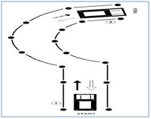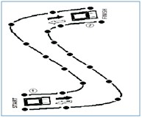
iii) After “L” shape and parallel parking, the applicant shall be
asked to go through the “?” shape test. Time limit for “?” shape will be 03 minutes.
2
1

iv) After “?” shape test, the applicant shall be asked to go through “S” shape test. Time limit for “S” shape will be 03 minutes.

2
1
- Touching any cone, crossing line, exceeding time limit,
adjusting vehicle more than once shall be straight disqualification.
- “L” shape test and parallel parking test will be for all M.CAR/JEEP/LTV/LTV-PSV applicants.
- “?” shape test will be only for LTV/LTV-PSV applicants. viii)“S” shape test will be only for LTV-PSV applicants.

- USE OF UNFAIR MEANS:

  - Use of unfair means will result in straight disqualification. Legal and criminal proceedings will also be initiated against such person.
  - Use of Influence, threats to use influence or offering bribe will result in disqualification. Legal and criminal proceedings will also be initiated against such person.
www.nhmp.gov.pk
05
GUIDE FOR PRACTICAL DRIVING TEST PART - I & II
- Get start from the start point
- Drive forward and move to the finish point at point no. 02
- Drive back in reverse and stop at the start
point at point no. 01
- Total time allowed is 03 min
- Touching any cone or exceeding time limit will be straight disqualification
- Get start from the start point
- Drive forward and move to the finish point at point No. 02
- Drive back in reverse and stop at the start point
at point No. 01
- Total time allowed is 03 min
- Touching any cone or exceeding time limit will be straight disqualification

GUIDE FOR PRACTICAL DRIVING TEST PART - I & II
PROCEDURE FOR PRACTICAL DRIVING TEST PART-II

The applicant having passed practical driving test part-I can appear for practical driving test-II on the same day or as directed by the examiner. The applicant should bring the following documents while appearing for practical driving test part-II:
- Valid Original CNIC
- Learner permit original
- Test Result Part-I
- Prescribed Copy of Highway Code

The applicant can use his/her own vehicle for undergoing practical driving tests.
Practical driving test-II shall consist of following steps;

- COCKPIT DRILL:
After sitting in the vehicle, the applicant should follow the cockpit drill procedure before starting the vehicle. The following steps are required from the applicant during the cockpit drill;
  - The applicant must make sure that all the doors are closed properly. If any of the door is open or half closed, the applicant should close it properly.
  - The applicant should adjust the seat as per his/her convenience.
  - After seat adjustment, the applicant should adjust steering according to his/her seat.
  - The applicant should adjust side mirrors as well as back view mirror of the vehicle according to his/her seat position.
  - The applicant should wear seat belt after seat and mirrors adjustment.
  - Before starting of vehicle, the applicant should make sure that the hand brake is working/applied properly.

- VEHICLE CONTROL:
  - Prior to starting, the applicant should make sure that the gear is in neutral position.
  - Clutch should be pressed and checked properly before switching on the ignition switch.

06 www.nhmp.gov.pk

GUIDE FOR PRACTICAL DRIVING TEST PART - I & II
- Use of accelerator should be appropriate.
- After starting, the applicant should press the clutch, apply first gear, push down hand brake and release clutch gently to move the vehicle.
- The applicant's both hands should be on the steering either in 10 and 2 or 9 and 3 position.
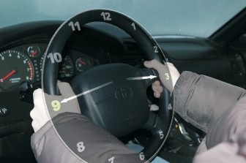
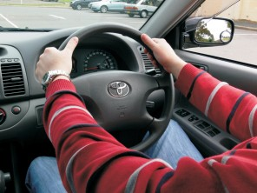
9 and 3 10 and 2
- The applicant should not look down to the clutch or the gear while shifting/changing gear.

- MOVING:
  - The applicant should move the vehicle in a safe manner and without creating any hazard for others.
  - Moving of vehicle should be smooth and without any jerks or switching off the engine.

- LANE DISCIPLINE:
  - The applicant should use appropriate lane of the road. For instance, if he/she intends to turn left, the vehicle should be in left lane of the road and vice versa.
  - Speed should be according to usage of lane. For instance, while moving in the middle lane speed should not be too slow to obstruct traffic.
  - Driving with tyres in two lanes must be avoided except in case when the driver is changing lane after giving indicator.
  - The change of lane should not be abrupt and should be done after giving indicator and ensuring, through use of side/back mirrors, that it is safe to change the lane.

- OVERTAKING:
  - Before overtaking, the applicant should observe traffic by using
www.nhmp.gov.pk 07

GUIDE FOR PRACTICAL DRIVING TEST PART - I & II
side mirrors as well as back view mirror.
- The driver should ensure, by using side/back mirrors, that right hand lane is clear and there is no fast approaching vehicle from rear. The applicant should use right side indicator before changing lane.
- After lane is changed, the indicator should be switched off.
- Speed should be adequate to cross/overtake the vehicles on left side.
- Over speeding is not allowed while overtaking.
- After completely crossing the vehicle, the applicant should observe blind spot on left side by turning shoulders a bit to the left side.
- If clear, left side indicator should be switched on and lane should be changed back in a safe and smooth manner. No abrupt or sharp cutting is allowed.
- After lane change, the indicator must be switched off.
- Overtaking from the wrong side or dangerous overtaking will result in straight disqualification.

- USE OF INDICATORS:
  - The applicant should use indicators as per road/traffic situation. For lane change, road joining, entering/exiting roundabout, taking U-turn, or during turning etc, relevant indicators must be used.
  - Indicators must be used properly and timed in a manner so that the approaching traffic can judge intentions of the applicant.
  - The non-use of indicators where required would result in straight disqualification.

- RIGHT OF WAY:
The applicant should strictly follow the rule for right of way. Following things about right of way should be kept in mind:
  - While joining roads, the vehicles already on the main road have the right of way.
  - At junctions, either the first approaching vehicle or vehicle on the right side has the right of way.
  - At round-about, the vehicles already in the round about or

08 www.nhmp.gov.pk

GUIDE FOR PRACTICAL DRIVING TEST PART - I & II
vehicles on the right hand have the right of way.
- At pedestrian/zebra crossing, the applicant must reduce speed and carefully observe the pedestrians. In case of approaching pedestrians, the vehicle must be stopped and wait until the pedestrians have crossed the road completely.
- Violating the right of way will be straight away disqualification.

- ANALYZING DANGER:
The applicant should be vigilant to analyze danger while driving;
  - In case of any hazard/accident etc. or poor road conditions the applicant should observe/analyze and reduce speed accordingly.
  - In case of any blockage or diversion on road, the applicant should be capable to analyze well in time and drive in a safe manner according to the situation.
  - Parked vehicles must be watched while taking turn, changing lane or joining roads.
  - At sharp turns, the applicant must reduce speed and should be more careful.
  - While driving the applicant should watch speed breakers/rumbles carefully and reduce speed accordingly.

- OBSERVING TRAFFIC SIGNS:
  - The applicant should observe and obey all traffic signs e.g. speed limit, school, hospital etc.
  - The applicant should follow all traffic signals as breaking/violating any traffic signal will be straight disqualification.
  - The applicant should observe and obey all the traffic controllers. Violating any traffic controller will be straight disqualification.
  - The applicant should follow road markings accordingly. For example, if road markings indicate left turn for left lane traffic and straight for middle lane traffic, the applicant should follow accordingly.
  - The applicant should respect and show courtesy towards other road users. The applicant should take care of the rights of other road users.
www.nhmp.gov.pk 09

GUIDE FOR PRACTICAL DRIVING TEST PART - I & II
- JUNCTIONS:
  - The applicant must reduce speed before approaching a junction.
  - Traffic should be observed. Relevant lane of road should be used on approaching a junction.
  - The applicant must be vigilant while taking turn right/left and should observe traffic carefully.
  - The applicant should use indicators and use proper lane before taking turn.
  - Violating traffic rules or taking wrong/dangerous turn will be straight disqualification.

- EMERGENCY STOP:
  - The applicant should be alert in case of emergency stop.
  - The applicant must have full control over vehicle in case of emergency stop.
  - In case of emergency stop the applicant should apply brakes wisely and according to the situation, keeping control over the vehicle.
  - Losing control over vehicle will be straight disqualification.

- ATTITUDE TOWARDS OTHER ROAD USERS:
  - The applicant shall be courteous towards other road users.
  - The applicant should ignore mistakes of other road users and take care of their rights.

- SAFE DISTANCE FROM OTHER VEHICLES:
  - The applicant should keep safe distance from other vehicles.
  - In normal weather conditions minimum safe distance will be a 03 seconds time gap while in adverse conditions minimum safe distance time gap will be 05 seconds.

- USE OF UNFAIR MEANS:
Use of unfair means, influences, threatens to use influence or offering bribe will result in straight-away disqualification. Legal and criminal proceedings will also be initiated against such person.

10 www.nhmp.gov.pk

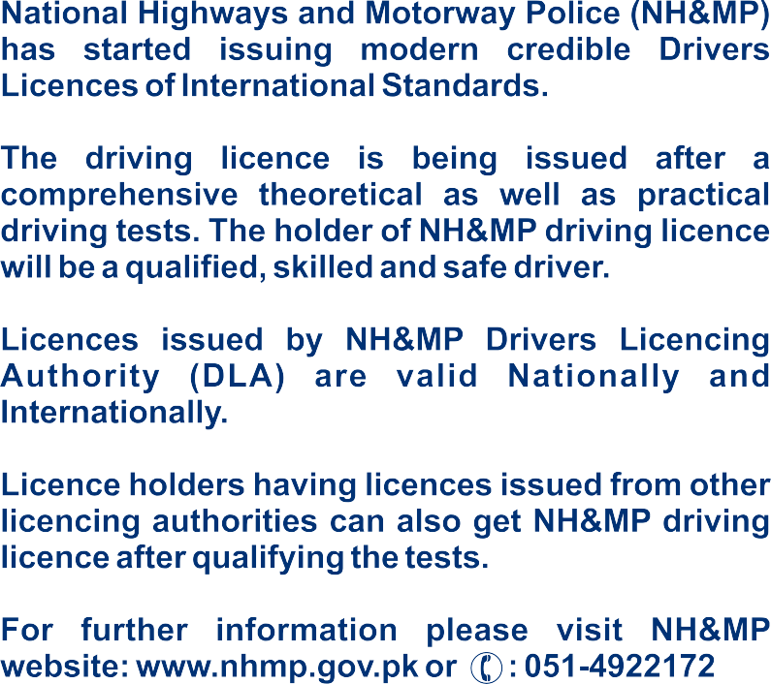

Saudi Arabia Traffic Rules
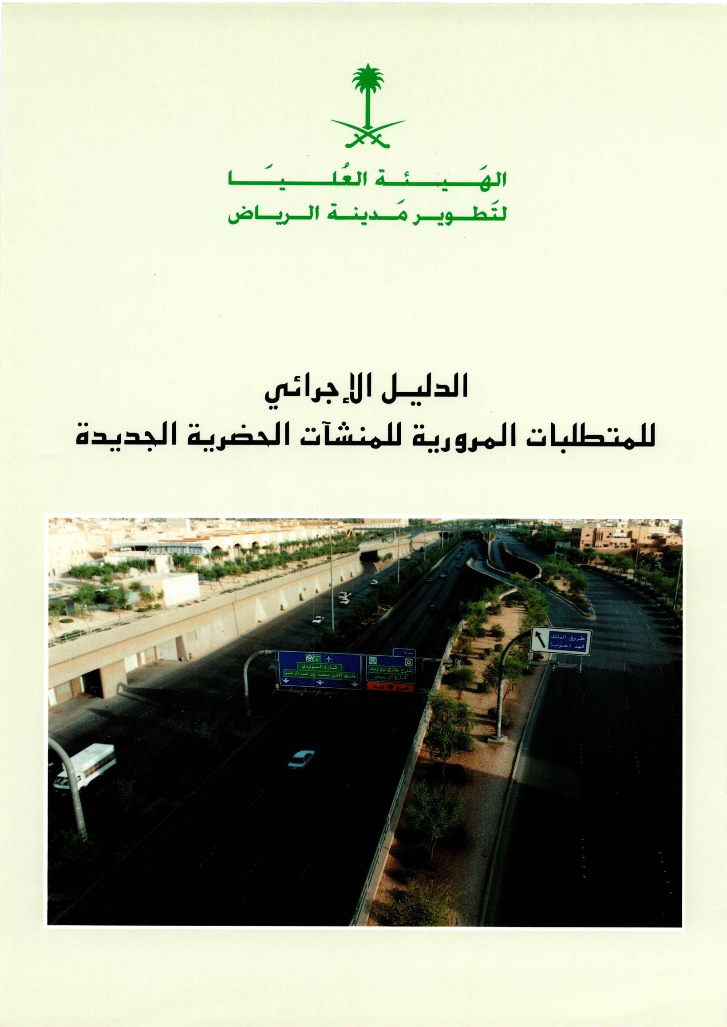

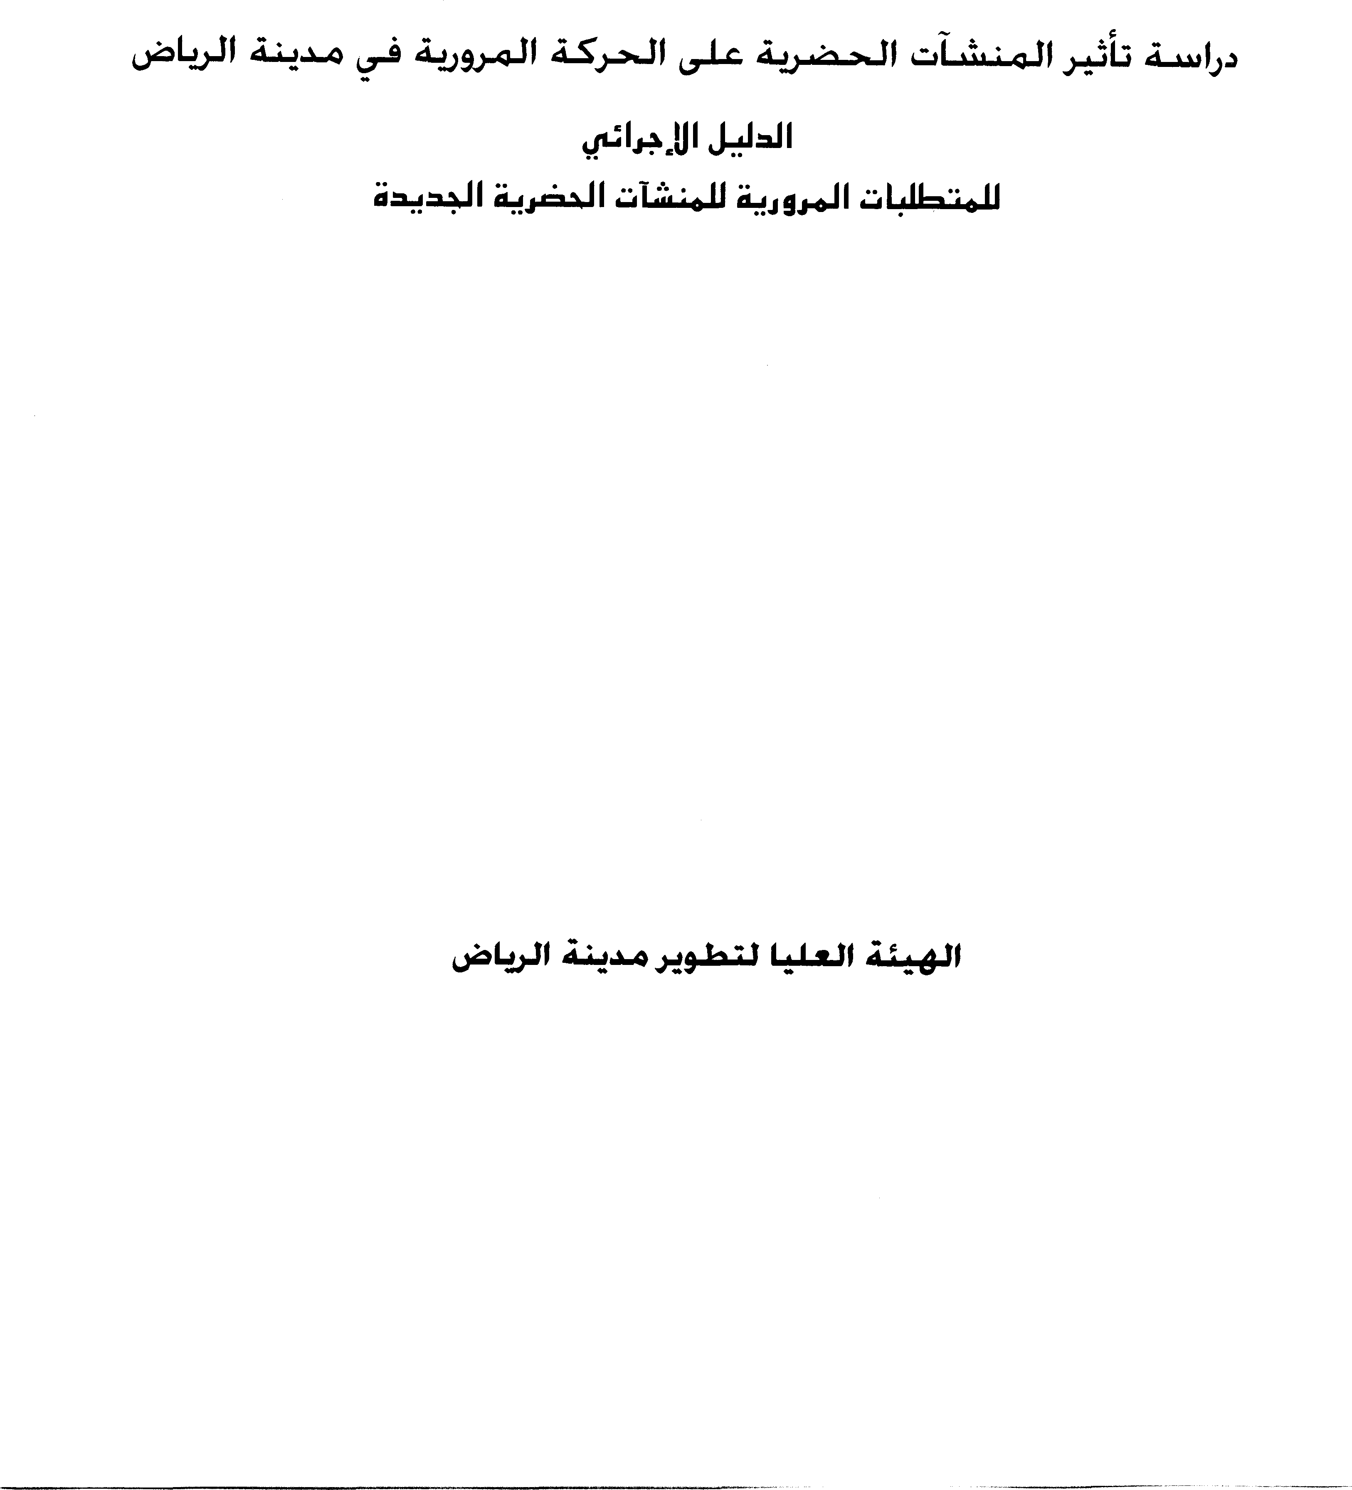

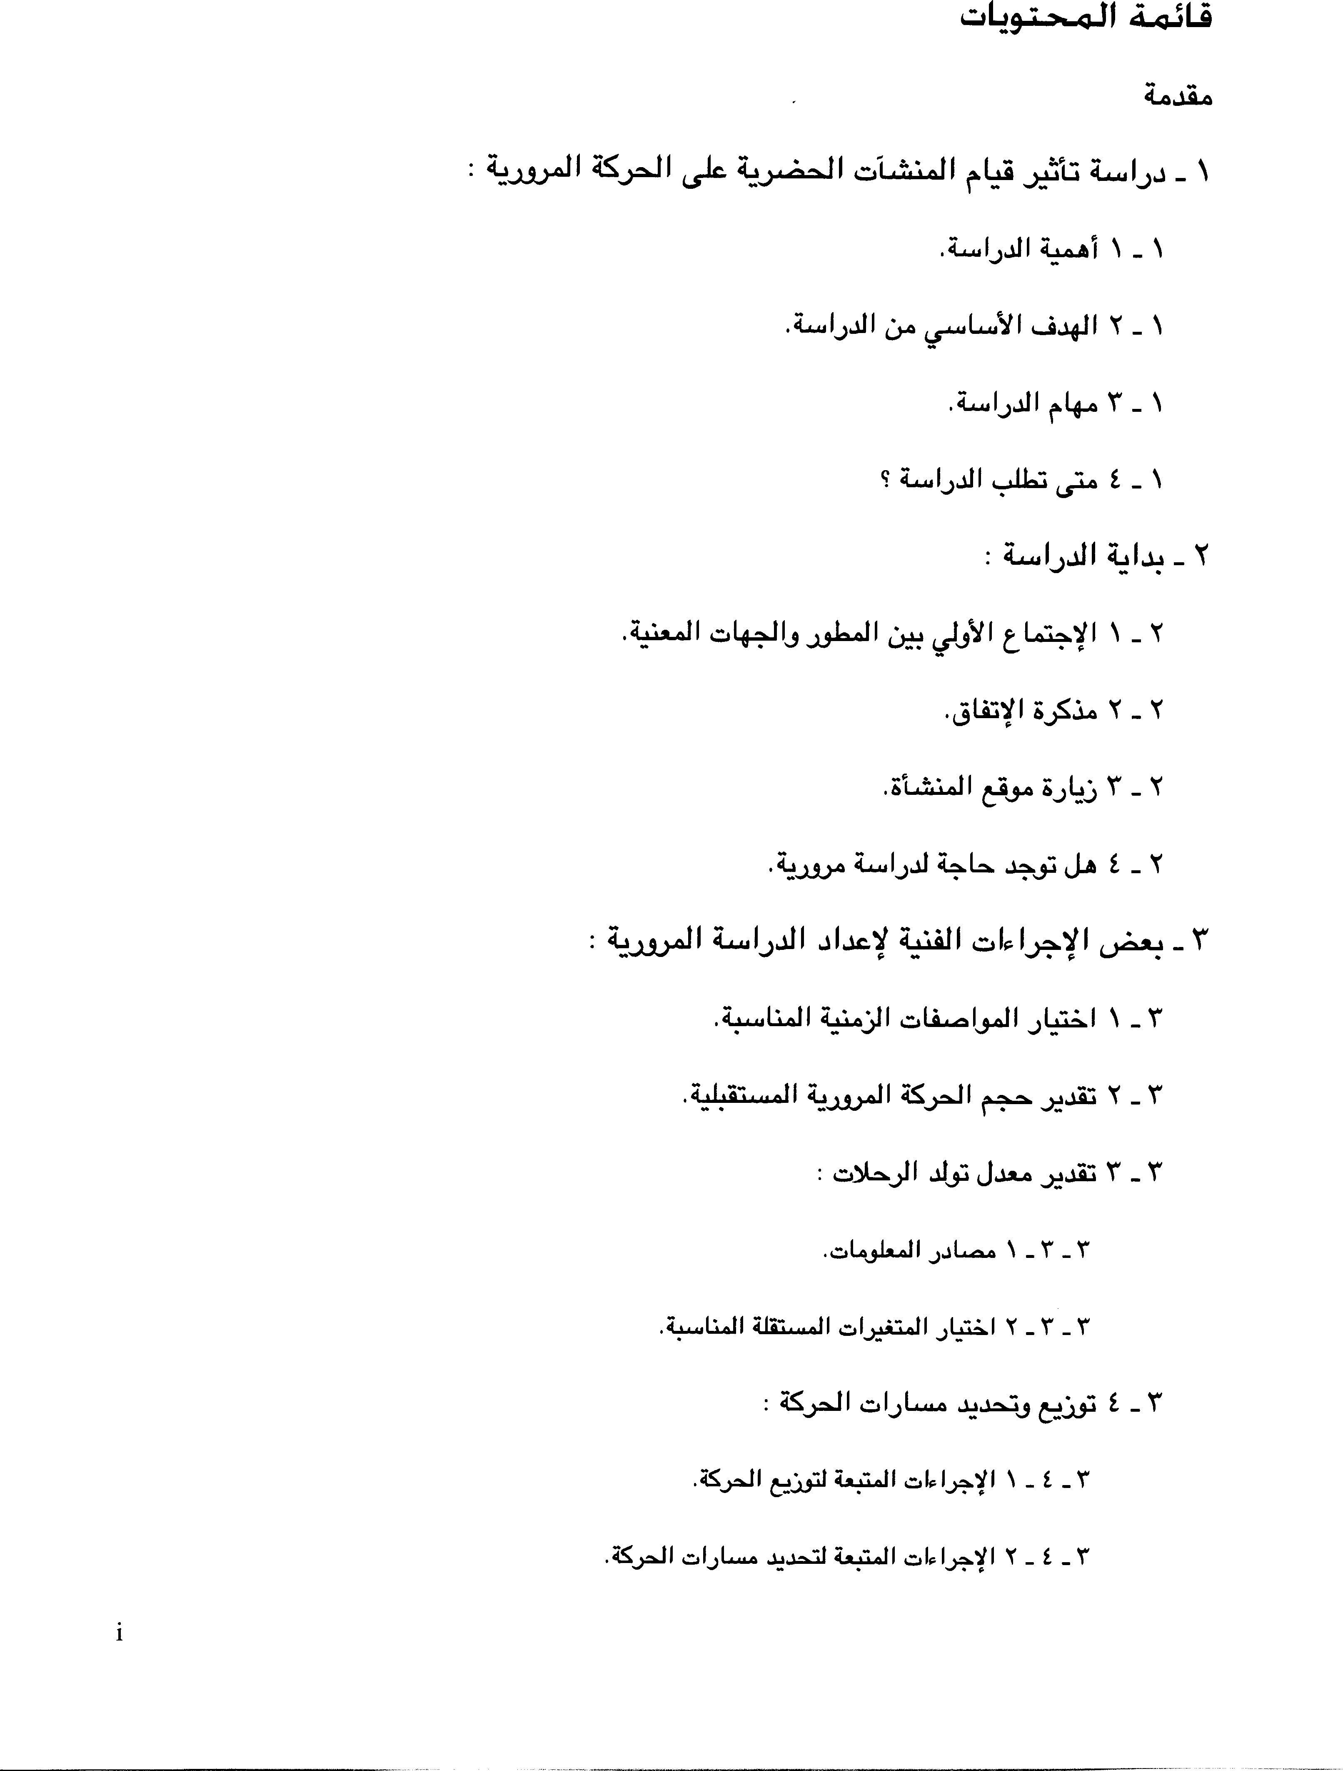

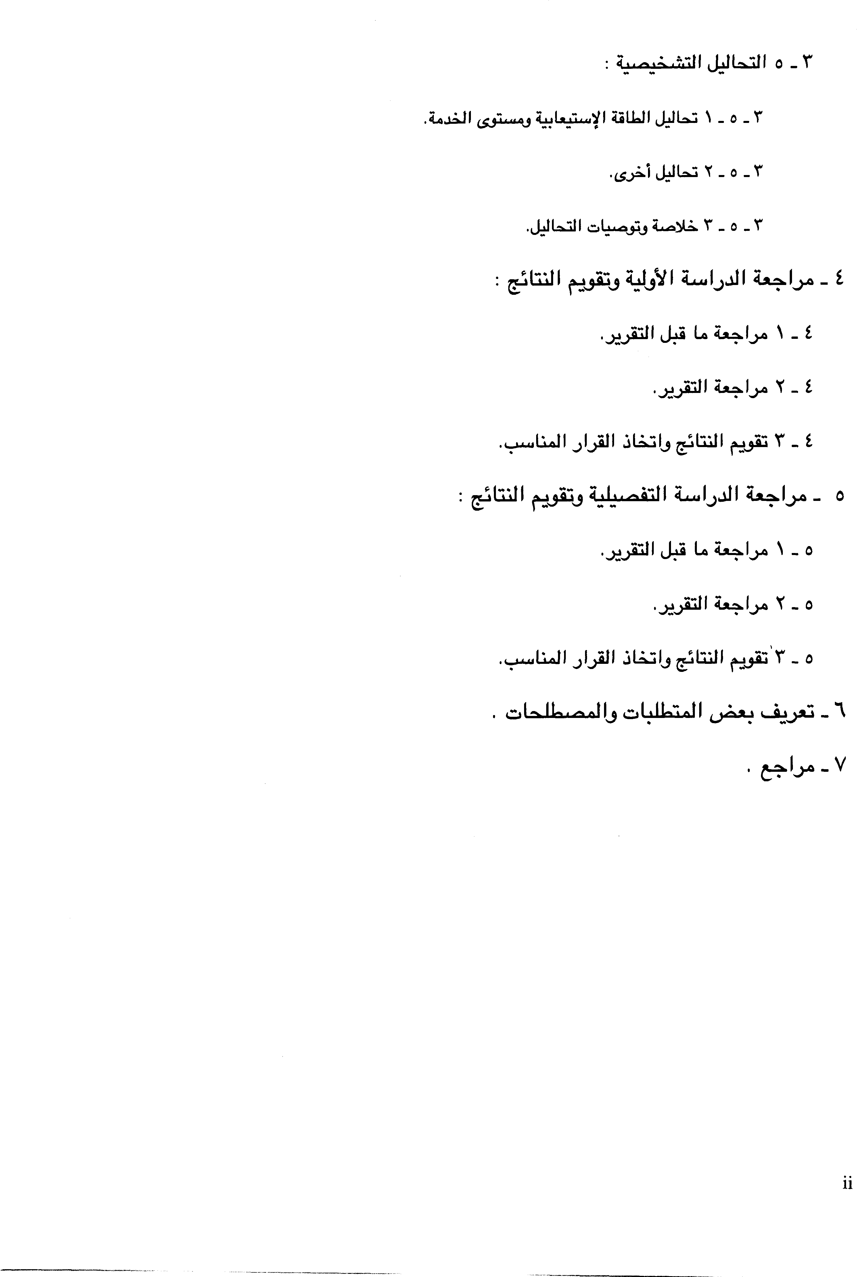

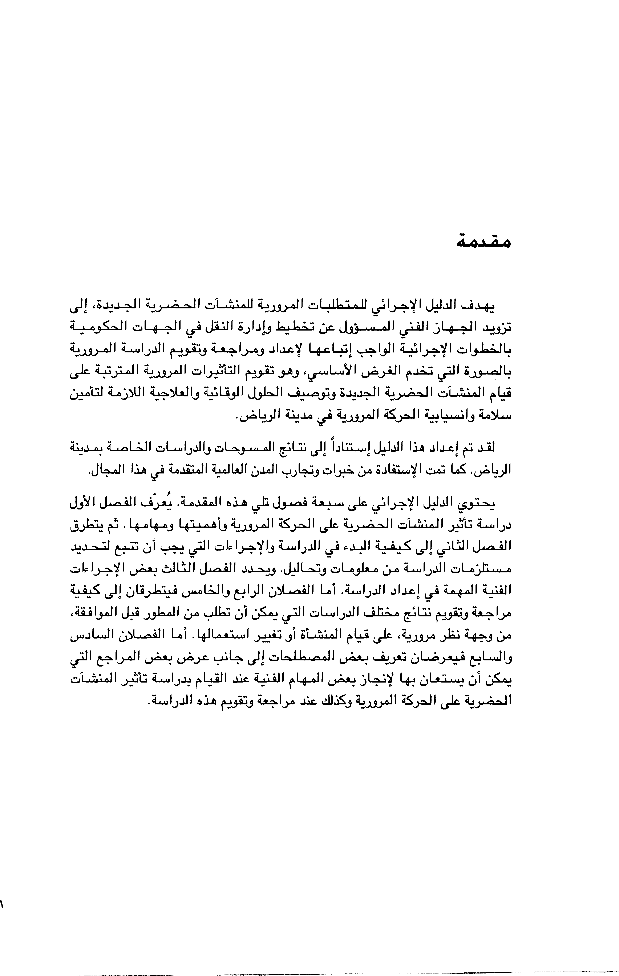

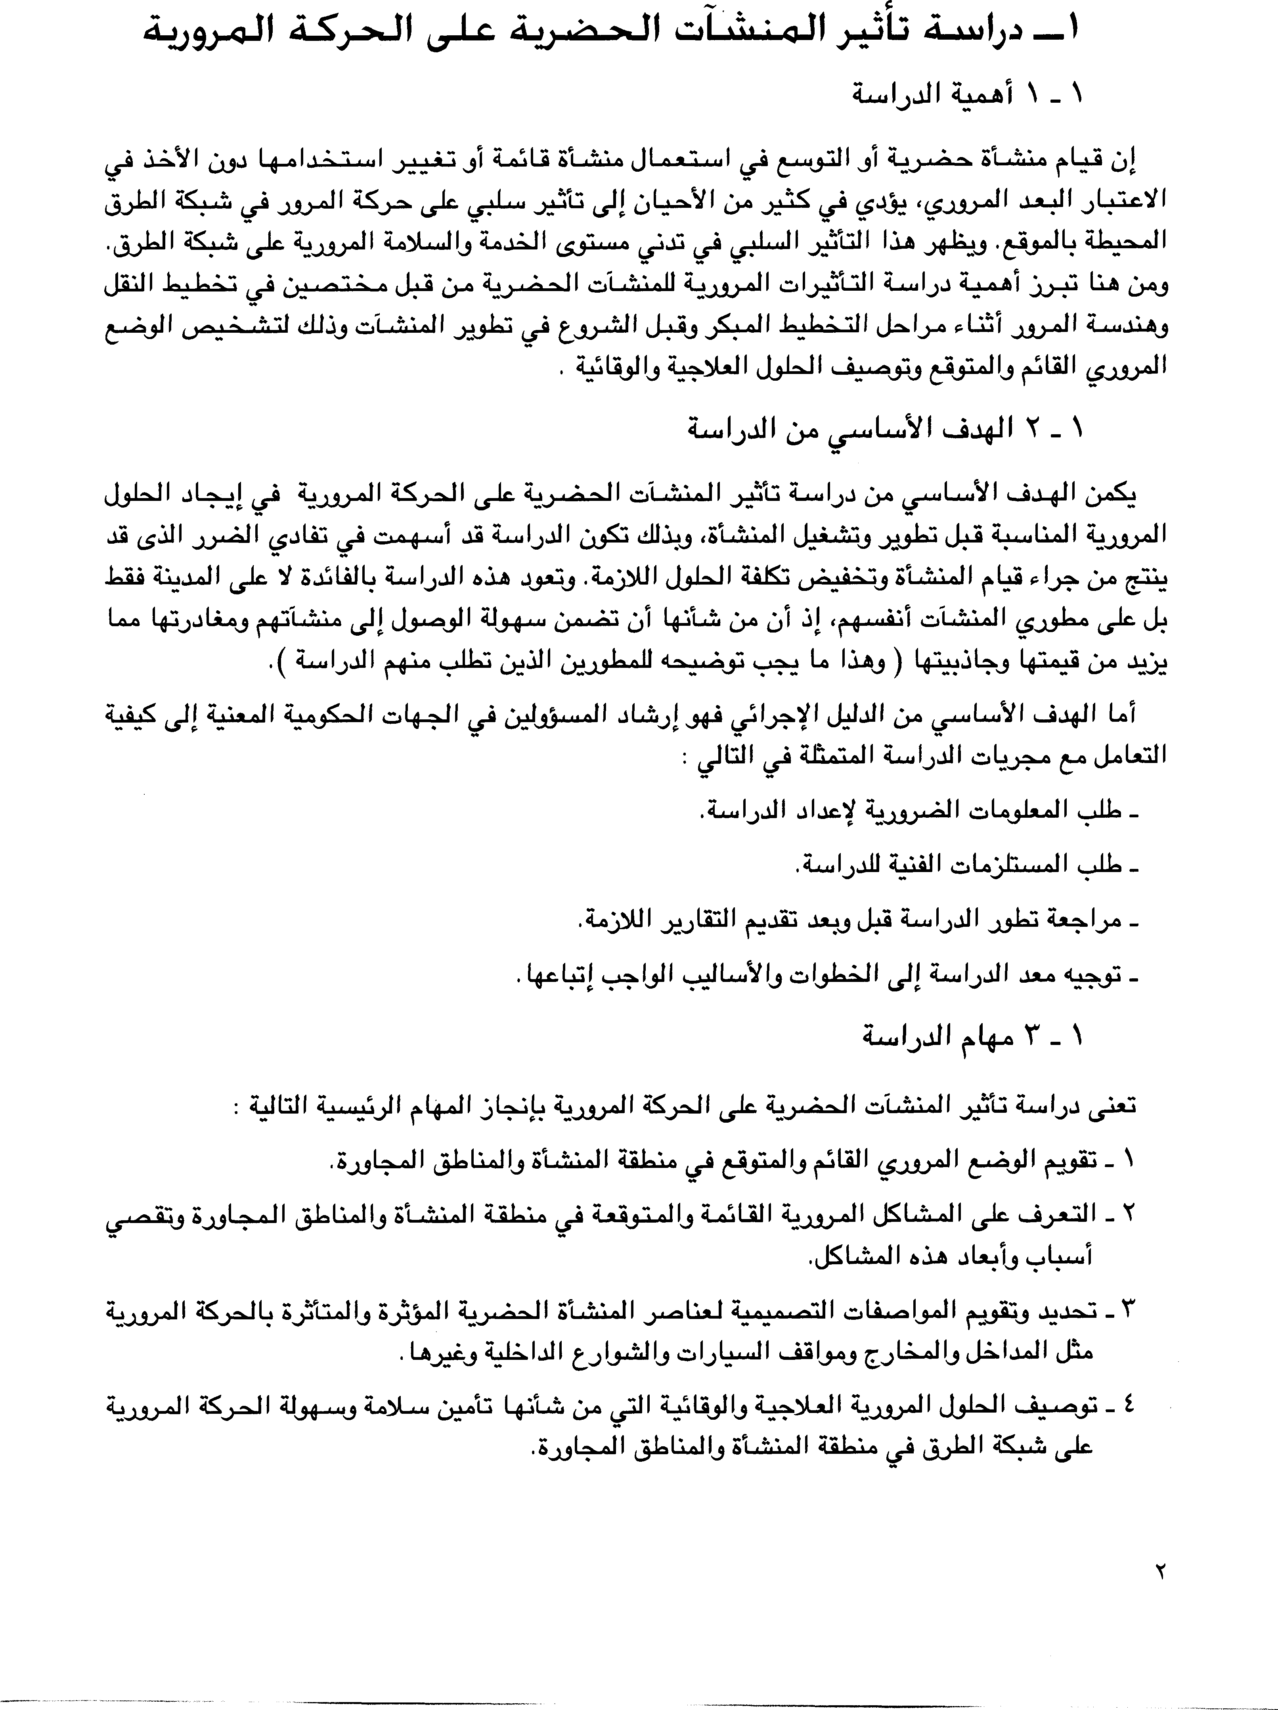



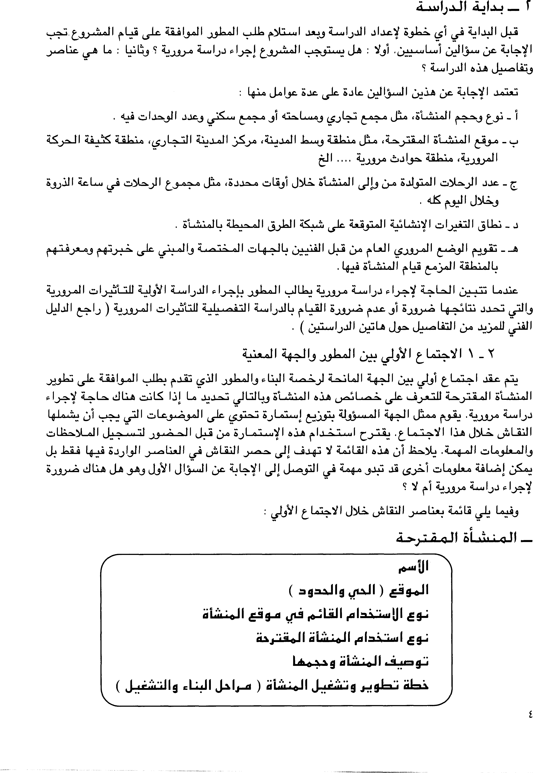

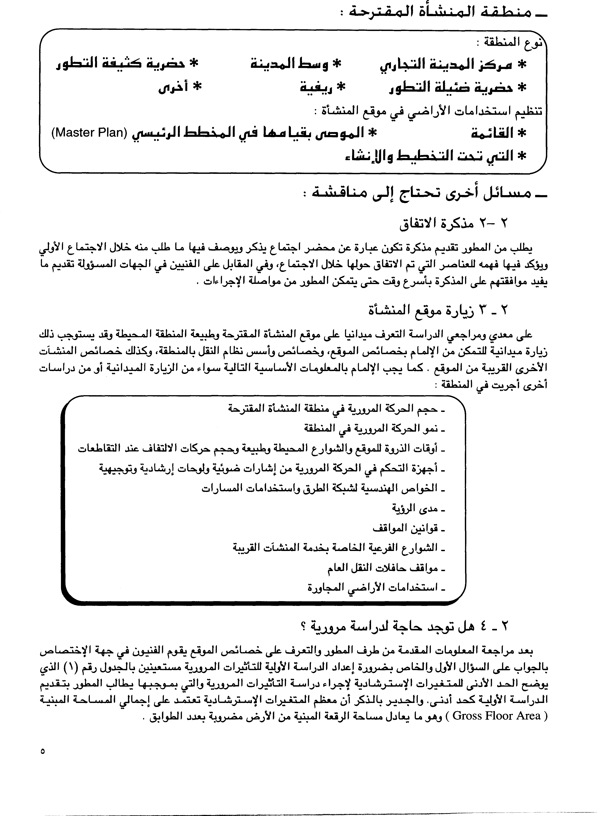

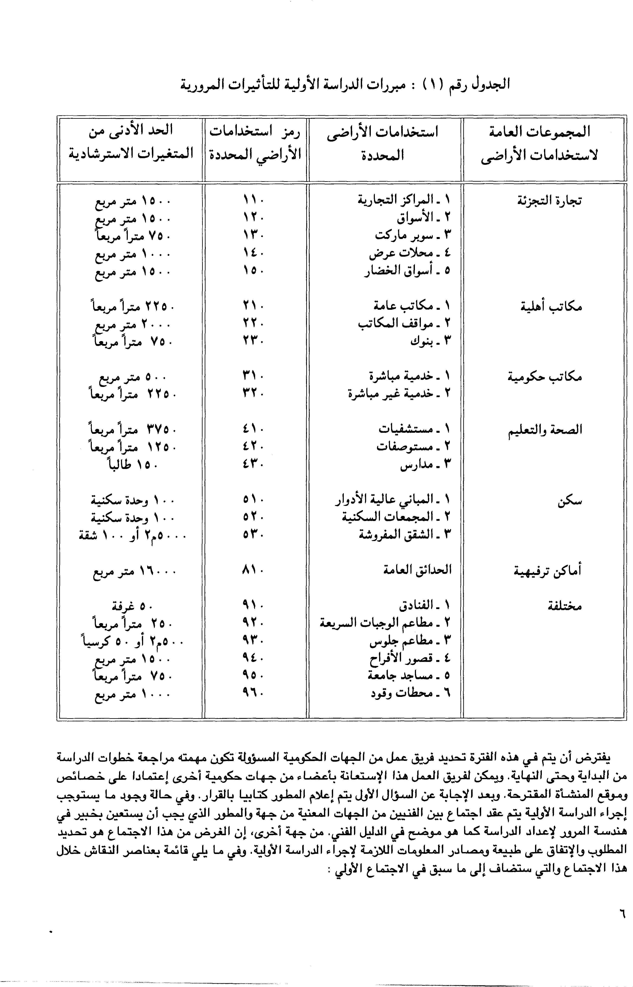

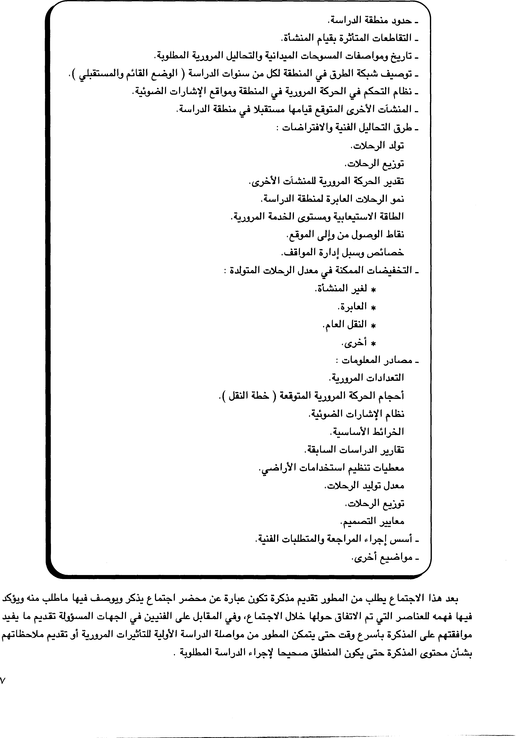

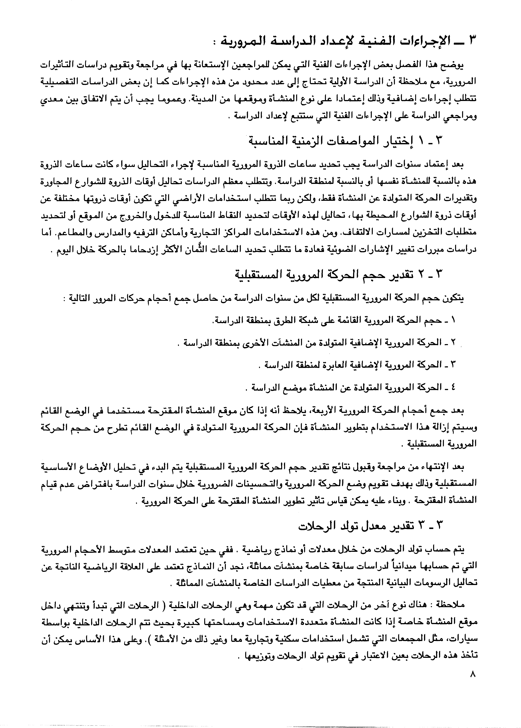

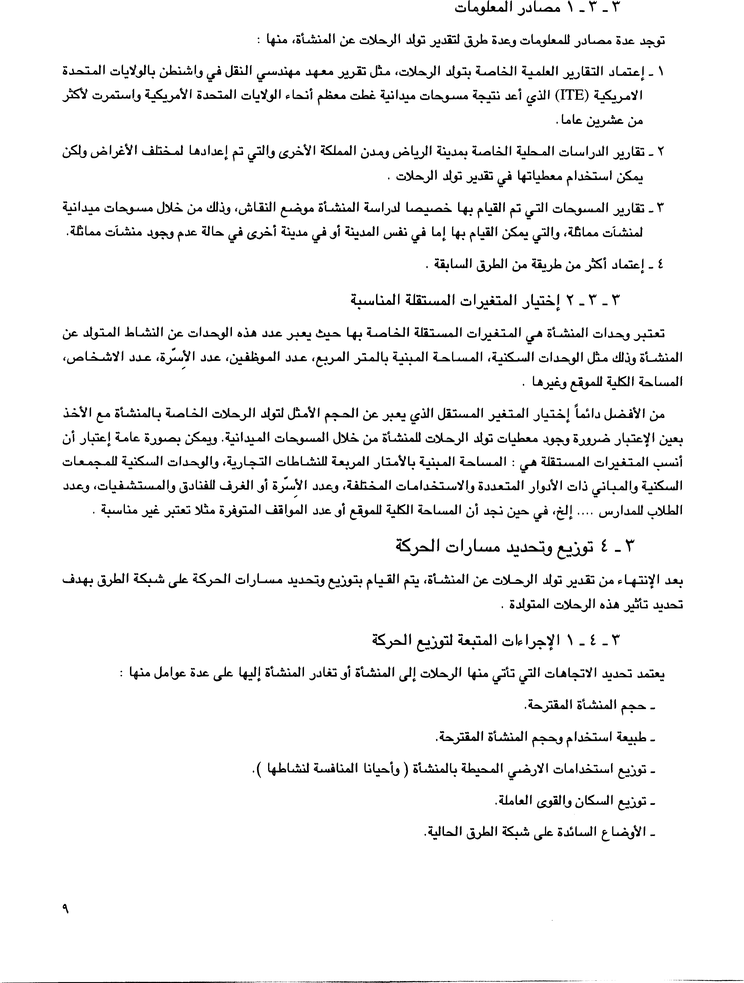

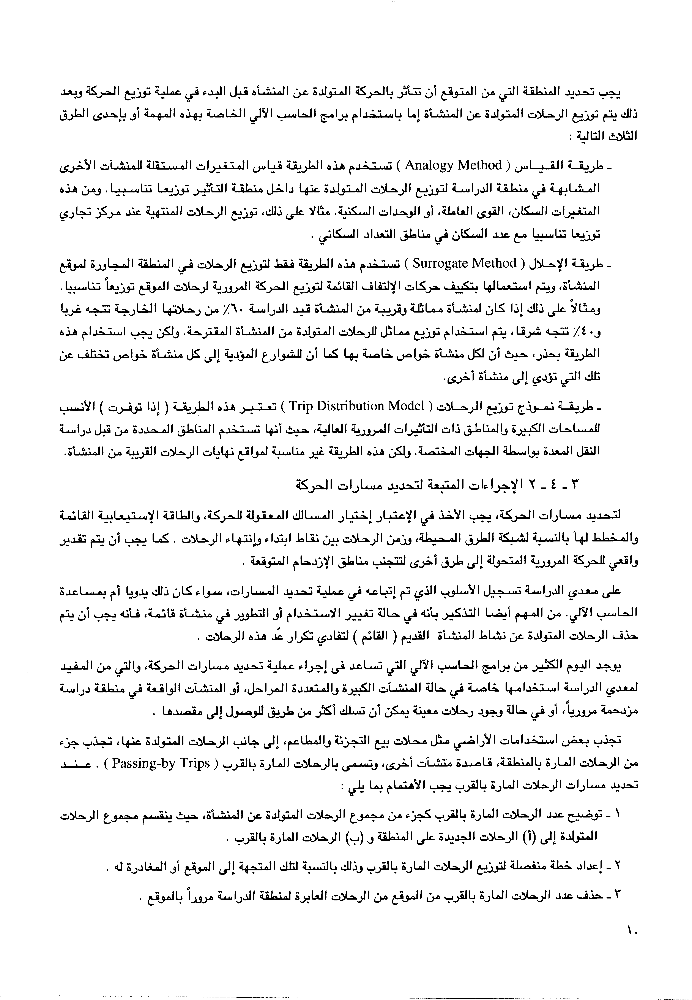

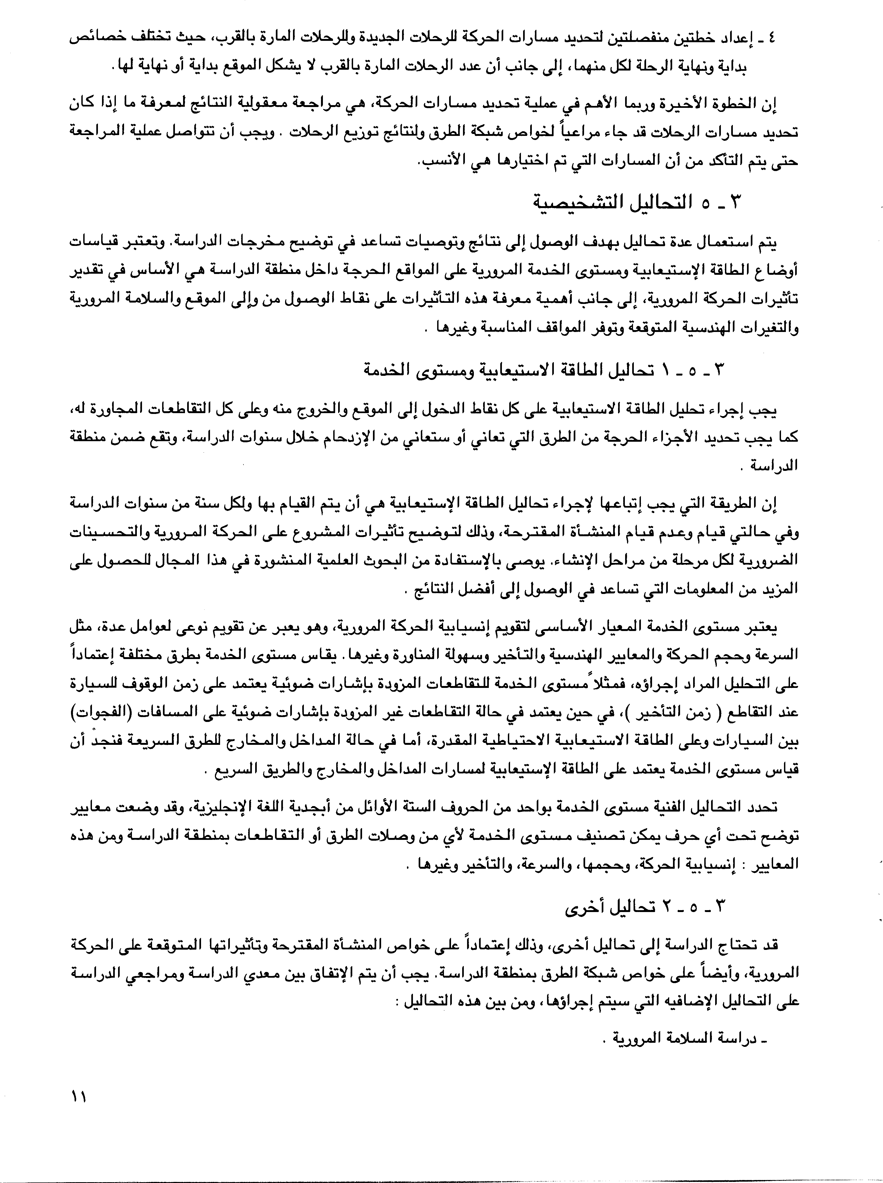

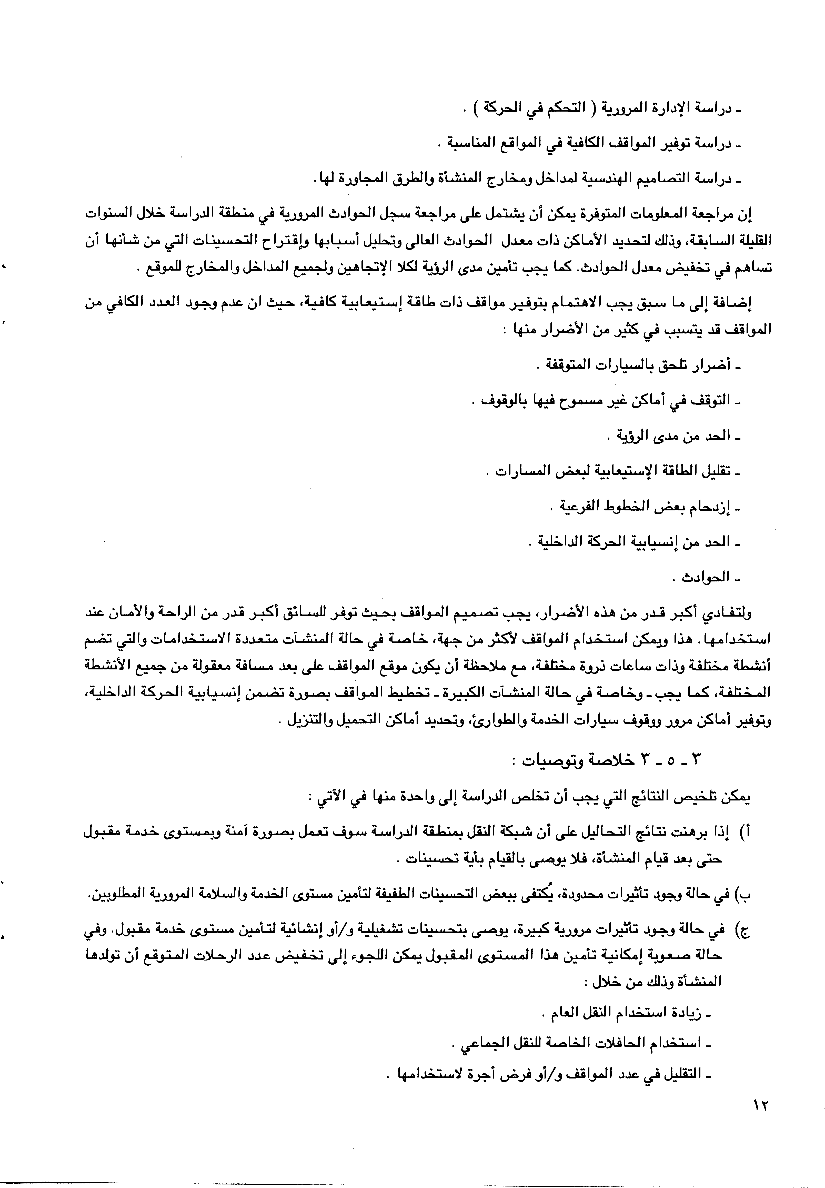

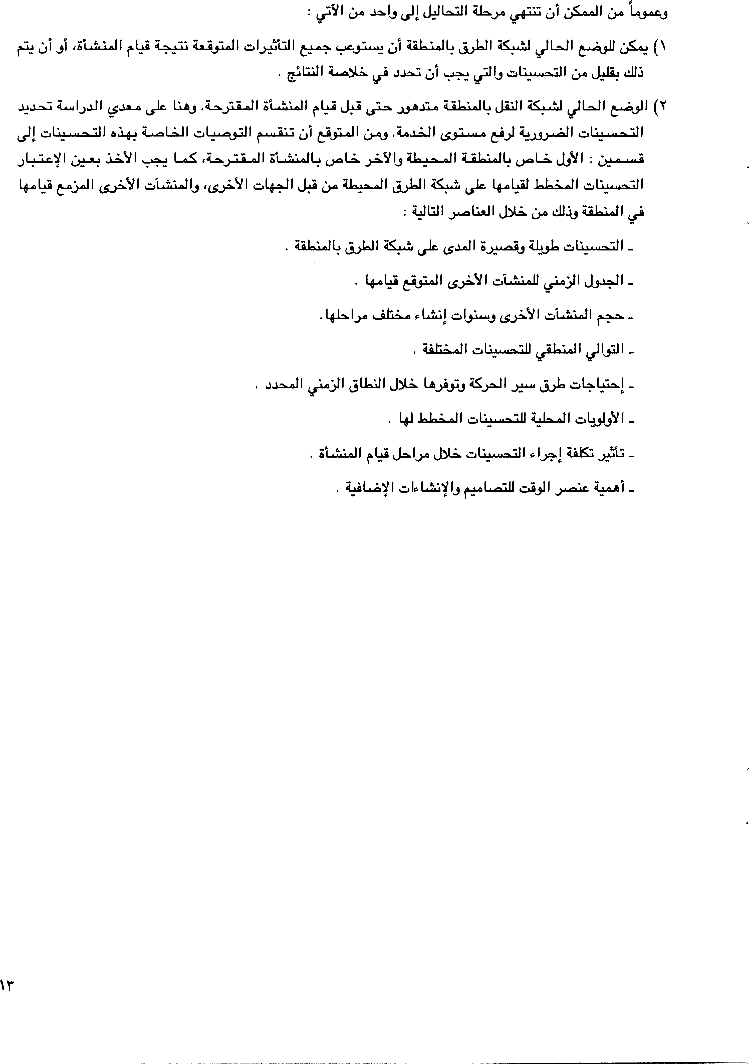

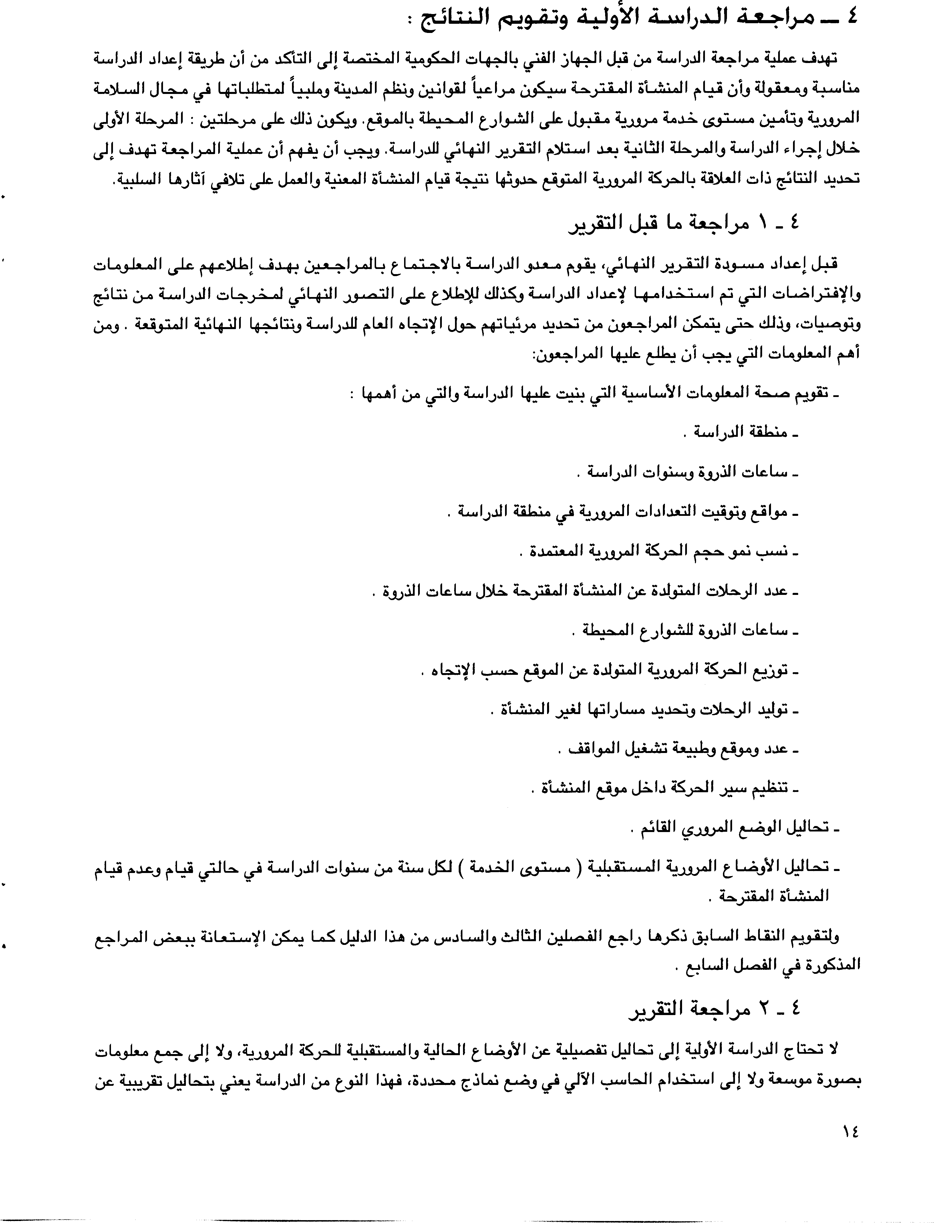

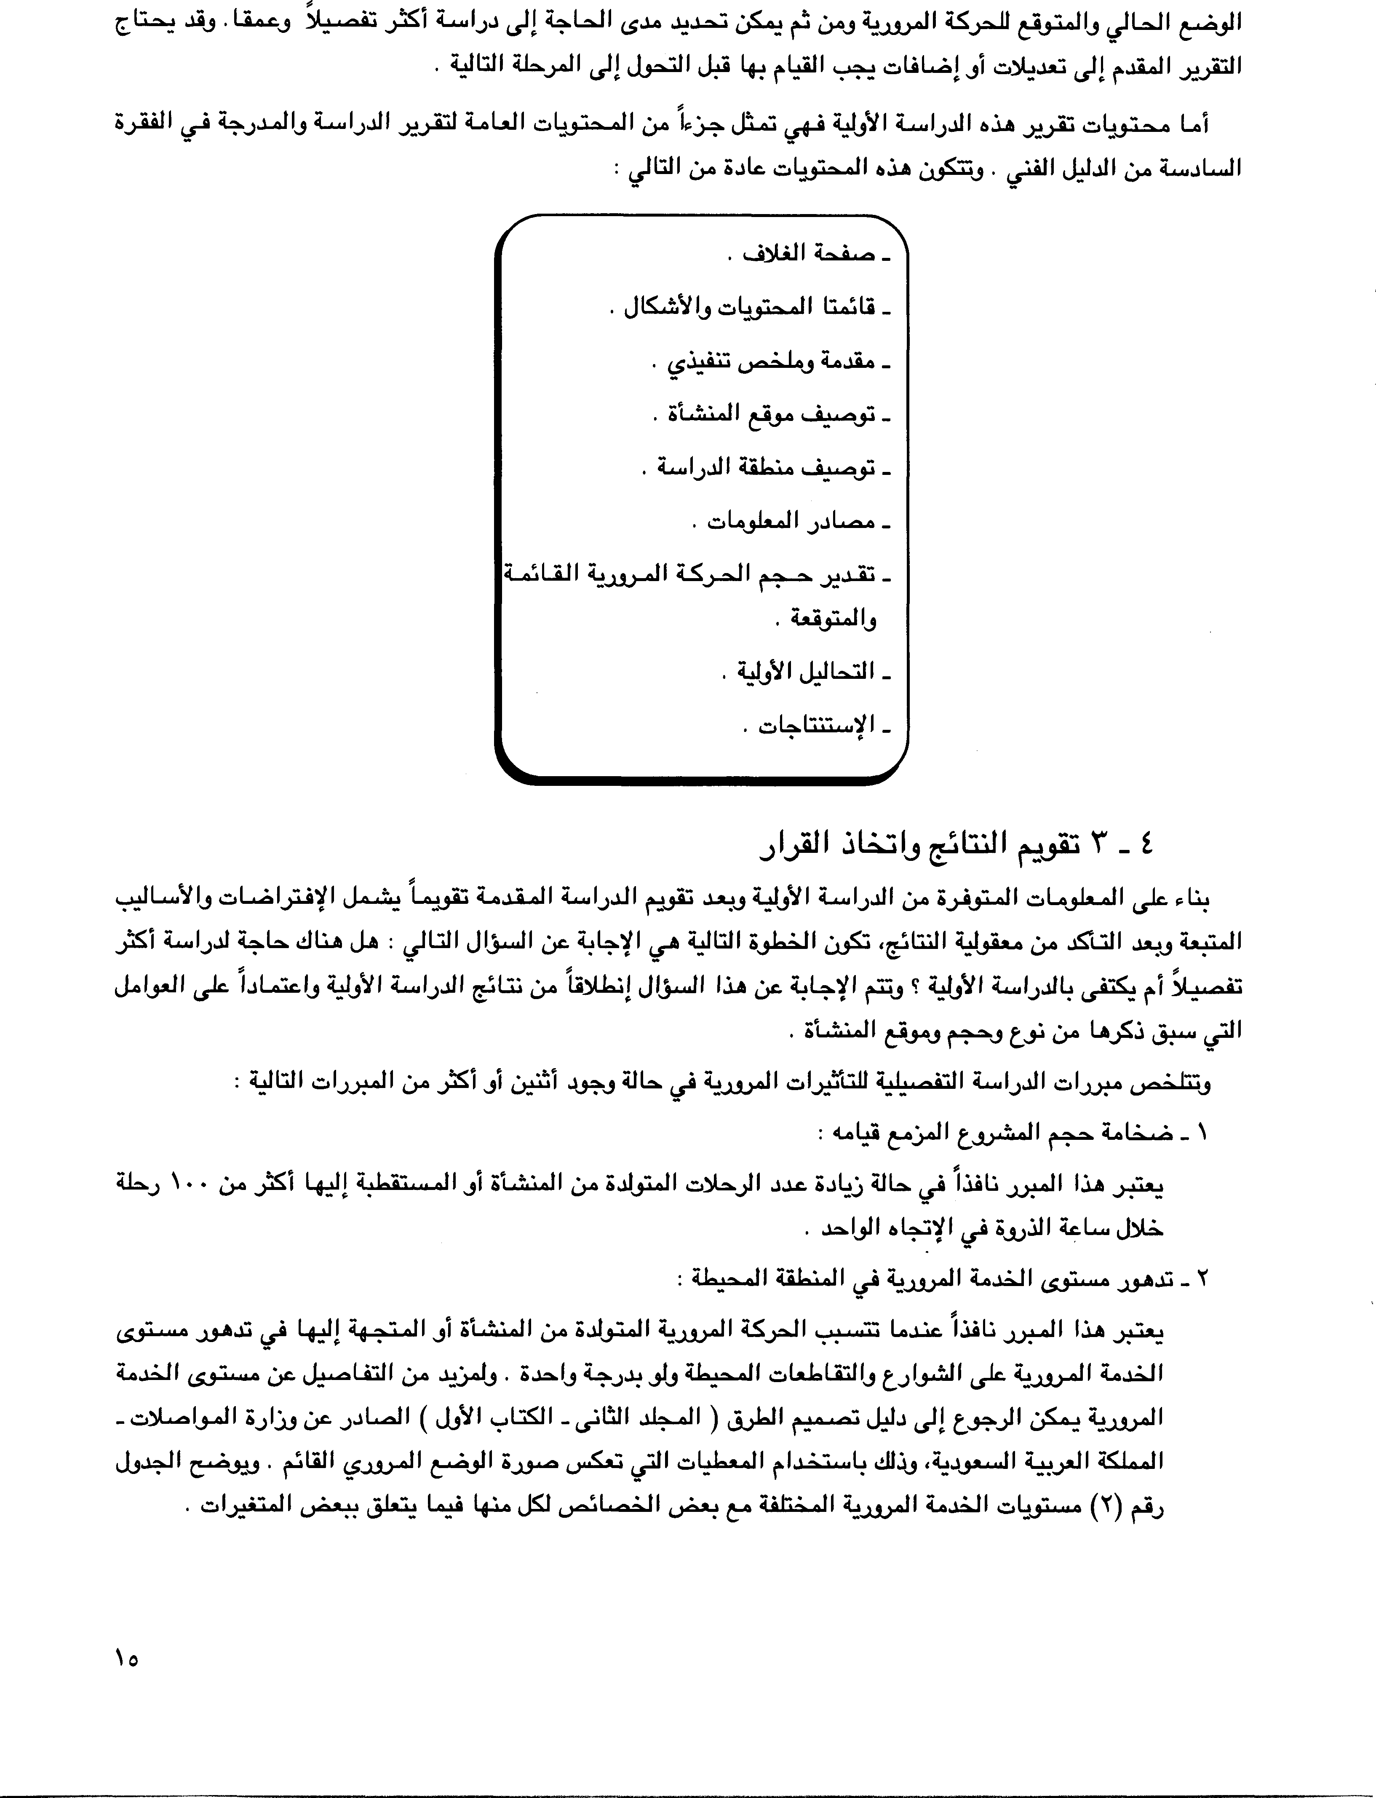

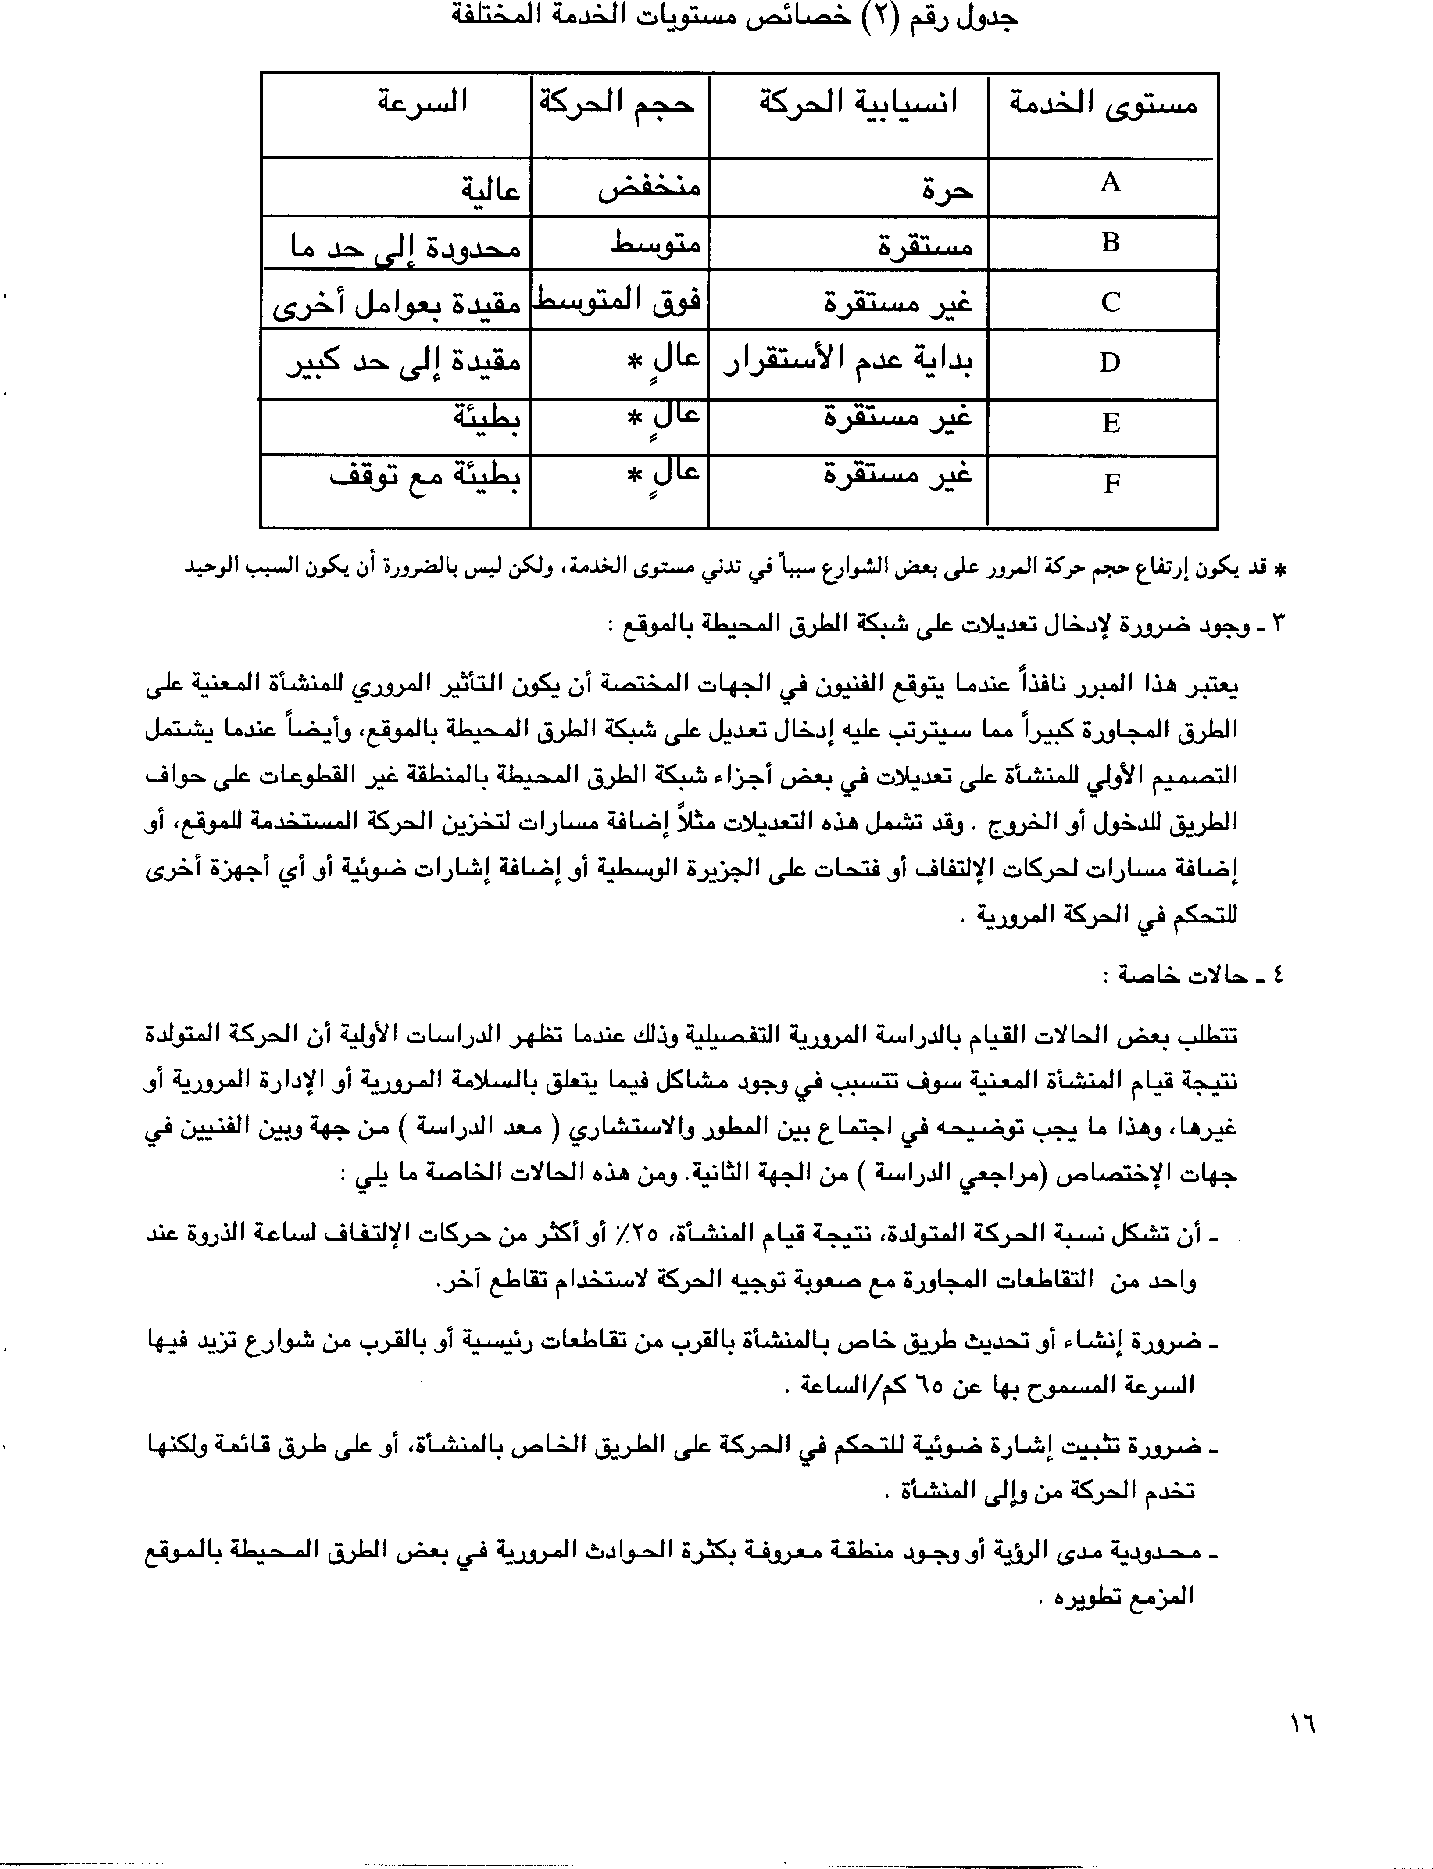



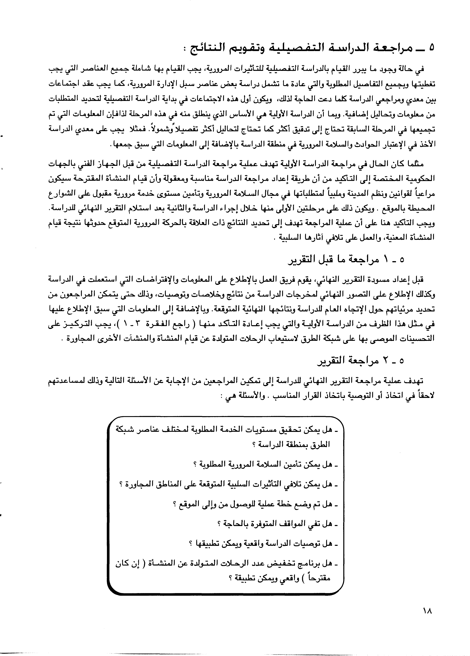

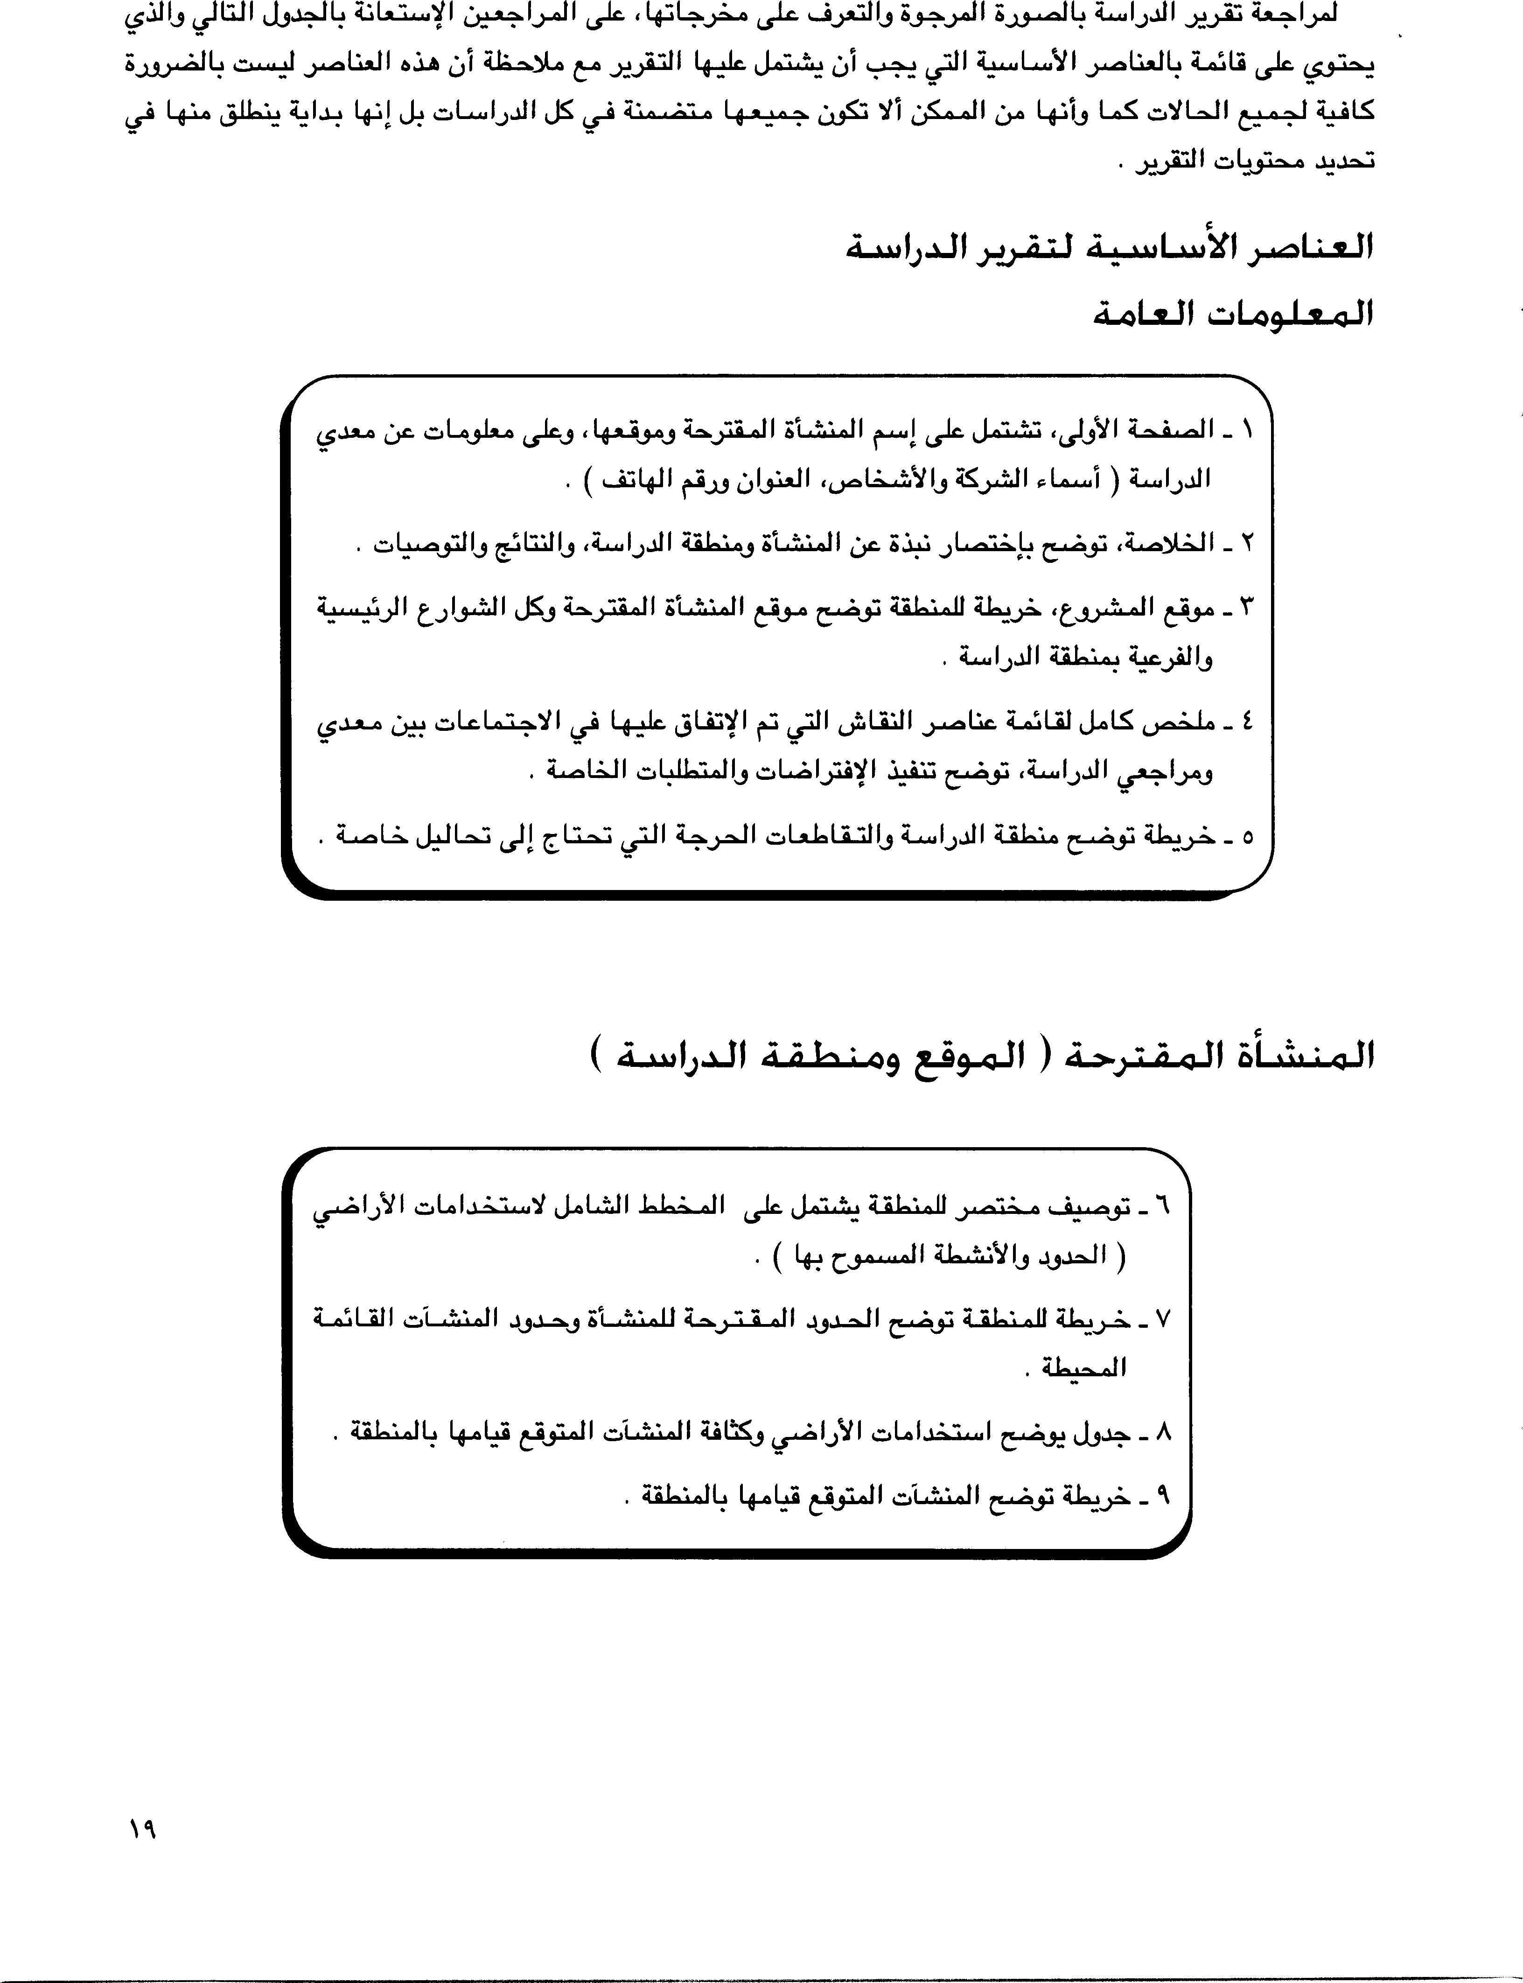

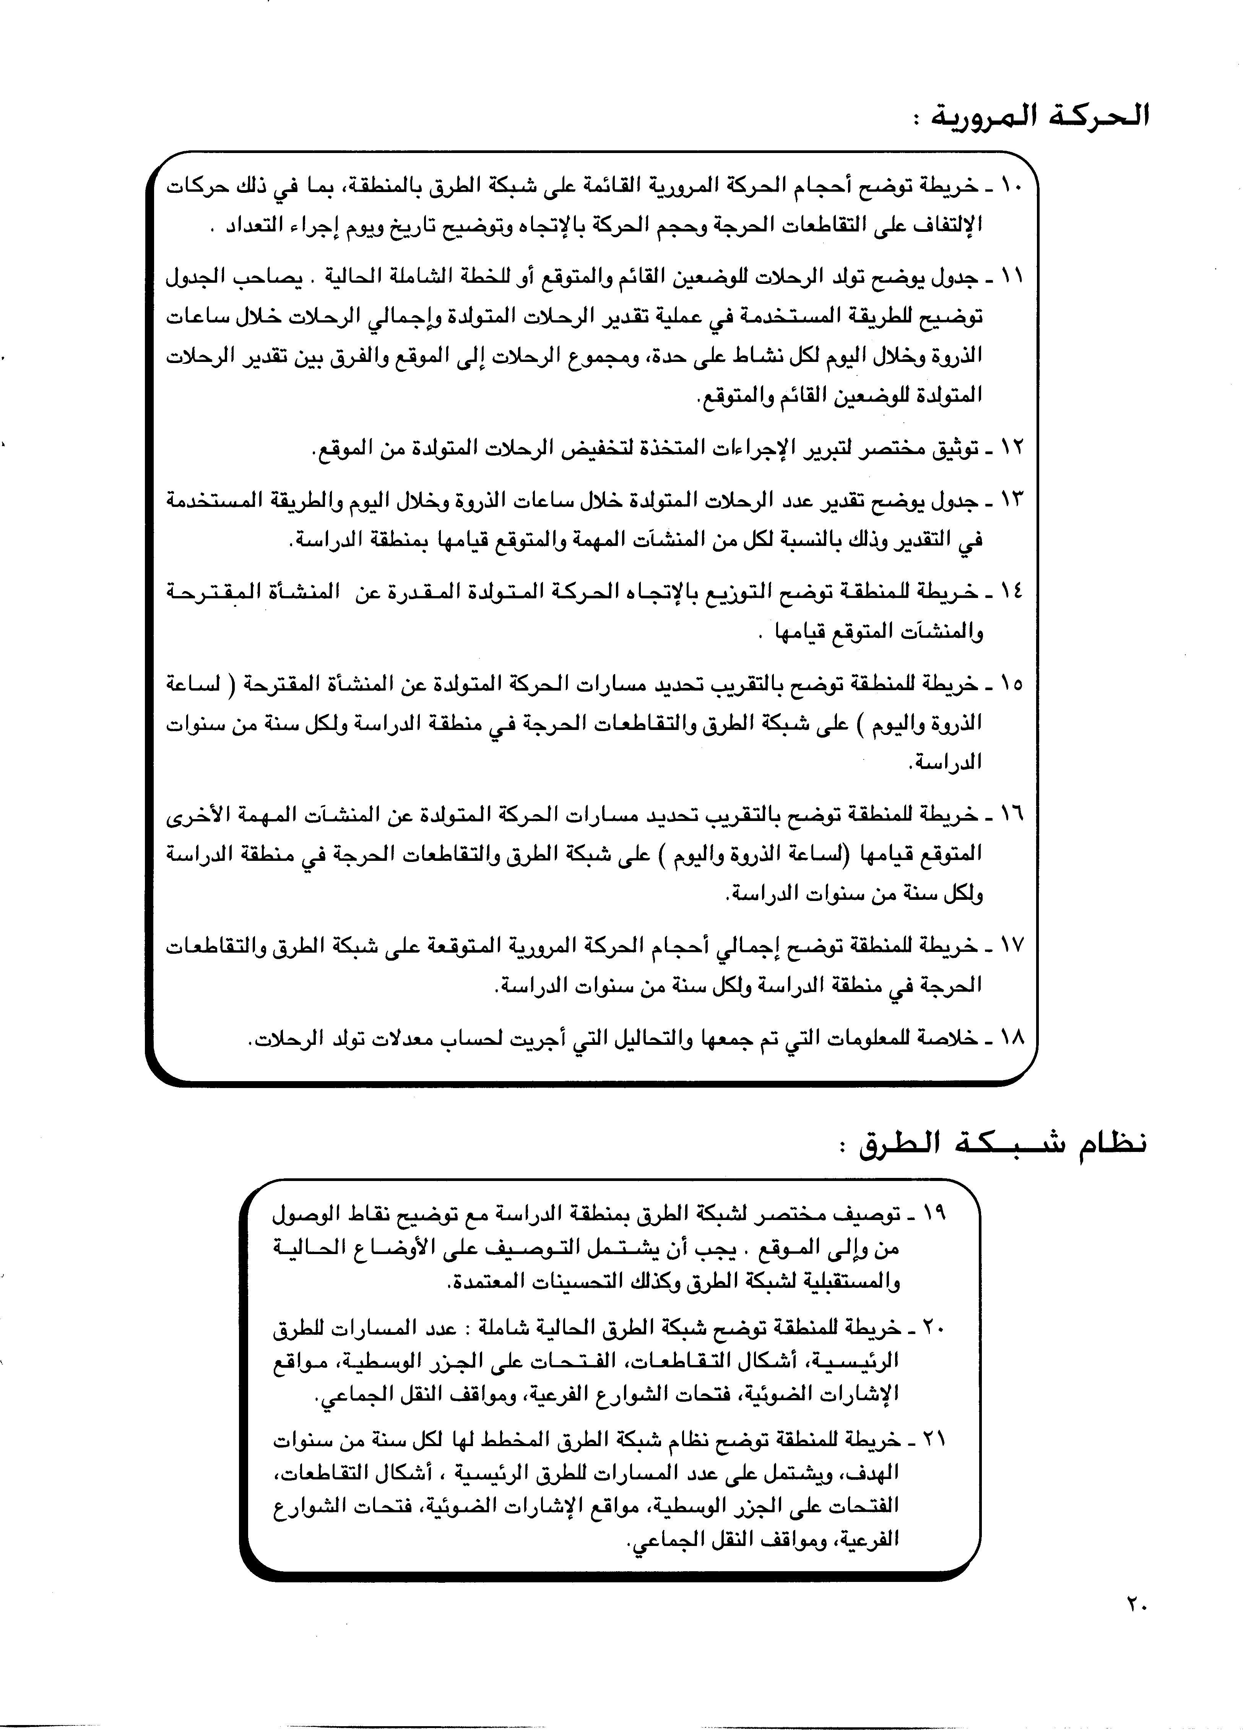

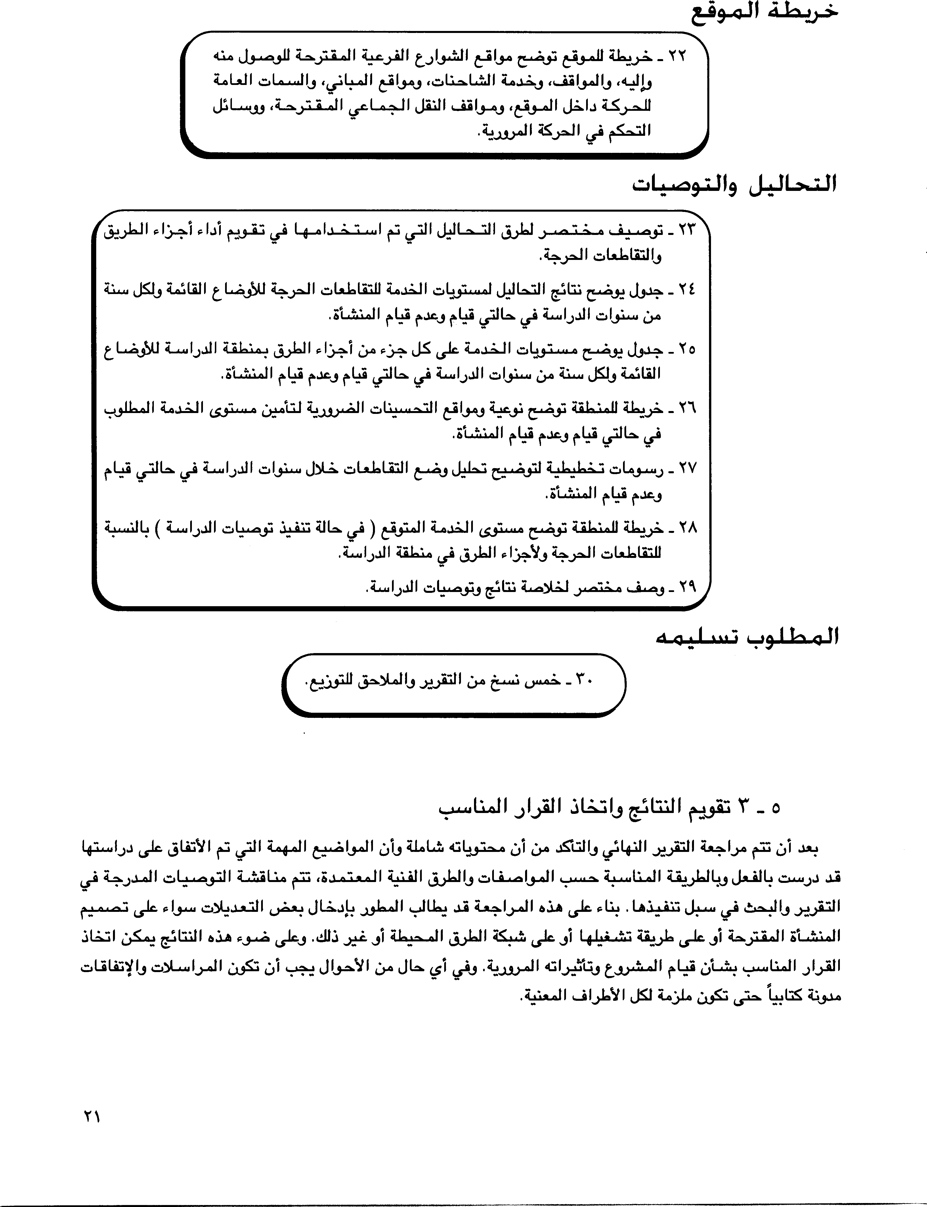

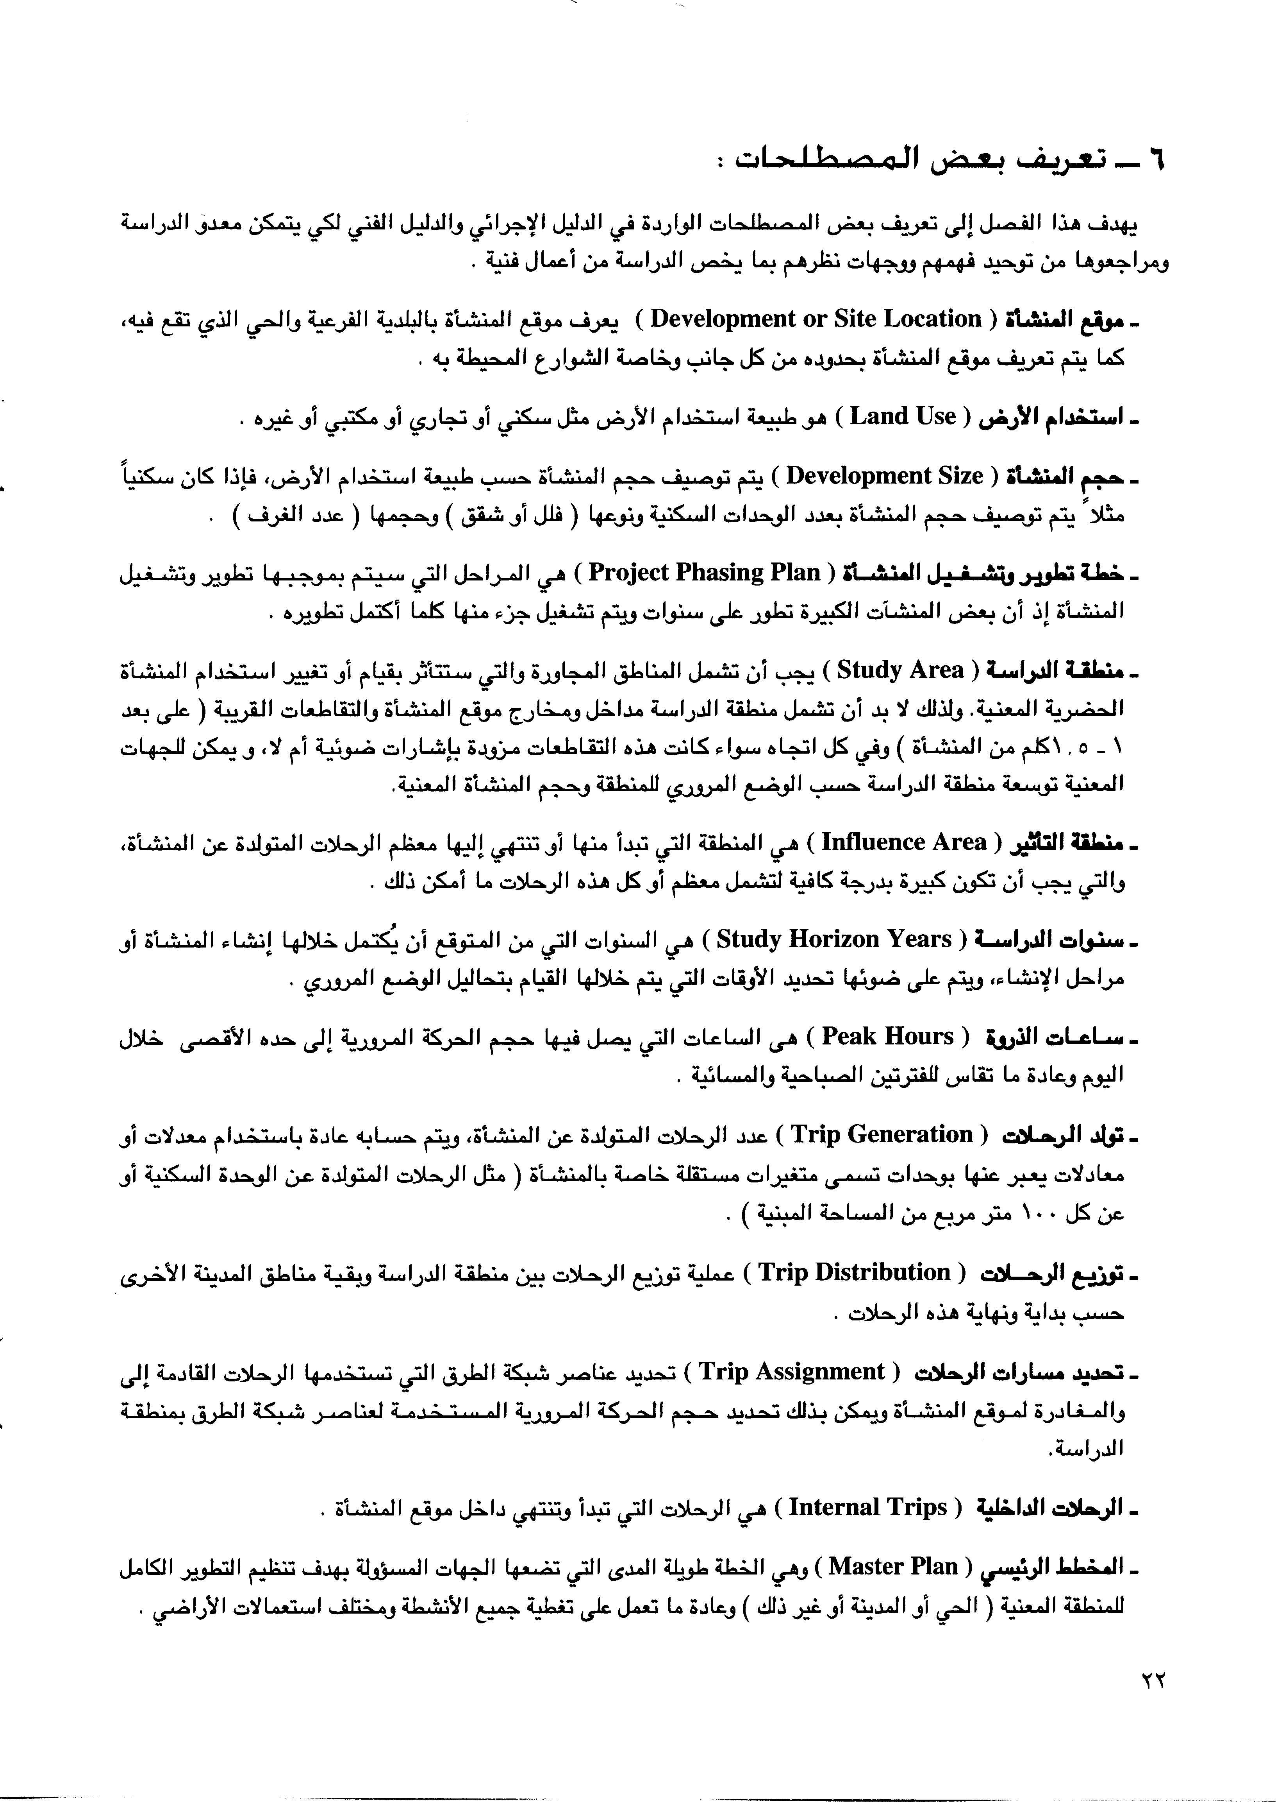

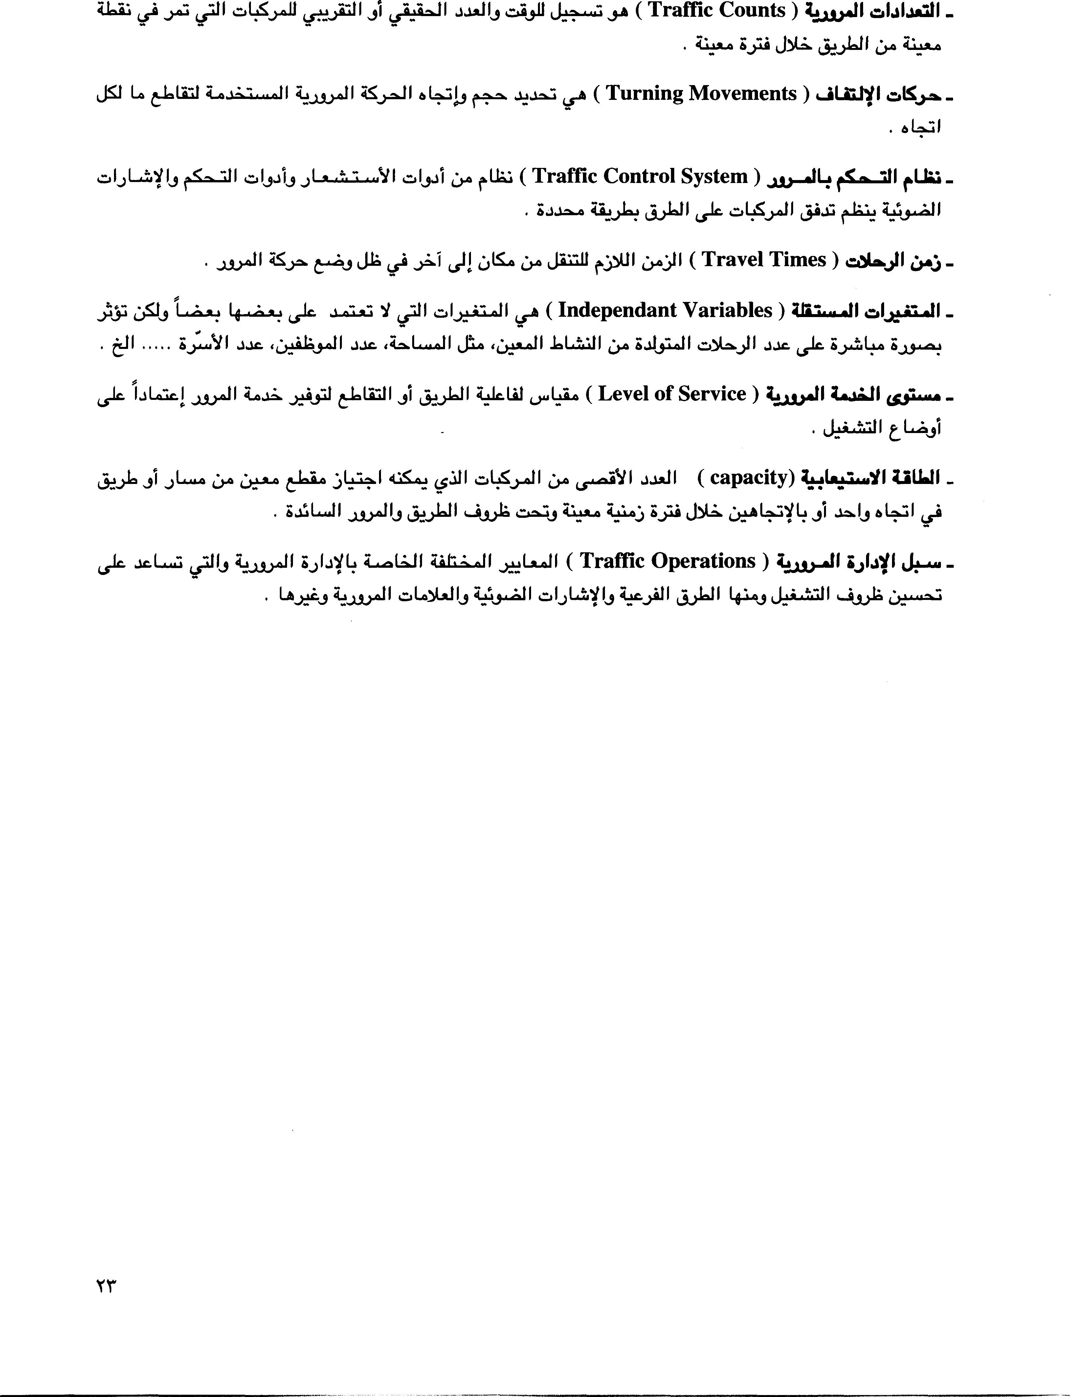

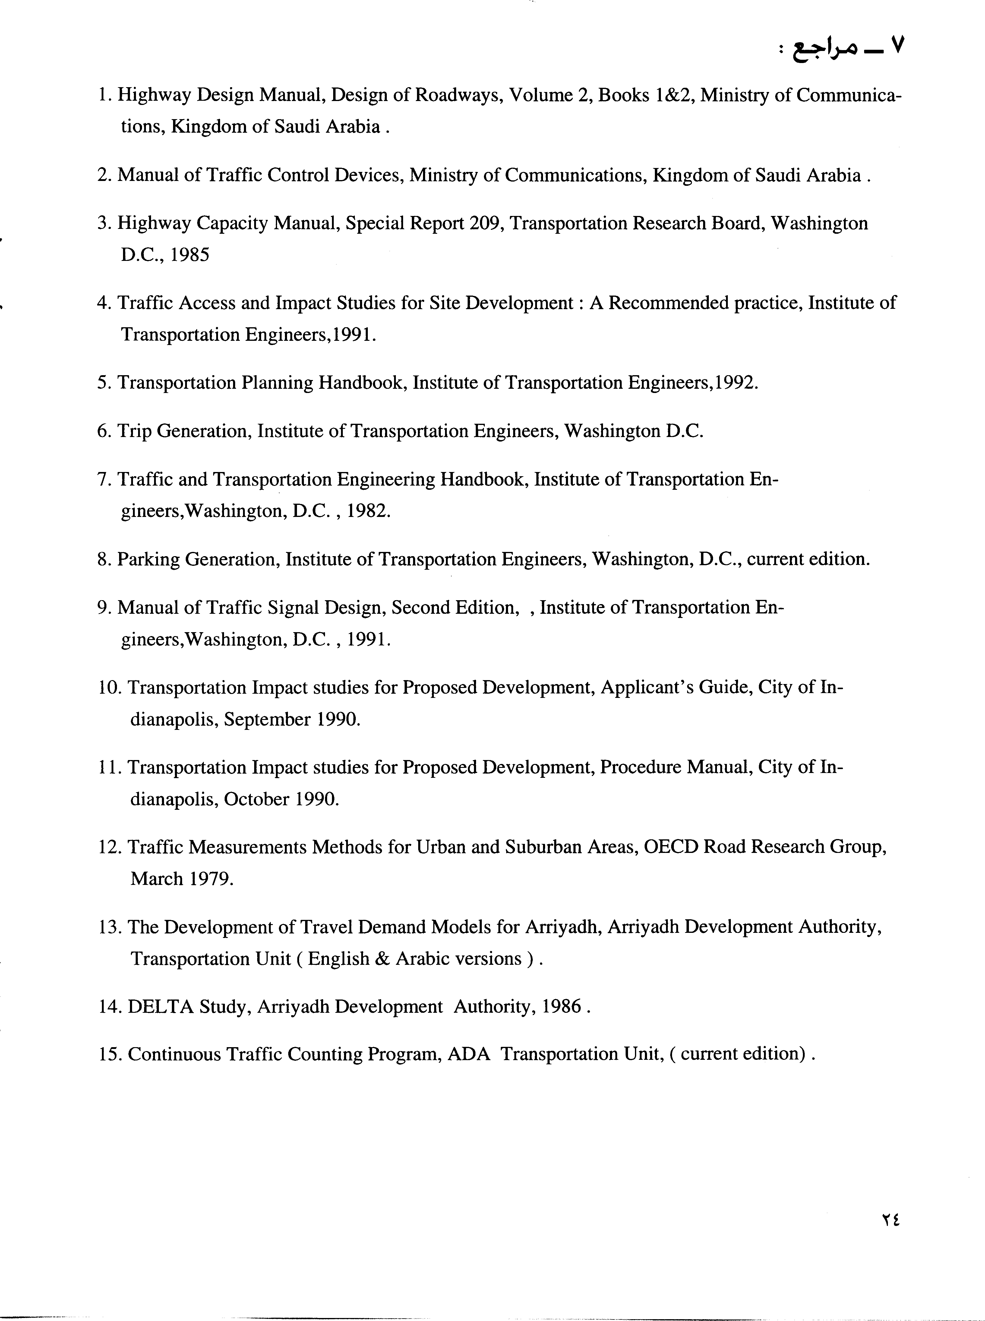


Driving Rules in Qatar
Qatar driving can be intimidating, frustrating and even dangerous. Experienced drivers, however have adapted and found - knowing what to expect can be half the battle. You won't be able to change the system or the drivers – so it is better to accept reality and save yourself the anguish.

Accept and adapt to the local driving conditions

DO NOT:

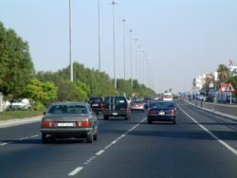
- lose your temper
- use bad language
- use hand gestures
- demonstrate aggressive behavior
- be put off by the flashing of headlights or the honking of horns
- listen to driver gossip (get out on the road and try it first)

DO BE PATIENT!

There is an order to driving on the roads in Qatar, be patient observe the system and you will come to understand it.

Defensive / Aggressive Driving

A contradiction in terms, but the safest way to arrive at your destination.

Be aware of your surroundings at all times, expect the unexpected and be prepared for it. Assume that any vehicle around you will make an incorrect action (just because the vehicle in the front is indicating right, this doesn't mean that he's going to turn right!) Anticipate the worst of actions by the vehicles around you.

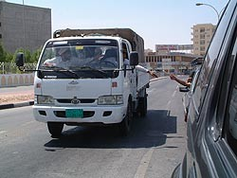
When choosing a vehicle some people prefer the security of a large size - and others the agility of a smaller vehicle. Choose what you are most comfortable driving.
Maintain an awareness of vehicles to your rear and those passing (on the left or right) by keeping a close eye on all of your mirrors. This is referred to as situational awareness.

The Flashing of Headlights

If you are driving in the left lane (well any lane) and the vehicle behind you is approaching quickly with flashing headlights - the driver is in a hurry and wishes you out of his path. If it is safe to do so – signal and move over. Do not touch your brake pedal flashing your brake lights - telling the driver "back off buddy you're too close." The driver behind will interpret this as very aggressive behavior.
Flashing headlights are a gesture to give way in some countries. Beware – not usually the case in Qatar. Locally this translates to – "you’d better wait – I’m coming through".

Honking the Horn

The honking of car horns usually means I'm here, but as you will find there can be an enthusiastic volley when the lights turn to green, or if the vehicle behind thinks there was a space for you to join the traffic on the roundabout or that you were taking too long to move. Don’t be intimidated by the honking. Take your time and join the traffic when you’re ready.

Lane Protocol

People tend to drive in the left lane, as vehicles approaching from the right tend not to stop when joining the main road, so:

- On a three lane road most people will drive in the middle or left lane, leaving the right lane to the water trucks, pickups, and entering vehicles.
- On a two lane road most people will drive in the left lane
- On a single lane road: BE CAREFUL!!

Roundabout Protocol

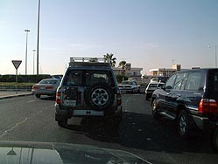
Usually when approaching a roundabout from a two lane carriageway the right lane is meant for turning right and the left lane for continuing straight ahead, turning left or turning back - unless otherwise stated.

On a three lane carriageway the right lane is for turning right, the middle lane is for going straight ahead and the left lane is for turning left or turning back unless otherwise stated.

Many roundabouts are now being fitted with a separate slip road for turning right.

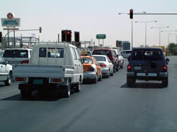
EXAMPLE:

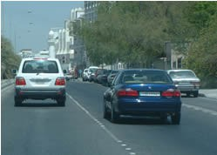
Ideally if you approach the roundabout from the middle lane and intend to go straight ahead you should drive into the roundabout position yourself in the centre - as if there is another vehicle on your left and right sides. Follow the round shape of the roundabout. As you approach your exit you should indicate and turn off, almost as if you’re making a right turn.
Some people follow this lane discipline, but I have to say that they may be the minority. So just because someone is in the middle lane do not assume they are going straight ahead, they may be turning left or believe it or not they may even wish to turn right,.
Approaching the roundabout, it seems many people position themselves in the shortest – or fastest moving queue regardless of which way they might be turning in the roundabout

I once heard someone call a roundabout over here a straight-on-about, this is generally because some people don’t indicate or follow lane discipline

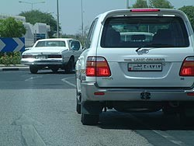
Now going through the maneuver as in example above will probably be more like this: approach the roundabout from the middle lane intending to go straight ahead, when you see a gap in the traffic, pull away as quick as possible to get ahead of the traffic on your left, then cut straight through the roundabout (making it a straight-on-about) as soon as you see your exit aim straight for it checking your right mirror, because remember the vehicle on your right should have turned right, but maybe he’s trying to turn left.
Vehicles in the roundabout have the right of way. Most drivers comply.

Caution

If someone is driving erratic, pulling out in front of you, suddenly stopping, cutting you off, and obviously having no consideration for others, take one or two deep breaths, get out of the way, and let them go. Then smile to yourself, because it is not worth a duel or the trouble.

Be mindful of trucks carrying any load and in particular when they are going around a roundabout or overtaking you.

Avoid driving behind:

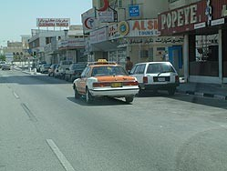
Taxi's: they are likely to stop anywhere without indicating to pick up or drop a fair

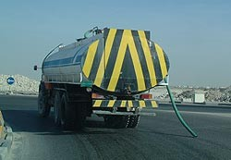
Police Checks and Penalties
Trucks in general and especially Water Trucks: They are often very slow and unpredictable. You also have very limited forward vision when behind a truck.

The Traffic Police from time to time will carry out random checks on:
- Driving licenses
- Vehicle registration documents
- The wearing of seat belts
For not wearing your belt the fine is QR100

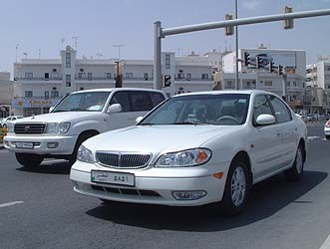
There are now speed limits on all roads, and the police have mobile radar cameras and unmarked cars fitted with video cameras.

Speeding fines vary from QR300 to QR500.

Be aware that the police can and do impound your vehicle if your speed is excessive.

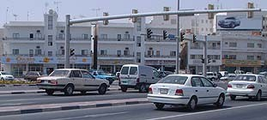
Many traffic signals have a static camera, which will take a picture with flash of anyone jumping a red light. The fine is QR1200

You can be subjected to a traffic penalty without your knowledge. Frequently the first you will learn of the penalty will be upon annual vehicle re-registration, when in a car accident, or trying to leave the country.

Rules, regulations and procedures are subject to changes - sometimes frequent changes. The above advice is current at this time.

Remember: don’t be put off by what you have read here or by what other people might say, because after you’ve been here for a short time you will see that there is an order to the way people drive

ACCIDENT GUIDELINES

Should you be involved in an accident, strict procedures will apply, however - if you handle yourself well and follow this advice - it need not be such a harrowing experience.
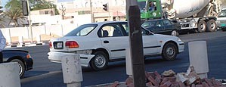
- DO NOT MOVE THE VEHICLES - no
matter where the accident occurs, whether on your property or on a main road causing major congestion. The police need to see the position of all vehicles to assess responsibility. They will likely allow you to move your vehicle once an assessment has been completed.

DO NOT MOVE YOUR VEHICLE UNTIL THE POLICE TELL YOU TO

- If you have a colleague or friend who speaks Arabic - try to get them to come to the accident scene. Whilst many of the police do speak English, some may not be fluent.

- Contact police on 4890699, 4890670 or 999, provide them with the location of the accident including names of landmarks near to you i.e. large shops, buildings etc.

- If there are injuries call 999 and ask for an ambulance or contact Hamad Hospital on 4392222. If you are injured and are able, it is advisable to arrange for someone else to come and stay with your vehicle.

- At the accident scene you will be asked to provide your license, vehicle registration and insurance documents (it is advisable to have photocopies of these documents available in your vehicle). The police will listen to the explanations of all involved and complete their preliminary roadside report. They will advise all involved when to attend the Traffic Department (normally the following day, although it can be immediate) to receive the documentation required for repair-work and the insurance companies.
It is illegal for any garage in Qatar to carry out any accident or body work repairs on your vehicle without the authorized paperwork from Police and or insurance company.

- Ensure you get contact details from the policeman making the road side report - his name, which police station he is from, details of his shift schedule over the next few days. Try your best to retrieve his personal GSM phone number, (THIS WILL SAVE YOU A LOT OF FRUSTRATION, WASTED TIME AND RUNNING AROUND)

- It is advisable that your company PRO or well informed Arabic speaking colleague assist you at the police station.
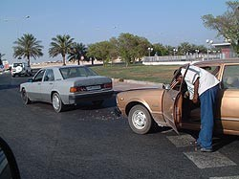
- DO NOT SIGN ANYTHING unless you fully understand what it is, DO NOT accept the blame if you think it is not your fault.

- Do not lose your temper Do not use bad language
- Do not use aggressive behavior Do be patient
- DO SMILE AND BE RESPECT FULL TO THE POLICE (it works wonders)

In all my dealings with the Police force here in Qatar I have only found them to be polite and very helpful

DRIVER LICENSE REQUIREMENTS:

- International Driver’s license is Valid for up to 6 months with an official visit visa, starting from the Date of entry to Qatar when accompanied with most first world country’s valid driver’s license.
- Most first world home countries’ driver’s licenses are good for the duration of a tourist visa.
- Any Other Driver’s License and for all people with a permanent visa, the driver’s license is only valid for 7 Days, starting from the Date of entry to Qatar. A temporary driver’s license will need to be obtained before the end of 7 days.
- A temporary Qatari license can be obtained after a vision exam and a fee of QR. 150.
- If in doubt whether your driver’s license will be accepted, check with the Qatar Embassy.

PLEASE NOTE THAT INSURANCE COMPANIES WILL NOT COVER ANY DAMAGE TO THE VEHICLE DUE TO DRIVING OFF ROAD.

With Compliments from BASELINE Trading

Traffic Rules in Dubai
Source: https://licensing.rta.ae/handbook/lmv/lmv_en.pdf

Introduction
- A License To Drive
- Steps to Obtain and Keep Your License
- Expats Driving in Dubai
- Licenses Recognised by the UAE
- License Renewal
- Learning to Drive
- Learning to Drive in 5 Stages
- Your Driving Instructor Will Help You to Learn
- Theory Training Curriculum
- Practical Training Curriculum
- The Challenge of Driving Safely
- Practice is the Best Way
- Driving Defensively
- You Will Continue to Learn for Years
- Managing Risk
- Speed
- Seat Belts
- Alcohol, Drugs and Medicines
- Driving in Different Conditions
- Driving in Fog
- Driving Safely at Night
- Driving When Tired
- Driving When Angry
- Floods in Dubai
- Vehicle Maintenance
- Driver Assistance Systems
- Electric Vehicles
- Reducing Your Risk of a Crash
- Mobile Phones and Other Driver Distractions
- Road User Safety
- Dealing with Vulnerable Road Users
- Sharing the Road With Other Vehicles
- Giving Way To Emergency Vehicles
- Dealing with Cyclists on the road
- Bus & Taxi Lanes in Dubai
- Dubai Tram and Dubai Metro
- Signs and Markings Related to Dubai Tram
- Rules and Responsibilities
- Being a Responsible Driver
- Disciplined Driving
- What are Road Rules
- Road Signs
- Regulatory Signs
- Warning Signs
- Road Markings
- Traffic Control at Intersections
- Speed Limits
- Giving Way to Pedestrians
- Turning
- Roundabouts
- Changing Lanes and Overtaking
- Driving on Freeways
- Interchanges
- Safe behavior in the event of a collision
- Driving in Dubai
- Salik in Dubai
- Parking
- Paid Parking in Dubai
- Eco Friendly Driving Habits
- Test Yourself Questions
- Traffic Violations, Fines & Black Points
- RTA Easy Licensing
- Keep Learning and Enjoy Your Driving Experience

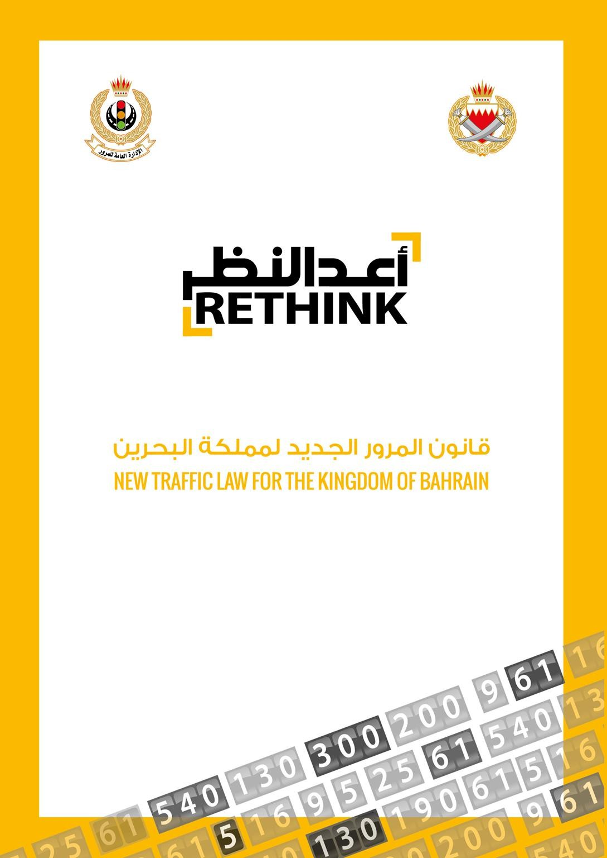
Bahrain Traffic Rules:
Source: https://services.bahrain.bh/wps/PA_GDTDhBoardServices/faces/javax.faces.resource/en/GDTLaw.pdf?rel=v1

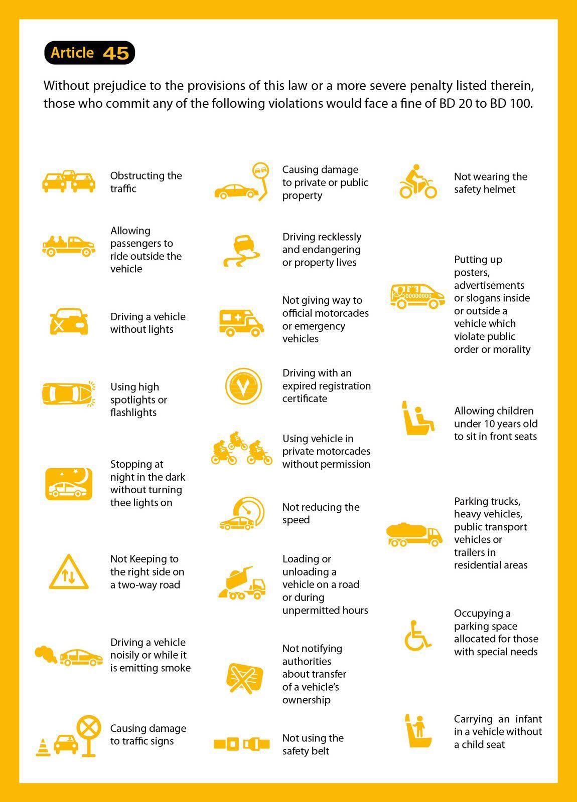

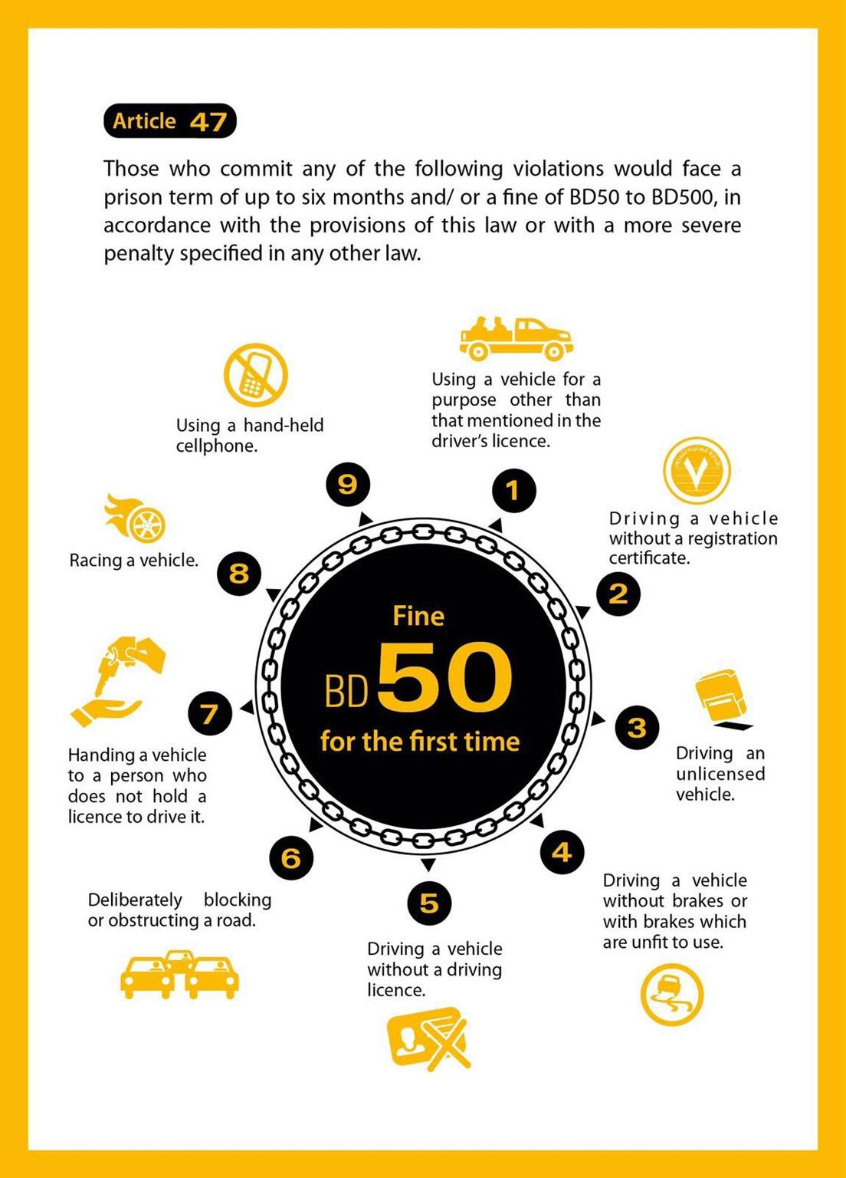

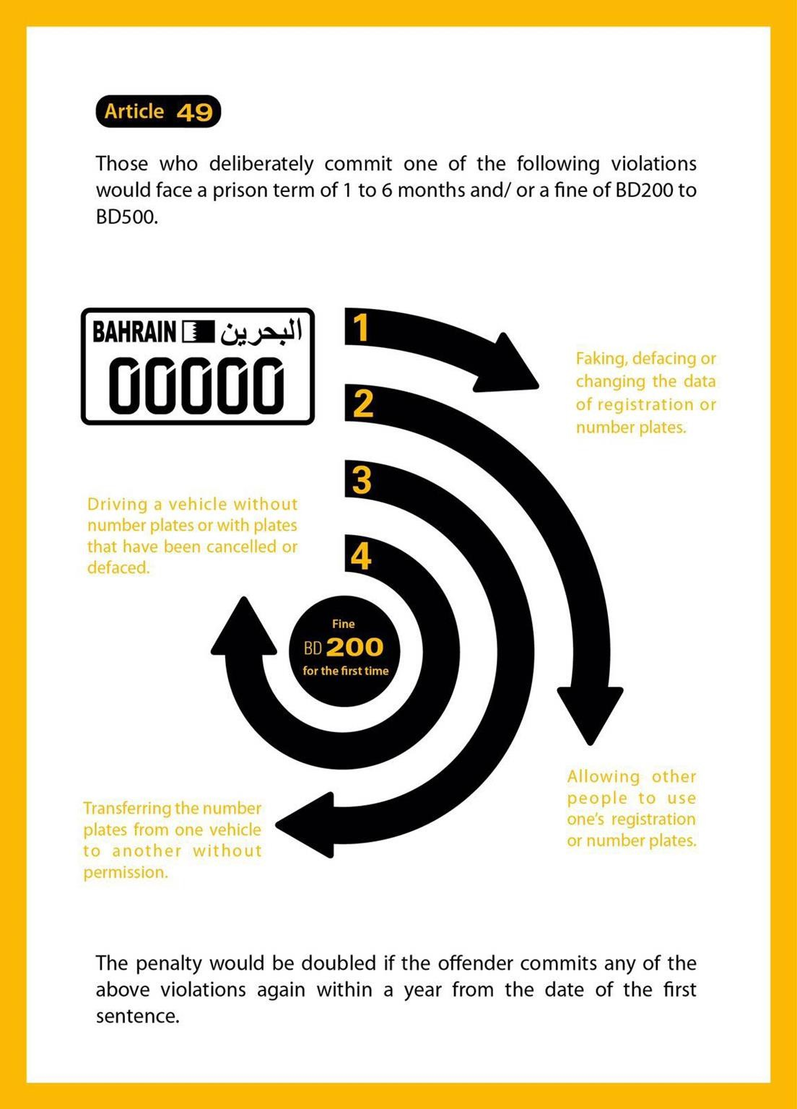

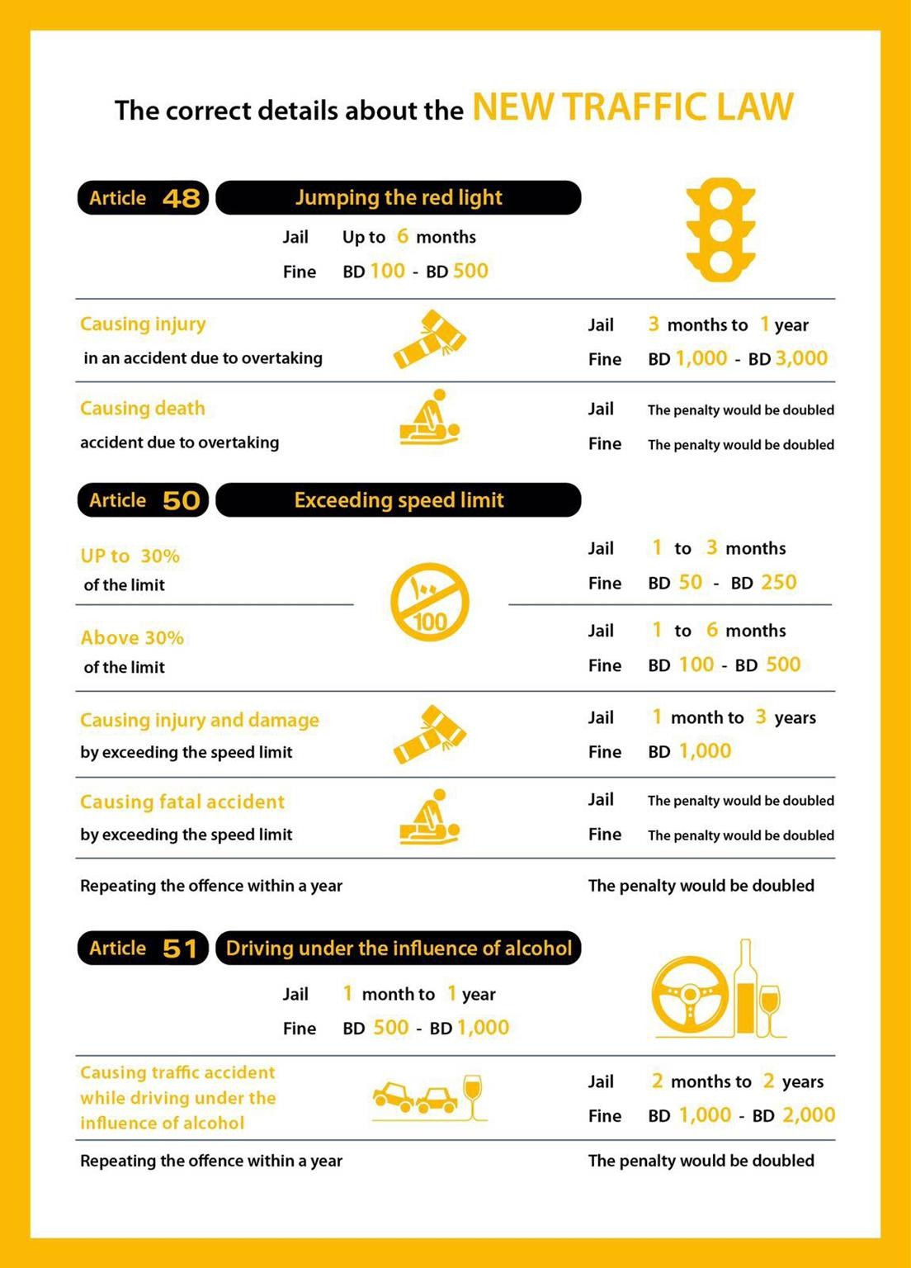



Canadian Manual of Standard Traffic Signs & Pavement Markings
Canadian Traffic Rules:
Source:
https://www.atstraffic.ca/wp-content/uploads/2016/08/MoST_PM.pdf



September 2000
TABLE OF CONTENTS

  - General Provisions

  - Introduction
  - Authority and Jurisdiction
  - Requirements of Signing
  - Functional groups of Signs
  - Standardization of Application
  - Standardization of Design
    - Shape and Colour
    - Dimensions
    - Message
      - Interdictory and mandatory/permissive symbols
    - Retroreflectivity and Illumination
      - Means of Reflectorization
      - Means of Illumination

  - Standardization of Placement
    - Side of the Roadway
1.7.2. Longitudinal Positioning
    - Lateral Positioning
    - Height
    - Angle
    - Mounting and Grouping

  - Sign Posts and Bases
  - Overhead Signs
  - Maintenance
  - Sign Supply
2.0 Regulatory Signs
3.0 Warning Signs
  - Guide Signs
  - Introduction
  - Control City & Destination Selection Policy
  - General Conventions for Guide Signs
    - Colour and Retroreflectivity
    - Lettering
4.3.3. Arrows and Borders
4.3.4 Abbreviations
  - Guide Sign Warrants and Application Policy
  - Freeway Guide Signs
    - Background
    - Conventions for G-5 Signs
    - Guide Sign Theory
Fig. 4.1 to 4.xx Sample Guide Sign Applications

5.0 School and Pedestrian Signs
6.0 Information Signs
  - Pavement Markings
  - Introduction
    - Materials
    - Longitudinal Markings
      - Colour
      - Pattern
      - Intersections
      - Double Lines
      - Single Solid Dividing Lines
      - Lane Edge Lines
    - Transverse Pavement Markings
      - Color
      - Shapes
      - Stop Lines
      - Crosswalks
      - Lane Use Arrows
      - Letters and Symbols

- Chevron and Crosswalks Marking in Gore Areas
  - Chevron Pavement Markings in Gore Areas
  - Crosshatch Pavement Markings in Medians
  - Advance Crossing Markings
- Raised Pavement Markers (RPM’s)
  - Guidelines for installations
  - RPM – Reflective White Mon-direction
  - RPM – Reflective Yellow Mon-directional
  - RPM – Reflective Yellow Bi-directional
  - RPM – Reflective Red an White Bi-directional
  - Reflectors –CMB & CRB

- Delineators
  - Introductions
  - Application
  - Specifications
  - Delineators on Conventional Highways
  - Delineators on Freeway and Expressways
- Reserved Lanes
- Left Turn Pavement Markings
  - Rural
  - Urban
- Two Way Left Turn Lanes
  - General
  - Application
  - Median Lane Width
  - Intersection Treatment
- No Passing Zones
  - Barrier Lines
  - Field Measurement

Australian Road Rules
As at 19 March 2018

As approved by the Transport and Infrastructure Council Published by the Parliamentary Counsel’s Committee
Australian Traffic Rules:
Source:
https://pcc.gov.au/uniform/Australian-Road-Rules-19March2018.pdf

This is a consolidated version of the Australian Road Rules. These Rules are a national model law and are intended to provide the basis for nationally consistent road rules.
These Rules do not, by themselves, have any legal effect

Australian Road Rules
Contents
Part 1—Introductory 17
Division 1—General 17
- Australian Road Rules 17
- Commencement 17
- Objects of the Australian Road Rules 17
Division 2—Some features of the Australian Road Rules 18
- Definitions—the dictionary etc 18
- Diagrams 18
- Examples 18
- Headings 18
- Notes 18
- Reader’s Guide 18
- Offences 19
Part 2—Application of the Australian Road Rules 20
Division 1—Roads and road-related areas 20
- Australian Road Rules apply to vehicles and road users on roads and road-related areas 20
- What is a road 20
- What is a road-related area 20
Division 2—Road users and vehicles 22
- Road users 22
- What is a vehicle 22
- Who is a driver 22
- Who is a rider 22
- Who is a pedestrian 22
- References to driver includes rider etc 23
Part 3—Speed-limits 24
- Obeying the speed-limit 24
- Speed-limit where a speed-limit sign applies 24
- Speed-limit in a speed-limited area 25
- Speed-limit in a school zone 26
- Speed-limit in a shared zone 27
- Speed-limit elsewhere 27
Part 4—Making turns 29
Division 1—Left turns 29
- Application of Division to roundabouts, road-related areas and adjacent land 29
- Starting a left turn from a road (except a multi-lane road) 29
- Starting a left turn from a multi-lane road 30
- Making a left turn as indicated by a turn line 32
Division 2—Right turns 34
- Application of Division to certain right turns 34
- Starting a right turn from a road (except a multi-lane road) 34
- Starting a right turn from a multi-lane road 36
- Making a right turn 37
Division 3—Hook turns at intersections 39
- Making a hook turn at a hook turn only sign 39
- Optional hook turn by a bicycle rider 39
- Bicycle rider making a hook turn contrary to no hook turn by bicycles sign 41
Division 4—U-turns 42
- Beginning a U-turn 42
- Giving way when making a U-turn 42
- Making a U-turn contrary to a no U-turn sign 42
- Making a U-turn at an intersection with traffic lights 43
- Making a U-turn at an intersection without traffic lights 43
- Starting a U-turn at an intersection 43
- Repealed 44
Part 5—Change of direction and stop signals 45
Division 1—Change of direction signals 45
- Division does not apply to entering or leaving a roundabout or lane filtering 45
- What is changing direction 45
- Giving a left change of direction signal 46
- How to give a left change of direction signal 46
- Giving a right change of direction signal 47
- How to give a right change of direction signal 47
- How to give a right change of direction signal by giving a hand signal 47
- When use of direction indicator lights permitted 48
Division 2—Stop signals 49
- Division does not apply to bicycle riders or certain tram drivers 49
- Giving a stop signal 49
- How to give a stop signal 49
- How to give a stop signal by giving a hand signal 49
Part 6—Traffic lights, traffic arrows and twin red lights 51
Division 1—Obeying traffic lights and traffic arrows 51
- Stopping for a red traffic light or arrow 51
- Stopping for a yellow traffic light or arrow 53
- Exceptions to stopping for a red or yellow traffic light 54
- Proceeding through a red traffic light 54
- Proceeding through a red traffic arrow 55
60A Proceeding through a bicycle storage area before a red traffic light or arrow 55
- Proceeding when traffic lights or arrows at an intersection change to yellow or red 55
Division 2—Giving way at traffic lights and traffic arrows 57
- Giving way when turning at an intersection with traffic lights 57
- Giving way at an intersection with traffic lights not operating or only partly operating 58
- Giving way at a flashing yellow traffic arrow at an intersection 59
- Giving way at a marked foot crossing (except at an intersection) with a flashing yellow traffic
light 60
Division 3—Twin red lights (except at level crossings) 61
- Stopping for twin red lights (except at level crossings) 61
Part 7—Giving way 62
Division 1—Giving way at a stop sign, stop line, give way sign or give way line
applying to the driver 63
- Stopping and giving way at a stop sign or stop line at an intersection without traffic lights 63
- Stopping and giving way at a stop sign or stop line at other places 64
- Giving way at a give way sign or give way line at an intersection (except a roundabout) 65
- Giving way at a give way sign at a bridge or length of narrow road 67
- Giving way at a give way sign or give way line at other places 68
Division 2—Giving way at an intersection without traffic lights or a stop sign, stop
line, give way sign or give way line applying to the driver 69
- Giving way at an intersection (except a T–intersection or roundabout) 69
- Giving way at a T–intersection 72
Division 3—Entering or leaving road-related areas and adjacent land 75
- Giving way when entering a road from a road-related area or adjacent land 75
- Giving way when entering a road-related area or adjacent land from a road 76
Division 4—Keeping clear of and giving way to particular vehicles 78
- Keeping clear of trams travelling in tram lanes etc 78
- Giving way to buses 78
- Keeping clear of police and emergency vehicles 79
- Giving way to police and emergency vehicles 79
Division 5—Crossings and shared zones 81
- Stopping at a children’s crossing 81
- Giving way at a pedestrian crossing 82
- Overtaking or passing a vehicle at a children’s crossing or pedestrian crossing 84
- Giving way to pedestrians in a shared zone 84
Division 6—Other give way rules 85
- Giving way when driving through a break in a dividing strip 85
- Giving way on a painted island 86
- Giving way in median turning bays 86
- Giving way when moving from a side of a road or a median strip parking area 87
Part 8—Traffic signs and road markings 89
Division 1—Traffic signs and road markings at intersections and other places 90
- Left turn signs 90
- Right turn signs 90
- No turns signs 91
- No left turn and no right turn signs 91
- Traffic lane arrows 92
Division 2—Traffic signs and road markings generally 94
- No overtaking or passing signs 94
- No overtaking on bridge signs 94
- Emergency stopping lane only signs 95
- Keep clear markings 95
- Road access signs 96
- One-way signs 97
- Keep left and keep right signs 98
- No entry signs 98
- Hand-held stop signs 99
101A Safety ramp and arrester bed signs 99
Division 3—Signs for trucks, buses and other large vehicles 100
- Clearance and low clearance signs 100
- Load limit signs 100
- No trucks signs 101
- Trucks must enter signs 102
- No buses signs 102
- Buses must enter signs 102
- Trucks and buses low gear signs 103
Part 9—Roundabouts 104
- What is a roundabout 104
- Meaning of halfway around a roundabout 104
- Entering a roundabout from a multi-lane road or a road with 2 or more lines of traffic
travelling in the same direction 104
- Giving a left change of direction signal when entering a roundabout 108
- Giving a right change of direction signal when entering a roundabout 109
- Giving way when entering or driving in a roundabout 109
- Driving in a roundabout 110
- Obeying traffic lane arrows when driving in or leaving a roundabout 110
- Giving a change of direction signal when changing marked lanes or lines of traffic in a
roundabout 110
- Giving a left change of direction signal when leaving a roundabout 111
- Giving way by the rider of a bicycle or animal to a vehicle leaving a roundabout 111
Part 10—Level crossings 112
- What is a level crossing 112
- Stopping and giving way at a stop sign at a level crossing 112
- Giving way at a give way sign or give way line at a level crossing 113
- Entering a level crossing when a train or tram is approaching etc 113
- Leaving a level crossing 114
Part 11—Keeping left, overtaking and other driving rules 115
Division 1—General 115
- Unreasonably obstructing drivers or pedestrians 115
- Keeping a safe distance behind vehicles 115
- Keeping a minimum distance between long vehicles 115
- Entering blocked intersections 116
128A Entering blocked crossings 116
Division 2—Keeping to the left 117
- Keeping to the far left side of a road 117
- Keeping to the left on a multi-lane road 117
- Keeping to the left of oncoming vehicles 118
- Keeping to the left of the centre of a road or the dividing line 119
- Exceptions to keeping to the left of the centre of a road 121
- Exceptions to keeping to the left of a dividing line 122
- Keeping to the left of a median strip 125
- Driving on a one-way service road 126
- Keeping off a dividing strip 126
- Keeping off a painted island 127
- Exceptions for avoiding obstructions on a road 128
Division 3—Overtaking 130
- No overtaking unless safe to do so 130
- No overtaking etc to the left of a vehicle 130
- No overtaking to the right of a vehicle turning right etc 131
- Passing or overtaking a vehicle displaying a do not overtake turning vehicle sign 131
- Keeping a safe distance when overtaking 132
- Driver being overtaken not to increase speed 132
Division 4—Driving in marked lanes or lines of traffic 133
- Driving within a single marked lane or line of traffic 133
- Moving from one marked lane to another marked lane across a continuous line separating the
lanes 134
- Giving way when moving from one marked lane or line of traffic to another marked lane or
line of traffic 134
148A Giving way when moving within a single marked lane 135
- Giving way when lines of traffic merge into a single line of traffic 136
- Driving on or across a continuous white edge line 136
- Riding a motor bike or bicycle alongside more than 1 other rider 137
151A Lane filtering between vehicles on a motor bike 138
Division 5—Obeying overhead lane control devices applying to marked lanes 140
- Complying with overhead lane control devices 140
Division 6—Driving in marked lanes designated for special purposes 141
- Bicycle lanes 141
- Bus lanes 142
- Tram lanes 142
155A Tramways 143
- Transit lanes 145
- Truck lanes 145
- Exceptions to driving in special purpose lanes etc 146
- Marked lanes required to be used by particular kinds of vehicles 147
Division 7—Passing trams and safety zones 149
- Passing or overtaking a tram that is not at or near the left side of a road 149
- Passing or overtaking a tram at or near the left side of a road 149
- Driving past a safety zone 149
- Driving past the rear of a stopped tram at a tram stop 150
- Stopping beside a stopped tram at a tram stop 151
164A Staying stopped if a tram comes from behind a stopped driver and stops 151
Part 12—Restrictions on stopping and parking 153
Division 1—General 153
- Stopping in an emergency etc or to comply with another rule 153
- Application of Part to bicycles 153
Division 2—No stopping and no parking signs and road markings 154
- No stopping signs 154
- No parking signs 154
- No stopping on a road with a yellow edge line 155
Division 3—Stopping at intersections and crossings 156
- Stopping in or near an intersection 156
- Stopping on or near a children’s crossing 157
- Stopping on or near a pedestrian crossing (except at an intersection) 158
- Stopping on or near a marked foot crossing (except at an intersection) 159
- Stopping at or near bicycle crossing lights (except at an intersection) 159
- Stopping on or near a level crossing 160
Division 4—Stopping on clearways and freeways and in emergency stopping lanes 162
- Stopping on a clearway 162
- Stopping on a freeway 162
- Stopping in an emergency stopping lane 163
Division 5—Stopping in zones for particular vehicles 164
- Stopping in a loading zone 164
- Stopping in a truck zone 164
- Stopping in a works zone 165
- Stopping in a taxi zone 165
- Stopping in a bus zone 166
- Stopping in a minibus zone 166
- Stopping in a permit zone 167
- Stopping in a mail zone 167
Division 6—Other places where stopping is restricted 169
- Stopping in a bicycle lane, bus lane, tram lane, tramway, transit lane, truck lane or on tram
tracks 169
- Stopping in a shared zone 169
- Double parking 170
- Stopping in or near a safety zone 171
- Stopping near an obstruction 172
- Stopping on a bridge or in a tunnel etc 172
- Stopping on a crest or curve outside a built-up area 173
- Stopping near a fire hydrant etc 173
- Stopping at or near a bus stop 174
- Stopping at or near a tram stop 174
- Stopping on a path, dividing strip, , nature strip, painted island or traffic island 175
- Obstructing access to and from a footpath, driveway etc 175
- Stopping near a postbox 176
- Stopping on roads—heavy and long vehicles 177
- Stopping on a road with bicycle parking sign 177
- Stopping on a road with motor bike parking sign 178
- Stopping in a parking area for people with disabilities 178
203A Stopping in a slip lane 179
Division 7—Permissive parking signs and parking fees 180
- Meaning of certain information on or with permissive parking signs 180
- Parking for longer than indicated 181
205A Parking outside times indicated 182
- Time extension for people with disabilities 182
- Parking where fees are payable 183
Division 8—Parallel parking 184
- Parallel parking on a road (except in a median strip parking area) 184
208A Parallel parking in a road-related area (except in a median strip parking area) 185
- Parallel parking in a median strip parking area 186
Division 9—Angle parking 187
- Angle parking 187
Division 10—Other parking related rules 193
- Parking in parking bays 193
- Entering and leaving a median strip parking area 193
- Making a motor vehicle secure 194
Part 13—Lights and warning devices 196
Division 1—Lights on vehicles (except bicycles, animals and animal-drawn vehicles) 196
- Division does not apply to riders of bicycles, animals or animal-drawn vehicles 196
- Using lights when driving at night or in hazardous weather conditions 196
- Towing a vehicle at night or in hazardous weather conditions 196
- Using fog lights 197
- Using headlights on high-beam 197
- Lights not to be used to dazzle other road users 198
- Using lights on vehicles that are stopped 198
- Using hazard warning lights 199
- Using warning lights on buses carrying children 199
Division 2—Lights on animal-drawn vehicles 201
- Using lights when riding an animal-drawn vehicle at night or in hazardous weather
conditions 201
Division 3—Horns and radar detectors 202
- Using horns and similar warning devices 202
- Using radar detectors and similar devices 202
Division 4—Portable warning triangles for heavy vehicles 203
- Heavy vehicles to be equipped with portable warning triangles 203
- Using portable warning triangles 203
Part 14—Rules for pedestrians 205
Division 1—General 205
- No pedestrians signs 205
- Pedestrians on a road with a road access sign 205
- Crossing a road—general 206
- Crossing a road at pedestrian lights 206
- Crossing a road at traffic lights 207
- Crossing a road to or from a tram 208
- Crossing a road on or near a crossing for pedestrians 209
- Crossing a level crossing 209
235A Crossing a pedestrian level crossing that has a red pedestrian light 210
- Pedestrians not to cause a traffic hazard or obstruction 211
- Getting on or into a moving vehicle 212
- Pedestrians travelling along a road (except in or on a wheeled recreational device or toy) 212
- Pedestrians on a bicycle path or separated footpath 212
Division 2—Rules for persons travelling in or on wheeled recreational devices and
wheeled toys 215
240A No wheeled recreational devices or toys sign 215
- Wheeled recreational devices and toys not to be used on certain roads 215
- Travelling in or on a wheeled recreational device or toy on a road 216
- Travelling in or on a wheeled recreational device or toy on a footpath or shared path 216
- Travelling on rollerblades etc on a bicycle path or separated footpath 217
- Wheeled recreational devices or wheeled toys being towed etc 218
244A Meanings of scooter and motorised scooter 218
244B Wearing of helmets by users of motorised scooters 219
244C Motorised scooters not to be used 219
Part 15—Additional rules for bicycle riders 220
- Riding a bicycle 220
- Carrying people on a bicycle 220
- Riding in a bicycle lane on a road 221
247A Entering a bicycle storage area 221
247B Giving way while entering or in a bicycle storage area 221
- Riding across a crossing 222
- Riding on a separated footpath 222
- Riding on a footpath or shared path 222
- Riding to the left of oncoming bicycle riders on a path 223
- No bicycles signs and markings 223
- Bicycle riders not to cause a traffic hazard 224
- Bicycles being towed etc 224
- Riding too close to the rear of a motor vehicle 225
- Bicycle helmets 225
- Riding with a person on a bicycle trailer 225
- Equipment on a bicycle 226
- Riding at night 226
- Stopping for a red bicycle crossing light 226
- Stopping for a yellow bicycle crossing light 227
- Proceeding when bicycle crossing at an intersection or another place on a road 227
262A Repealed 228
Part 16—Rules for persons travelling in or on vehicles 229
- Application of Part to persons in or on trams 229
- Wearing of seatbelts by drivers 229
- Wearing of seatbelts by passengers 16 years old or older 229
- Wearing of seatbelts by passengers under 16 years old 230
- Exemptions from wearing seatbelts 234
- How persons must travel in or on a motor vehicle 235
- Opening doors and getting out of a vehicle etc 237
- Wearing motor bike helmets 237
- Riding on motor bikes 238
- Interfering with the driver’s control of the vehicle etc 239
Part 17—Additional rules for drivers of trams, tram recovery vehicles and public
buses 240
Division 1—Trams 240
- Division also applies to tram recovery vehicles and public buses travelling along tram tracks 240
- Stopping for a red T light 240
- Stopping for a yellow T light 240
- Exception to stopping for a red or yellow T light 241
- Proceeding after stopping for a red or yellow T light 241
- Proceeding when a red traffic light and a white T light or white traffic arrow is showing 241
- Proceeding when a white T light or white traffic arrow is no longer showing 241
Division 2—Public buses 243
- Application of Division 243
- Stopping for a red B light 243
- Stopping for a yellow B light 243
- Exception to stopping for a red or yellow B light 243
- Proceeding after stopping for a red or yellow B light 244
- Proceeding when a red traffic light and a white B light or white traffic arrow is showing 244
- Proceeding when a white B light or white traffic arrow is no longer showing 244
Part 18—Miscellaneous road rules 246
Division 1—Miscellaneous rules for drivers 246
- Duties of a driver involved in a crash 246
- Driving on a path 247
- Driving on a nature strip 248
- Driving on a traffic island 249
- Making unnecessary noise or smoke 249
- Insecure or overhanging load 249
292A Restricting movement of load 249
- Removing fallen etc things from the road 250
- Keeping control of a vehicle being towed 251
- Motor vehicle towing another vehicle with a towline 251
- Driving a vehicle in reverse 252
- Driver to have proper control of a vehicle etc 252
- Driving with a person in a trailer 252
- Television receivers and visual display units in motor vehicles 253
- Use of mobile phones 254
Division 2—Rules for people in charge of animals 256
- Leading an animal while in or on a vehicle 256
- Rider of an animal on a footpath or nature strip to give way to pedestrians 256
- Riding an animal alongside more than 1 other rider 256
Division 3—Obeying directions 258
- Direction by a police officer or authorised person 258
Part 19—Exemptions 259
- Exemption for drivers of police vehicles 259
- Exemption for drivers of emergency vehicles 259
- Stopping and parking exemption for police and emergency vehicles and authorised persons 259
- Exemption for police officers and emergency workers on foot 260
- Exemption for drivers of trams etc 260
- Exemption for road workers etc 260
- Exemption for oversize vehicles 261
- Exemption for tow truck drivers 262
- Exemption for postal vehicles 263
313A Exemption for garbage truck drivers etc 263
313B Exemption for breakdown vehicles 264
Part 20—Traffic control devices and traffic-related items 265
Division 1—General 265
- Diagrams of traffic control devices, traffic-related items and symbols 265
- Legal effect of traffic control devices mentioned in the Australian Road Rules 265
- When do traffic control devices comply substantially with the Australian Road Rules 265
- Information on or with traffic control devices 267
- Limited effect of certain traffic control devices 268
- Legal effect of traffic-related items mentioned in the Australian Road Rules 269
- When do traffic-related items comply substantially with the Australian Road Rules 269
- Meaning of information on or with traffic control devices and traffic-related items 269
- References to traffic control devices and traffic-related items on a road etc 269
- References to lights that are traffic signals 271
323A Audible lines 271
Division 2—Application of traffic control devices to lengths of roads and areas 272
- Purpose of Division 272
- References to traffic control devices—application to lengths of road and areas 272
- When do traffic control devices apply to a length of road or area—the basic rules 272
- Length of road to which a traffic sign (except a parking control sign) applies 273
- References to a traffic control device applying to a length of road 273
- Traffic control devices applying to a marked lane 273
- Traffic control devices applying to a slip lane 273
- Traffic control devices applying to an intersection 274
- Parking control signs applying to a length of road 274
- Parking control signs applying to a length of road in an area to which another parking control
sign applies etc 275
- How parking control signs apply to a length of road 275
- Traffic control devices applying to an area 276
- How separated footpath signs and separated footpath road markings apply 277
Division 3—Application of traffic control devices to persons 279
- Purpose of Division 279
- References to traffic control devices—application to persons 279
- When do traffic control devices apply to a person—the basic rules 279
- Traffic control devices (except road markings and parking control signs) 279
- Road markings 280
- Traffic signs (except parking control signs) applying to a length of road 280
- Traffic signs (except parking control signs) applying to an area 280
- Traffic control devices applying to a driver in a marked lane 281
- Traffic control devices applying to a driver in a slip lane 281
- Parking control signs 281
Part 21—General 282
- Meaning of abbreviations and symbols 282
- References to a driver doing something etc 282
- References to certain kinds of roads 282
- References to stopping or parking on a length of road etc 282
- References to left and right 283
- References to stopping as near as practicable to a place 283
- References to pedestrians crossing a road 283

United Kingdom
Traffic Signs Manual
United Kingdom Traffic Rules:
Source:
https://www.gov.uk/government/publications/traffic-signs-manual

Chapter 1

Introduction

Department for Transport

Department for Infrastructure (Northern Ireland) Scottish Government
Welsh Government

Content

- INTRODUCTION 5
  - Overview 5
  - Definitions 6
  - Responsibility 6
  - References 7
  - Format 7
  - Further information 8
- THE GOLDEN RULES 9
  - General 9
  - Standardization of traffic signs 9
  - Reducing sign clutter 10
  - Duplication of regulatory signs 11
- LEGAL ASPECTS AND RESPONSIBILITIES 12
  - Responsibility 12
  - Legal framework 12
  - Location 12
  - Removing unlawful traffic signs 13
- CLASSIFICATION OF SIGNS 14
  - General 14
  - Warning signs 14
  - Regulatory signs 15
  - Informatory, directional and tourist signs 16
  - Design of signs 18
- POSITIONING OF SIGNS 20
  - General 20
  - Siting along the road 20
  - Lateral placement 21
  - Mounting heights 22
  - Orientation 22
- MOUNTING SIGNS 24
  - Support structures 24
  - Design of support structures 24
  - Multiple signs on a support structure 25
- SIGN BACKGROUNDS 27
  - General 27
  - Backing boards 27
- MAINTENANCE OF SIGNS 29
  - General 29
- REMOVING SIGNS AND SUPPORTS 31
  - General 31
- SPECIFICATION FOR SIGNS 32
  - General 32
- ILLUMINATION OF SIGNS 33
  - General 33
  - Legislation 33
  - Lighting and reflectorisation 35
  - Road markings 35
- SOURCES OF FURTHER ADVICE 36
  - General 36
  - Design Manual for Roads and Bridges (DMRB) 36
  - Manual for Streets 36
  - Institute of Highway Engineers guidance 36
APPENDIX A 37
Standard colours for traffic signs 37
Standard colours for road markings 37
APPENDIX B 38
British Standards for traffic signs 38
British Standards for road marking materials 38
Other relevant British Standards 38
LIST OF FIGURES 40
INDEX 41

DRIVING PRACTICES IN THE

UNITED STATES
United States Traffic Rules:
Source:
https://2009-2017.state.gov/documents/organization/234570.pdf

The operation of a motor vehicle in the United States is a privilege, not a right, and is reserved for those of the requisite age, physical competence, and responsibility to properly perform the complex skills and duties associated with operation of an automobile.

INTRODUCTION
MANDATORY INSURANCE
DRIVING UNDER THE INFLUENCE
MOVING VIOLATIONS
The Point System
NON-MOVING VIOLATIONS
Parking Zone Violations
Meter Violations
TOWABLE OFFENSES
Parking on Private Property
Snow Emergency Routes
Parking Signs
Handicapped Parking
Parking is Prohibited
Unregistered Vehicle or Expired Vehicle Registration
OBTAINING A U.S. DRIVER’S LICENSE
SAFE AND RESPONSIBLE DRIVING PRACTICES
Top Tips for Safety
In the Event of an Accident
DRIVING REGULATIONS IN THE UNITED STATES

